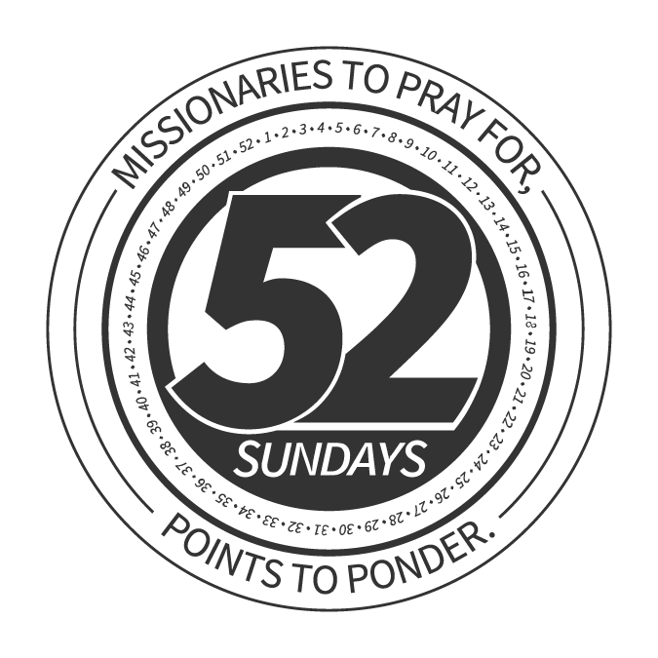 | DEVOTION: November 5  _________________________________________________  Stewards of Gratitude  DAVID WAGANER

DAYLIGHT SAVINGS TIME

I remember as a passenger flying in a small airplane from Tulsa, OK to Ponca City, OK when I was introduced to a new term. The pilot informed the passengers
that due to the icy fog conditions; we would be unable to land.

An aircraft flying low over an area, leaving a trail of fog in the flight path, can cause icy fog. Icy fog is marked by near-zero visibility up to an altitude of only a few hundred feet. As a result of icy fog conditions, we were delayed in our return to Ponca City until the visibility conditions improved so the pilot could land safely. A little inconvenience seemed the better alternative to an unsafe landing of the plane.

One definition of gratitude states, “It is the quality of being thankful; readiness to show appreciation for and to return kindness.” Many times, we equate being thankful to expressing gratitude, however, being thankful should lead us to show appreciation with acts of kindness.

Expressing gratitude to others for actions shown to us seems like an automatic response. But often we fail to do so. Have you ever had difficulty finding the right moment to express gratitude to someone?

A failure to show gratitude can usher in clouds to block our view of what’s ahead of us. Gratitude has the power to revolutionize your entire outlook on life. Look for opportunities to express gratitude as a stewardship response during the month of November as we celebrate Thanksgiving!

DEVOTION: November 12
_________________________________________________

Stewards of Tears
DAVID WAGANER

VETERANS DAY

Many children are taught that crying is a sign of weakness.

I am so thankful for rarely hearing anyone tell me that. As Christians, we are accountable as stewards of everything God has given us. Then why on earth do we learn to store up tears instead of utilizing this God-given ability to shed them?

The psalmist discovered the comfort of God after shedding tears.

- “My tears have been my food day and night, while they say to me all day long, ‘Where is your God?’” — Psalm 42:3
- “You have fed them with the bread of tears, and you have made them to drink tears in large measure.” — Psalm 80:5

Strong’s Concordance indicates 697 biblical references to tears, crying or weeping. A long list of biblical characters shed tears, including Abraham, Hannah, King David and Jeremiah.

We even know that “Jesus wept,” according to John 11:35. Christ certainly touched the followers when He wept with the hurting and as He approached His ultimate path toward the cross in the closing days of His early ministry Christ was the strongest person ever and yet He allowed tears to stream down His face.

We learn from the New Testament book of 2 Corinthians 1:3-5, “Blessed be the God and Father of our Lord Jesus Christ, the Father of mercies and God of all comfort, who comforts us in all our affliction so that we will be able to comfort those who are in any affliction with the comfort with which we ourselves are comforted by God. For just as the sufferings of Christ are ours in abundance, so also our comfort is abundant through Christ.”

In Revelation 21:4 we read that one day God will, “...wipe away every tear from their eyes; and there will no longer be any death; there will no longer be any mourning, or crying, or pain; the first things have passed away.”

Be a faithful steward today and let the tears of sadness over the world’s lostness and tears of gladness for the joy that you know in Christ, stream down your face today!

SCRIPTURES: Psalm 43:3, 80:5; John 11:35; 2 Corinthians 1:3-5; Revelation 21:4

DEVOTION: November 19
_________________________________________________

Stewards of Gratitude
DAVID WAGANER

I recently read the story of a customer in a restaurant accidentally leaving his jacket in a restaurant near McAlester, OK.

The customer was a senior adult, but what sets this story apart from others was what was in the coat and how the restaurant workers handled it. The customer and his wife had driven over 100 miles in order to see a used car and had $14,000 in
the coat. They anticipated a purchase.

The car wasn’t in good condition, so the couple stopped to have lunch and then returned to their home. The next morning the man discovered that his jacket was missing and remembered leaving it at the restaurant near McAlester. He called the manager of the restaurant and after answering a few questions found that the manager and an employee put the jacket away in hopes that the man would return for it.

The man made the trip back to the restaurant to claim both his jacket and the $14,000. The man attempted to offer the owner and staff a reward, but it was refused.

The response from both the restaurant owner and employee brought tears to the senior adult’s eyes. He was touched through the actions and committed to “pay it forward” to others as a way of showing his gratitude.

Too often, many only think how entitled he/she is to the rewards awaiting them in life instead of the opportunity to touch others through doing what’s right!

DEVOTION: November 26
_________________________________________________

Can It Happen Again?
DR. CHRIS SCHOFIELD

In 1900, the country of Wales was at an incredibly low spiritual ebb.

Morals were collapsing, crime rates were rising and churches were weak and declining. But God was at work, calling His remnant back to the three things that always precede Great Awakenings: fervent prayer, deep repentance and evangelistic passion.

As the prayer and repentance began to grow, God poured out His Spirit like a sweeping flood. In 1904, numbers equaling 10 percent of the nation’s entire population were converted in just six months.

In North America today, that would mean 25 million to 30 million people being converted and transformed in less than one year. Could God move again in such power?

According to Hebrews 13:8, we know He still can.
So, will God send another Great Awakening? That remains to be seen.

Please let it begin in you, your family and your church.

SCRIPTURES

Hebrews 13:8

