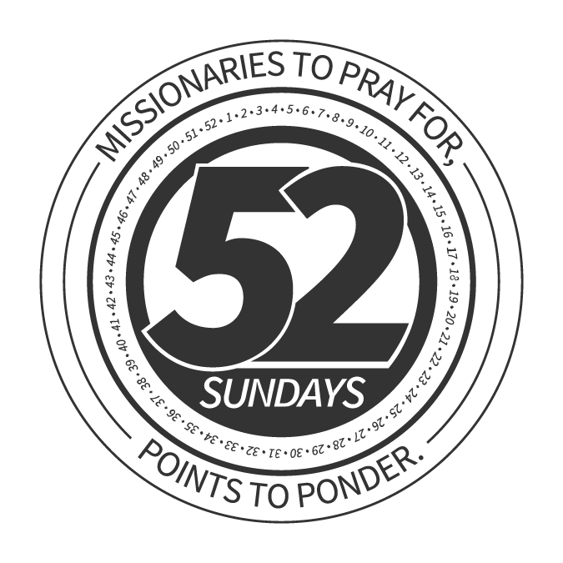 | MISSIONARY HIGHLIGHT: October 1  _________________________________________________  Jackie Lewis  EUROPE

Jackie Lewis is one of our missionaries in Europe, but she does not serve in the places tourists visit and buy postcards.

Jackie works with the Gypsy people, also known as the Roma people. These are the poorest, least educated and most oppressed people in all of Europe, east or west. Mostly they live in slums, in villages or in rough communities on the outskirts of larger cities.

Jackie works with Gypsy kids and also visits Gypsy families to witness and teach the Bible.

One of her big breakthroughs recently was finding André and his wife, Stanka (say STON-kah). She has been discipling them so they can reach their people with the gospel. Eventually there may be a church for the Gypsies in her area.

Folks, we know Jesus told us to care about “the least of these,” and the Gypsies in Europe fit the bill. God called our missionary, Jackie Lewis, to work with the Gypsies and we helped by supporting her through our Cooperative Program giving.

Now let’s pray for Jackie and for these two new believers, who will also be missionaries to the Gypsies!

MISSIONARY HIGHLIGHT: October 8
_________________________________________________

Anthony Beazley
SOUTHERN BAPTIST CHAPLAIN

Southern Baptists respect and appreciate America’s military men and women who defend our country.

One of the ways we serve the military is through more than 3,600 chaplains, who are endorsed by our North American Mission Board.

One of those chaplains we want to pray for today.

Anthony Beazley is a Southern Baptist chaplain who serves at the government’s VA medical center in West Palm Beach, Fla. More than 100 of our chaplains serve at VA hospitals like this one.

Anthony is a pastor to soldiers and veterans who come here for treatment. Some patients he listens to and visits like he is their friend — because he is indeed a friend.

Sometimes patients who are near death will ask questions about eternity. Anthony is able to tell them what the Bible says.

While the hospital pays Anthony’s salary, our church’s Cooperative Program giving helps fund our North American Mission Board which endorses and supports our chaplains.

So today we want to pray for Chaplain Beazley and thank God for his faithfulness and the ministry he provides to our brave military men and women, who risked life and limb for us.

MISSIONARY HIGHLIGHT: October 15
_________________________________________________

Johnny Maust
ECUADOR, SOUTH AMERICA

Did you know there are thousands of Baptists in Cuba? We don't hear much about them here in the United States, but Southern Baptists have sent many hundreds of volunteers to Cuba to partner with them.

Now, here’s another chapter in that story.

A while back, the Cuban Baptists sent out their first overseas missionaries to Ecuador, on the northeastern side of South America. They worked with Johnny Maust, one of our missionaries serving in Ecuador.

In fact, Johnny helped baptize six of the people the Cuban missionaries led to faith in Christ as they worked together.

Isn’t it great that, because of our faith in Jesus Christ, we can partner in so many ways to help get the gospel to people who need to hear?

We Baptists here in this state partner with Baptists in all the other 50 states to help send missionaries like Johnny to the mission field. Sharing to send missionaries — that’s what we call the Cooperative Program. Now, let us pray for our missionary Johnny and his Cuban Baptist partners.

MISSIONARY HIGHLIGHT: October 22
_________________________________________________

Phil Kesler
BRAZIL

One of our missionaries in South Brazil is Phil Kesler and we want to pray for him today.

Phil teaches many churches about the Bible and about how to share their faith. One way to talk to people, Phil tells them, is about names.

Many Brazilians in South Brazil are descended from Europeans who settled there in earlier times. Cities like Florianópolis have a very European look and feel to them.

Phil’s last name, “Kesler,” is German, because his ancestors were German. He meets many Keslers and Kesslers in South Brazil. When he taught a missions course in a church, one of the Baptist students was named Kessler and was training to become a missionary.

Of course in eternity, it is not important where a person comes from; Phil is more concerned about where they are going. But having the same names can lead to many conversations about that very point.

We support Phil Kesler in Brazil through our church’s Cooperative Program giving.

MISSIONARY HIGHLIGHT: October 29
_________________________________________________

Mary Alan
IRAQ

Just about every day on the news we hear about the battles and killings and suffering across the Middle East.

But we must remember two things: Our missionaries are serving in and around these troubled areas. They are even seeing more response now because of the problems.

One of our missionaries in Iraq we’ll call Mary. She says a Syrian man and his wife came to Iraq to escape the fighting in their homeland. They are Christians and have actually started a house church where they now live in Iraq!

Mary also tells of an Iraqi man named Elias. Islamic State fighters attacked his village and he had to flee for his life to another part of the country. There a missionary led him to faith in Christ. Now Elias is ministering to other refugees — he understands their situation very well, but also knows now that people need to hear the gospel even in the middle of fighting and confusion.

It is our church’s Cooperative Program giving that helps us send missionaries to these dangerous places. And now, how we need to pray for Mary Alan!

