_____________________________________________________________________

Analysis of SCSRC Regional Membership
_____________________________________________________________________
J. Warren Bradley, RRT, RCP
June 25, 2015

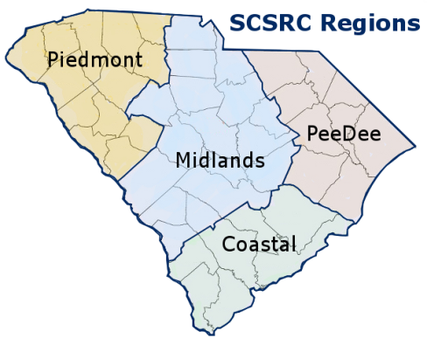

Introduction
It has been said that not everything that can be counted counts, and not everything that counts can be counted.⁰ I sat down at my computer months ago in order to answer a simple question regarding which SCSRC region has the highest membership rate. It seemed to be a fairly simple inquiry at the time…
Executive Summary
AARC/SCSRC membership data was aggregated with data for SC Counties, Cities, and SCSRC Regions and the results extrapolated using Microsoft Excel. Data analysis revealed that the Piedmont Region has the highest number of SCSRC members at (306/798 -38.11%). As expected, membership distribution was highest in larger cities such as Charleston, Greenville, and Columbia.
Subsequent analysis of South Carolina population data (US Census Bureau 2010) by county (region) demonstrated significant population inequality between SCSRC Regions. In order to statistically compensate for disparate populations a rate calculation (County SCSRC Members x 10,000) / County Population) was utilized to determine population adjusted membership. This analysis revealed that Greenwood County has the highest population adjusted membership at (4.2) SCSRC Members / 10K population. Interestingly, Abbeville County (pop 25,000) was also distinguished at (3.6) in a tie with Charleston County (pop 350,209) despite the fact the former only has a fraction of the population of the latter. Since there is a relatively linear relationship between population and regional HCO density, population adjusted SCSRC membership data provides a good way to compare involvement across areas of disparate population. In fact, hospital bed data indicates that the Midlands and Piedmont regions lead in both population and hospital beds. Mean SCSRC population adjusted membership per 10,000 population was highest in the Piedmont Region at (1.92), the Coastal followed with (1.8), Midlands at (1.17), and PeeDee at (1.12).

After demonstrating a significant population inequality, a hypothetical regarding the possible benefit of realigning SCSRC Regions to be more population equivalent, and a method for accomplishing this goal is offered for evaluation.

Analysis of South Carolina State Budget and Control Board data of South Carolina Licensed Respiratory Care Practitioners (RCP’s) was undertaken and as expected, the Piedmont Region who had the highest number of SCSRC Members also has the largest number of licensed practitioners (928, 32.04%). Even when the data is population adjusted, the Piedmont remains on top with (6.5) RCP’s / 10K Population.. Surprisingly, 389 of the (2896) total SC RCP’s (13.43%) were from other states.
When the ratio of regional SCSRC members to RCP’s was evaluated, the Coastal Region had the highest rank with (45.24%) of the available licensed practitioners represented as SCSRC members. This is followed by the Piedmont at (32.97%), the Midlands at (27.88%) and the PeeDee at (19.62%). The ratio for all regions (803/2896) was (27.73%). RCP’s from other states only accounted for (1.29%) of SCSRC members.

( I )
Analysis of SCSRC Regional Membership
_____________________________________________________________________
Regions: The SCSRC is currently divided into 4 geopolitical regions:
- Piedmont
- Midlands
- Coastal
- PeeDee

Initial Methods
In order to determine the percentage of current SCSRC members from each region, May 2015 AARC membership data was compiled using Microsoft Excel and population data for each SC County¹, data regarding SC cities by county², and SCSRC regions by county.³
Results
Region | SCSRC Members | % Total | Ranking
Piedmont | 306 | 38.11 | 1
Coastal | 214 | 26.65 | 2
Midlands | 206 | 25.65 | 3
PeeDee | 72 | 8.97 | 4
Other States | 5 | 0.62 | 5
Subtotal | 798 | 99.38
Out of State
NC | 3 | 0.37
GA | 1 | 0.12
WV | 1 | 0.12
Subtotal | 5 | 0.62
Total | 803 | 100

(1)
Data Analysis
Casual analysis demonstrates that the Piedmont region has a significantly larger number of SCSRC members than any other SCSRC region. Although Coastal and Midlands regions are almost identical, the PeeDee seems to be drastically underrepresented. Surprisingly, we also have five members with out of state addresses.

But this is based on raw data and is not population adjusted. Once we adjust for population the picture becomes slightly more nebulous.

SC Population
The Census data below⁵ and population heat map^{13, A3} indicate a lack of homogeneity in population across the arbitrary SCSRC regions.
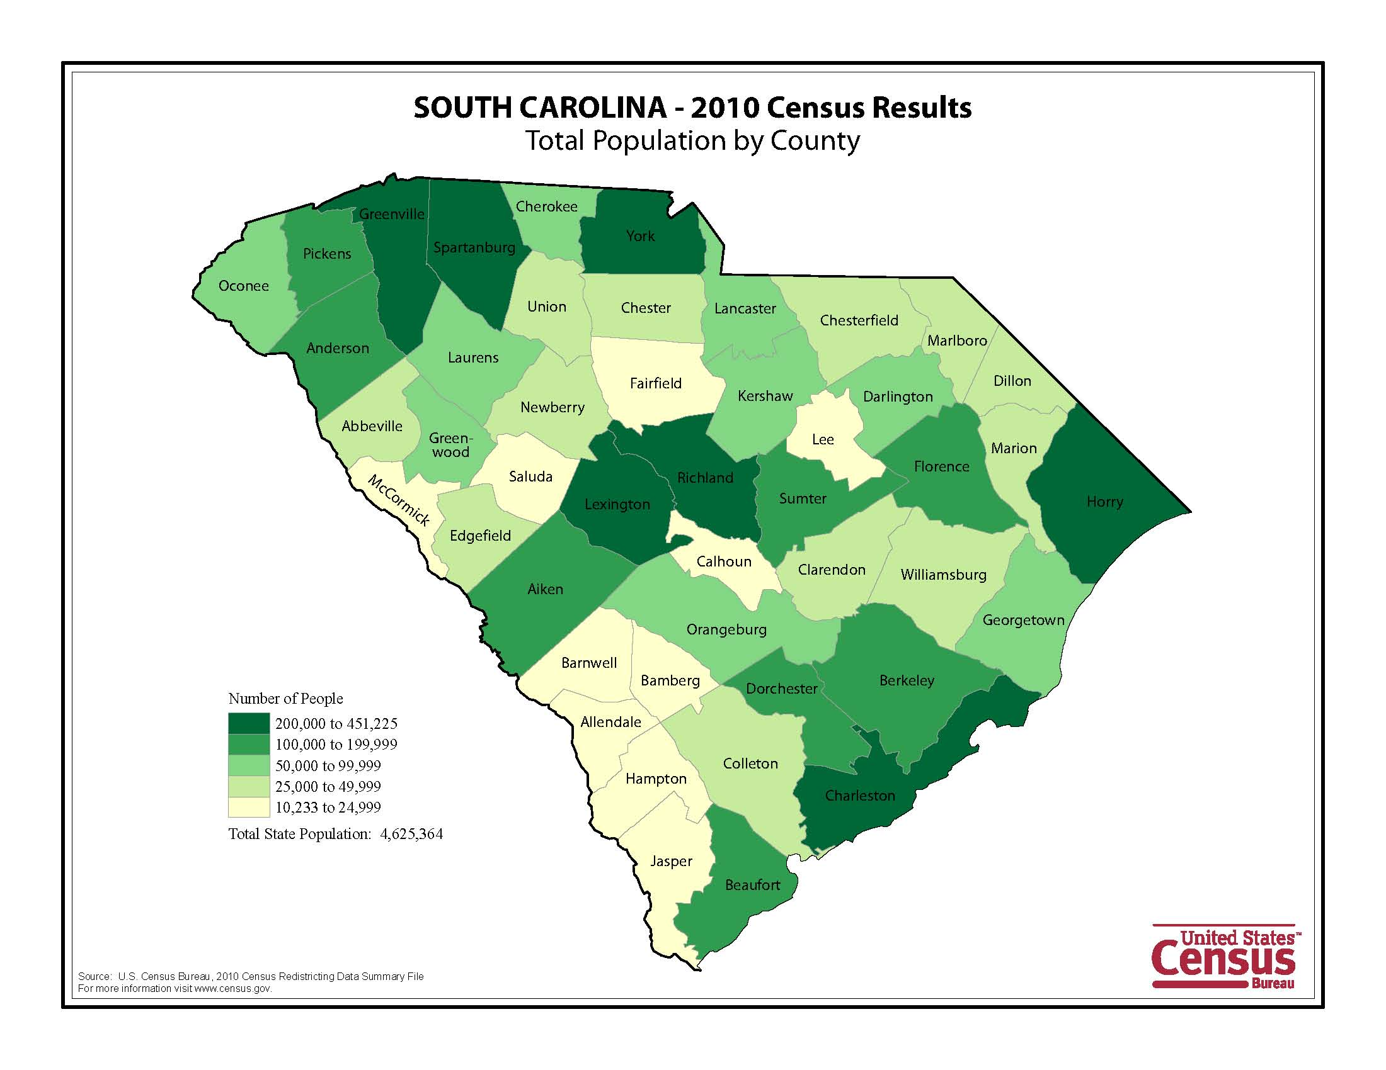
Membership Rate Calculation
In order to obtain more accurate statistics, it is necessary to perform a Rate calculation⁶ for membership using the formula (County SCSRC Members x 10,000) / County Population). This provides population adjusted SCSRC practitioners per 10,000 of SC population. This data along with similar percent of SCSRC, and % SC population by County data follows.
(2)
 |  |  |  |  |  | SCSRC
County | Members | % SCSRC | Population | % SC Population |  | Per 10K Pop
Greenwood | 29 | 3.61 | 69,661 | 1.506 |  | 4.2
Abbeville | 9 | 1.12 | 25,000 | 0.541 |  | 3.6
Charleston | 125 | 15.57 | 350,209 | 7.572 |  | 3.6
Newberry | 13 | 1.62 | 37,508 | 0.811 |  | 3.5
Dorchester | 44 | 5.48 | 136,555 | 2.953 |  | 3.2
Spartanburg | 82 | 10.21 | 284,307 | 6.147 |  | 2.9
Marion | 8 | 1.00 | 33,062 | 0.715 |  | 2.4
Greenville | 109 | 13.57 | 451,225 | 9.756 |  | 2.4
Pickens | 25 | 3.11 | 119,224 | 2.578 |  | 2.1
Lexington | 54 | 6.72 | 262,391 | 5.673 |  | 2.1
Calhoun | 3 | 0.37 | 15,175 | 0.328 |  | 2.0
McCormick | 2 | 0.25 | 10,233 | 0.221 |  | 2.0
Colleton | 7 | 0.87 | 38,892 | 0.841 |  | 1.8
Orangeburg | 16 | 1.99 | 92,501 | 2.000 |  | 1.7
Jasper | 4 | 0.50 | 24,777 | 0.536 |  | 1.6
Dillon | 5 | 0.62 | 32,062 | 0.693 |  | 1.6
Saluda | 3 | 0.37 | 19,875 | 0.430 |  | 1.5
Florence | 19 | 2.37 | 136,885 | 2.960 |  | 1.4
Union | 4 | 0.50 | 28,961 | 0.626 |  | 1.4
Barnwell | 3 | 0.37 | 22,621 | 0.489 |  | 1.3
Aiken | 21 | 2.62 | 160,099 | 3.462 |  | 1.3
Berkeley | 23 | 2.86 | 177,843 | 3.845 |  | 1.3
Richland | 47 | 5.85 | 384,504 | 8.314 |  | 1.2
Oconee | 9 | 1.12 | 74,273 | 1.606 |  | 1.2
Laurens | 8 | 1.00 | 66,537 | 1.439 |  | 1.2
Georgetown | 7 | 0.87 | 60,158 | 1.301 |  | 1.2
Chesterfield | 5 | 0.62 | 46,734 | 1.010 |  | 1.1
Anderson | 20 | 2.49 | 187,126 | 4.046 |  | 1.1
York | 24 | 2.99 | 226,073 | 4.888 |  | 1.1
Allendale | 1 | 0.12 | 10,419 | 0.225 |  | 1.0
Cherokee | 5 | 0.62 | 55,342 | 1.197 |  | 0.9
Clarendon | 3 | 0.37 | 34,971 | 0.756 |  | 0.9
Fairfield | 2 | 0.25 | 23,956 | 0.518 |  | 0.8
Sumter | 8 | 1.00 | 107,456 | 2.323 |  | 0.7
Horry | 20 | 2.49 | 269,291 | 5.823 |  | 0.7
Darlington | 5 | 0.62 | 68,681 | 1.485 |  | 0.7
Marlboro | 2 | 0.25 | 28,933 | 0.626 |  | 0.7
Kershaw | 4 | 0.50 | 61,697 | 1.334 |  | 0.6
Bamberg | 1 | 0.12 | 15,987 | 0.346 |  | 0.6
Beaufort | 10 | 1.25 | 162,233 | 3.508 |  | 0.6
Chester | 2 | 0.25 | 33,140 | 0.717 |  | 0.6
Lancaster | 4 | 0.50 | 76,652 | 1.657 |  | 0.5
Hampton | 1 | 0.12 | 21,090 | 0.456 |  | 0.5
Edgefield | 1 | 0.12 | 26,985 | 0.583 |  | 0.4
Williamsburg | 1 | 0.12 | 34,423 | 0.744 |  | 0.3
Lee | 0 | 0.00 | 19,220 | 0.416 |  | 0.0
NC | 3 | 0.37
GA | 1 | 0.12
WV | 1 | 0.12
All | 803 | 100.00 | 4,624,947 | 100.00
 |  |  | (3)
Results
When viewed with population adjusted data (shown below), Abbeville County, with only nine practitioners can hold up their head alongside Charleston with 125, since the two areas are proportionally identical with (3.6 practitioners /10,000 population) in population adjusted SCSRC membership. And of course Greenwood rules!

Usefulness
Assuming a relatively linear relationship between population and regional HCO density, population adjusted SCSRC membership data provides a good way to compare involvement across areas of disparate population.^{7,A4} (4)
Data by City – Members

Data granularity allows discrimination all the way down to the individual city (shown) or even HCO.

(5)
Regional Population Analysis

If we assume that the SCSRC Regions were initially assigned administratively in order to equally divide the state into management units based on the number of practitioners in each area, unequal growth has lead to significant inequality.

Population Inequality by Current SCSRC Region
Coastal | 19.710% |  | PeeDee | 15.356% |  | Midlands | 34.257% |  | Piedmont | 30.676%
Beaufort | 162,233 |  | Chesterfield | 46,734 |  | Aiken | 160,099 |  | Abbeville | 25,000
Berkeley | 177,843 |  | Darlington | 68,681 |  | Allendale | 10,419 |  | Anderson | 187,126
Charleston | 350,209 |  | Dillon | 32,062 |  | Bamberg | 15,987 |  | Cherokee | 55,342
Colleton | 38,892 |  | Florence | 136,885 |  | Barnwell | 22,621 |  | Edgfield | 26,985
Dorchester | 136,555 |  | Georgetown | 60,158 |  | Calhoun | 15,175 |  | Greenville | 451,225
Hampton | 21,090 |  | Horry | 269,291 |  | Chester | 33,140 |  | Greenwood | 69,661
Jasper | 24,777 |  | Marion | 33,062 |  | Clarendon | 34,971 |  | Laurens | 66,537
 |  |  | Marlboro | 28,933 |  | Fairfield | 23,956 |  | McCormick | 10,233
 |  |  | Williamsburg | 34,423 |  | Kershaw | 61,697 |  | Oconee | 74,273
 |  |  |  |  |  | Lancaster | 76,652 |  | Pickens | 119,224
 |  |  |  |  |  | Lee | 19,220 |  | Saluda | 19,875
 |  |  |  |  |  | Lexington | 262,391 |  | Spartanburg | 284,307
 |  |  |  |  |  | Newberry | 37,508 |  | Union | 28,961
 |  |  |  |  |  | Orangeburg | 92,501
 |  |  |  |  |  | Richland | 384,504
 |  |  |  |  |  | Sumter | 107,456
 |  |  |  |  |  | York | 226,073
7 | 911,599 |  | 9 | 710,229 |  | 17 | 1,584,370 |  | 13 | 1,418,749
Total |  |  |  |  |  |  |  |  |  | 4,624,947
4 Region Target |  |  |  |  |  |  |  |  |  | 1,156,237
3 Region Target |  |  |  |  |  |  |  |  |  | 1,541,649
Merge Coastal & PeeDee |  |  |  |  |  |  |  |  |  | 1,621,828
 |  |  |  |  | (6)
Suggested Modification of Regions to Attain Regional Parity

- Reassign Chesterfield and Marlboro Counties from the PeeDee to the Midlands Region.
- Merge the Coastal and remaining PeeDee region counties into a new Lowcountry Region.
- Reassign Newberry, Fairfield, and Chester Counties from the Midlands Region to the Piedmont Region and rename the Piedmont Region to the Upstate Region.

Resultant Regional Population Distribution
Region | Population | %
Lowcountry | 1,546,161 | 33.43%
Midlands | 1,565,433 | 33.85%
Upstate | 1,513,353 | 32.72%
 | 4,624,947

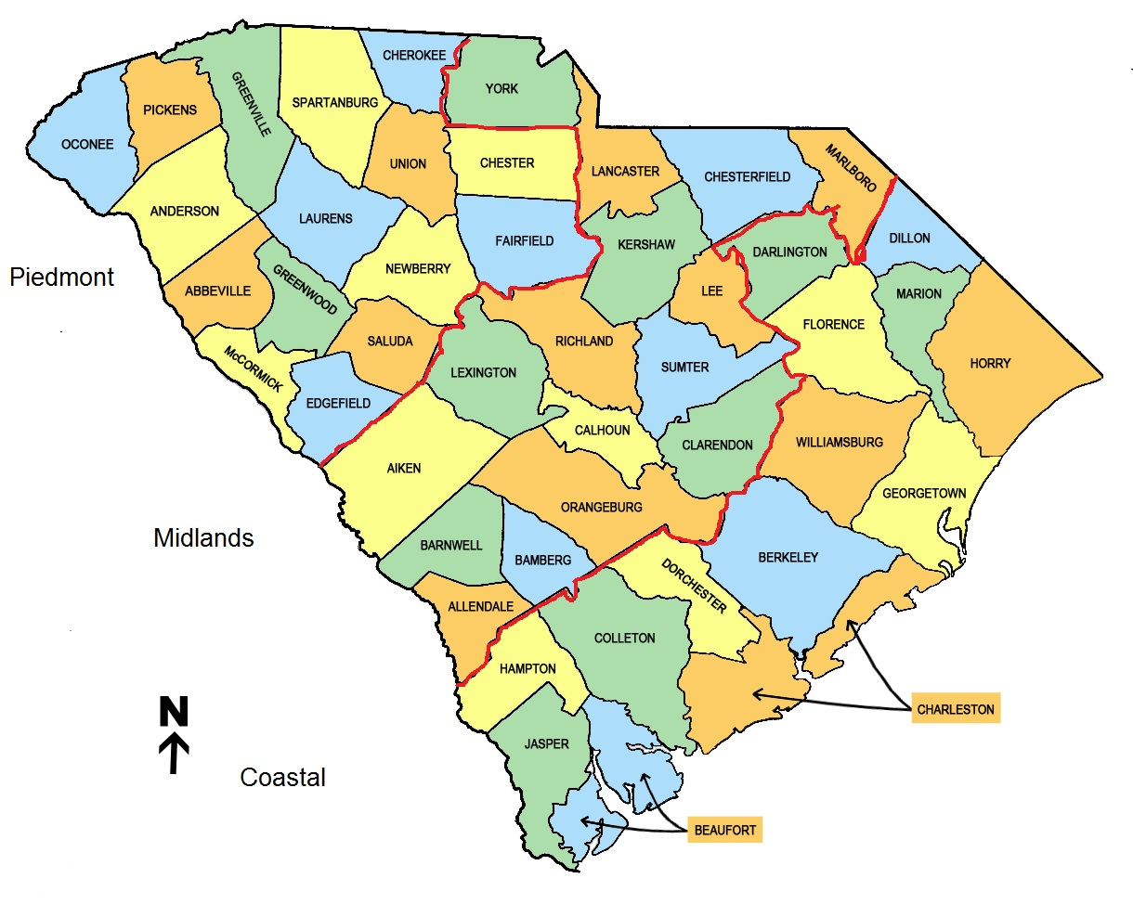
Lowcountry
Midlands
Upstate

(7)
Nomenclature, Geography, Convention, and Organizational Taxonomy

There are numerous ways to define regions and our current method seems to borrow from geographic (see below), political, and organizational conventions. Obviously our Piedmont region includes the mountainous counties of the Blue Ridge, and the Midlands stand in for our Coastal Plain. But the PeeDee and Coastal regions seem to be borrowed from the SC Forest Service. In any case, simplification using the suggested new Upstate, Midlands, Lowcountry schema is vastly superior. This model is based on realignment of contiguous counties into the new regions – so as to gerrymander 3 regions with essentially equivalent population. Accordingly, this population equivalence is held to be directly proportional to the density of healthcare organizations in those regions, and hence the equivalent need for RCP’s in each new region⁷. This is directly validated by the actual distribution of hospital beds^{8, A3}.

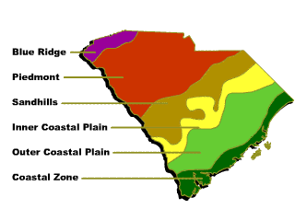

A Pragmatic Alternative to Change

If you ever fish for trout⁹, you can learn to predict where trout will lie based on the hydraulics of the stream. The trout wants to exert minimum effort to obtain a maximum food reward. He finds a current pocket with decreased flow, located behind an obstruction that is just adjacent to a high flow confluence. This is known as a current seam, where several currents combine into one and anything floating (such as a tasty insect) is naturally concentrated. The trout looks up all day, casually swimming against the weak current, until he sees a potential meal worth the effort of exerting himself – and then darts out to retrieve it with a casual sip. Although I dearly love methodical reorganization, it sometime pays to think like a trout.

Since remapping and renaming of SCSRC regions requires Board of Directors (BOD) approval and subsequent American Association for Respiratory Care (AARC) House of Delegates (HOD) approval, it may well represent a diminishing return on the investment to accomplish the proposed outcome. It is necessary from a pragmatic perspective to ask what benefit could ONLY be attained by remapping regions. The answer is that there is very little that could not also be accomplished by the use of statistical analysis in evaluating the performance of regions. To this end, I offer both the quiet trout and my original ‘reptile brain’ alternatives for evaluation. (8)

RCP’s, Population, and Licensure Rate by SCSRC Region^{5, 10}
Region | RCP’s | % Total |  | Population | Rate / 10K
Coastal | 473 | 16.33 |  | 911,599 | 5.2
PeeDee | 367 | 12.67 |  | 710,229 | 5.2
Midlands | 739 | 25.52 |  | 1,584,370 | 4.7
Piedmont | 928 | 32.04 |  | 1,418,749 | 6.5
Other | 389 | 13.43
Total | 2896 | 100.00 |  | 4,624,947

Source: South Carolina Budget and Control Board RCP Data (6/2015), 2010 US Census

Comparison with SCSRC Population Data

(9)

Ratio of SCSRC Members to RCP’s by Region

In the same way that we used a rate calculation to show population adjusted statistics by county and region, we can use the ratio of SCSRC members to RCP’s to provide an assessment of population adjusted SCSRC participation. This yields some surprising results – when, for example, the Coastal region with a significantly lower number of members actually has a higher percentage of members from the available pool of licensed respiratory care practitioners.

Composite Data Analysis
Region | Members | % Total | Ranking | RCP’s | % Total | Rank | RCP Ratio | Rank
Piedmont | 306 | 38.11 | 1 | 928 | 32.04 | 1 | 32.97 | 2
Coastal | 214 | 26.65 | 2 | 473 | 16.33 | 3 | 45.24 | 1
Midlands | 206 | 25.65 | 3 | 739 | 25.52 | 2 | 27.88 | 3
PeeDee | 72 | 8.97 | 4 | 367 | 12.67 | 5 | 19.62 | 4
Other States | 5 | 0.62 | 5 | 389 | 13.43 | 4 | 1.29 | 5
Total | 803 |  |  | 2896 |  |  | 27.73

Graphic Regional Ranking by Population, SCSRC Membership, Licensure, RCP Ratio, and Hospital Beds
Population | Membership | RCP’s | RCP Ratio | Hospital Beds
Midlands | Piedmont | Piedmont | Coastal | Midlands
Piedmont | Coastal | Midlands | Piedmont | Piedmont
Coastal | Midlands | Coastal | Midlands | PeeDee
PeeDee | PeeDee | Other States | PeeDee | Coastal
N/A | Other States | PeeDee | Other States | N/A

Overall Results

This study has yielded information that can provide actionable intelligence for policy makers. The methodologies used can form the basis of a periodic monitoring program to facilitate future administrative action. For example, a regional membership improvement program might be based on competition between regions judged by percentage change in RCP Ratio.

For the purposes of allocating membership drive and other society resources, regions should be prioritized in reverse order of RCP Ratio. In this schema, the PeeDee region would receive the most effort, followed by the Midlands and then Piedmont and Coastal regions. Additional efforts should be made to identify causal factors resulting in the high proportion of licensed therapists from the Coastal region who participate in the SCSRC.

If all regions increased recruiting to a 45%+ RCP Ratio (Like the Coastal Region), it would represent an increase of 915 new members – more than doubling of SCSRC membership. (1,718 projected members – 803 current members) / 803 current members = (915/803)* 100 = 113.9% projected increase¹¹ at a 45% RCP Ratio for all regions.
(10)
Conclusion

Analytics¹² can be invaluable in assigning SCSRC resources for the purpose of membership drives, educational activities, and in focusing BOD administrative activity. The data necessary is readily available and easy to extrapolate with simple Excel spreadsheet functionality. If the AARC would work to develop a national membership dashboard, all state societies would be able to focus their membership efforts more effectively and understand precisely how their performance compares to that of other state affiliates. The House of Delegates Resolution on this issue that I will be submitting follows the appendix of this report.

Recommendations

To optimize the administrative efficiency of the SCSRC, we must leverage analytics by monitoring vital metrics such as membership by region. If we can identify which regions, counties, or HCO’s represent opportunities for improvement we can focus our resources in those areas. We can utilize simple information technology solutions to solve complex problems. My recommendations include:

- Review this report and decide if further action for realignment of SCSRC Regions is warranted.
- Review the AARC National Membership Dashboard Resolution^{A7} and decide if submission is warranted.
- Review the data provided and determine if annual analysis would be beneficial.
- Recognize the Coastal Region for their high performance in recruiting more than 45% of licensed practitioners in the region to join the AARC/SCSRC.^{p 10}
- Recognize the practitioners of Greenwood, Abbeville, and Charleston counties for their high performance in population adjusted membership rate.^{A5}.
- Recognize the Piedmont Region for having the highest average population adjusted membership rate^{A6}
- Recognize the practitioners of Charleston as the city with the highest average population adjusted membership rate^{p5}
- Allocate resources to focus intensive recruitment efforts in the PeeDee Region.^{p10}
- Consider a competition among regions based on year over year improvement in any population adjusted metric or Member : RCP Ratio.
.
Future Reports
My next report, titled The Effect of Regional BBQ Styles on SCSRC Membership¹⁴ will be available soon.

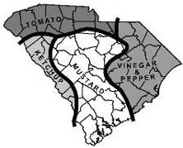

(11)
References

0) http://paleofuture.gizmodo.com/9-albert-einstein-quotes-that-are-totally-fake-1543806477 Often attributed to
Albert Einstein but, Einstein never said this. Its origin points to a 1963 paper by sociologist William Bruce Cameron:
"It would be nice if all of the data which sociologists require could be enumerated because then we could run them
through IBM machines and draw charts as the economists do. However, not everything that can be counted counts,
and not everything that counts can be counted."
1) http://en.wikipedia.org/wiki/List_of_counties_in_South_Carolina
2) http://www.state.sc.us/dmh/cities_towns.htm
3) http://www.scsrc.org/regions/
4) May 2015 AARC Membership Data
5) US Census Bureau, 2010 Census Redistricting Data
6) http://www.stats.indiana.edu/vitals/CalculatingARate.pdf
7) https://www.ahd.com/states/hospital_SC.html
8) (http://www.scdhec.gov/Agency/docs/health-regs/61-15.pdf
9) http://www.gameandfishmag.com/fishing/fishing_trout-fishing_sc_aa044804a/
10) South Carolina Budget and Control Board RCP Data (6/2015)
11) http://www.wikihow.com/Calculate-Growth-Rate
12) https://en.wikipedia.org/wiki/Analytics
13) https://commons.wikimedia.org/wiki/File:South_Carolina_population_map.png
14) https://goo.gl/qVWgPr
15) http://goo.gl/uGlmyO

Data, Information, Knowledge, Understanding, and Wisdom

With special thanks to the members of the 2015 SCSRC Information Technology Committee and the members of the Board of Directors for their support. This special report is dedicated to the Respiratory Care Practitioners of South Carolina, our patients, our coworkers, and the healthcare organizations we serve. Copyright © 2015, J. Warren Bradley, SCSRC, All rights reserved
(12)
Appendix 1
________________________________________________________________________________________

Population Heat Map

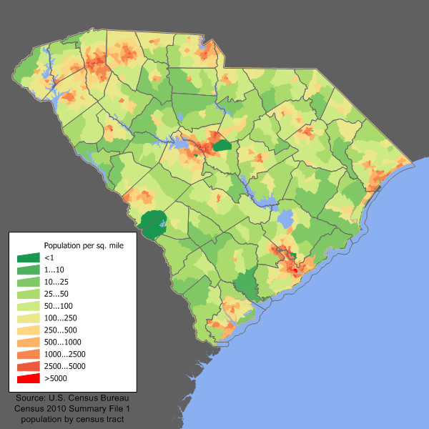

https://commons.wikimedia.org/wiki/File:South_Carolina_population_map.png

A1
Appendix 2
________________________________________________________________________________________

SC Licensed Practitioners from Other States
State | RCP's
AL | 3
AZ | 1
CA | 6
CO | 2
CT | 2
DE | 2
FL | 5
GA | 128
HI | 1
IA | 1
IL | 3
KY | 5
LA | 1
MA | 1
MD | 2
ME | 2
MI | 3
MO | 1
MT | 1
NC | 159
ND | 2
NE | 1
NJ | 4
NY | 2
OH | 5
PA | 7
PR | 1
SD | 2
TN | 13
TX | 3
UT | 1
VA | 15
WV | 3
 | 388

A2

Appendix 3
________________________________________________________________________________________

Distribution of SC Licensed Practitioners from Other States

State | RCP's
GA | 128
NC | 159
TN | 13
VA | 15
All Others | 73

A3
Appendix 4
________________________________________________________________________________________
Hospital Beds by SCSRC Region
Region | Beds |  | % SC Beds
Coastal | 2,533 |  | 20.24
PeeDee | 2,637 |  | 21.07
Midlands | 3,998 |  | 31.95
Piedmont | 3,347 |  | 26.74
 | 12,515 |  | 100.00
Data, American Hospital Directory: https://www.ahd.com/states/hospital_SC.html

A4

Appendix 5

Population Adjusted SCSRC Membership by County and Region
County | Region | Members | % SCSRC | Population | % Population | SCSRC / 10K Pop
Abbeville | Piedmont | 9 | 1.12 | 25,000 | 0.541 | 3.6
Aiken | Midlands | 21 | 2.62 | 160,099 | 3.462 | 1.3
Allendale | Midlands | 1 | 0.12 | 10,419 | 0.225 | 1
Anderson | Piedmont | 20 | 2.49 | 187,126 | 4.046 | 1.1
Bamberg | Midlands | 1 | 0.12 | 15,987 | 0.346 | 0.6
Barnwell | Midlands | 3 | 0.37 | 22,621 | 0.489 | 1.3
Beaufort | Coastal | 10 | 1.25 | 162,233 | 3.508 | 0.6
Berkeley | Coastal | 23 | 2.86 | 177,843 | 3.845 | 1.3
Calhoun | Midlands | 3 | 0.37 | 15,175 | 0.328 | 2
Charleston | Coastal | 125 | 15.57 | 350,209 | 7.572 | 3.6
Cherokee | Piedmont | 5 | 0.62 | 55,342 | 1.197 | 0.9
Chester | Midlands | 2 | 0.25 | 33,140 | 0.717 | 0.6
Chesterfield | PeeDee | 5 | 0.62 | 46,734 | 1.01 | 1.1
Clarendon | Midlands | 3 | 0.37 | 34,971 | 0.756 | 0.9
Colleton | Coastal | 7 | 0.87 | 38,892 | 0.841 | 1.8
Darlington | PeeDee | 5 | 0.62 | 68,681 | 1.485 | 0.7
Dillon | PeeDee | 5 | 0.62 | 32,062 | 0.693 | 1.6
Dorchester | Coastal | 44 | 5.48 | 136,555 | 2.953 | 3.2
Edgefield | Piedmont | 1 | 0.12 | 26,985 | 0.583 | 0.4
Fairfield | Midlands | 2 | 0.25 | 23,956 | 0.518 | 0.8
Florence | PeeDee | 19 | 2.37 | 136,885 | 2.96 | 1.4
Georgetown | PeeDee | 7 | 0.87 | 60,158 | 1.301 | 1.2
Greenville | Piedmont | 109 | 13.57 | 451,225 | 9.756 | 2.4
Greenwood | Piedmont | 29 | 3.61 | 69,661 | 1.506 | 4.2
Hampton | Coastal | 1 | 0.12 | 21,090 | 0.456 | 0.5
Horry | PeeDee | 20 | 2.49 | 269,291 | 5.823 | 0.7
Jasper | Coastal | 4 | 0.5 | 24,777 | 0.536 | 1.6
Kershaw | Midlands | 4 | 0.5 | 61,697 | 1.334 | 0.6
Lancaster | Midlands | 4 | 0.5 | 76,652 | 1.657 | 0.5
Laurens | Piedmont | 8 | 1 | 66,537 | 1.439 | 1.2
Lee | Midlands | 0 | 0 | 19,220 | 0.416 | 0
Lexington | Midlands | 54 | 6.72 | 262,391 | 5.673 | 2.1
Marion | PeeDee | 8 | 1 | 33,062 | 0.715 | 2.4
Marlboro | PeeDee | 2 | 0.25 | 28,933 | 0.626 | 0.7
McCormick | Piedmont | 2 | 0.25 | 10,233 | 0.221 | 2
Newberry | Midlands | 13 | 1.62 | 37,508 | 0.811 | 3.5
Oconee | Piedmont | 9 | 1.12 | 74,273 | 1.606 | 1.2
Orangeburg | Midlands | 16 | 1.99 | 92,501 | 2 | 1.7
Pickens | Piedmont | 25 | 3.11 | 119,224 | 2.578 | 2.1
Richland | Midlands | 47 | 5.85 | 384,504 | 8.314 | 1.2
Saluda | Piedmont | 3 | 0.37 | 19,875 | 0.43 | 1.5
Spartanburg | Piedmont | 82 | 10.21 | 284,307 | 6.147 | 2.9
Sumter | Midlands | 8 | 1 | 107,456 | 2.323 | 0.7
Union | Piedmont | 4 | 0.5 | 28,961 | 0.626 | 1.4
Williamsburg | PeeDee | 1 | 0.12 | 34,423 | 0.744 | 0.3
York | Midlands | 24 | 2.99 | 226,073 | 4.888 | 1.1
All |  | 803 | 100 | 4,624,947 | 100
A5
Appendix 6

Mean SCSRC Membership per 10K Populations by Region
Region | Mean Rate/ 10K Population
Piedmont | 1.92
Coastal | 1.80
Midlands | 1.17
PeeDee | 1.12

A6
Appendix 6
AMERICAN ASSOCIATION FOR RESPIRATORY CARE
BUSINESS PLAN

HOUSE OF DELEGATES

Resolution # ______ - ______ - ______
Resolved that the AARC should develop a real time online membership dashboard with state and national membership metrics such as the number and percentage of AARC members in each state and region - with data granularity by state region, county, city, and hospital/facility.

The resolution shall be one clear statement, as simple as possible

Executive Summary
Membership data should be leveraged to provide real time and historical, graphical membership data for review and recruiting usage by the leadership of state societies. We envision a map of the United States, with the number of licensed therapists and number and percentage of those therapists who are members of the AARC displayed. In addition, for side by side comparison this data could also be available in bar graph format with ranking from highest to lowest membership, by state. Clicking on any state in either the map display or bar graphs would drill down to state specific metrics. Clicking on any state subdivisions such as state regions, counties, cities, would further narrow the data, all the way down to the individual hospital level.
Hypothetically, if it becomes apparent from viewing the graphical data, that the majority of AARC members in any state are working at only a few facilities or in a particular region of any state, while other hospitals and regions are underrepresented, it would allow focused recruiting activity in the low membership areas using the best practice lessons learned from the high membership regions and facilities. Similarly, states could compare their success with the recruiting methods of more successful state societies in order to improve.
The process would also naturally generate inherent friendly competition between state societies, state regions, cities, and facilities. This completion alone could redouble local efforts, and significantly increase AARC and state society membership. If a significant carrot is offered to the state societies for most improved or highest membership, in lieu of a stick of shame, the competition would undoubtedly further bolster new membership.
Outcome
The effectiveness of the AARC and state societies to effect positive change is directly proportional to their membership. Hence increased membership should remain a permanent priority. Without the application of intellect and organization, data is meaningless. But if data is thoughtfully organized, it becomes information. In turn, if information is applied successfully it becomes knowledge. And if we are very lucky knowledge begets wisdom.
Strengths
Increased membership increases both financial and political resources. More importantly it increases professionalism and educational opportunities of our members and provides increased human resources for both state and national societies..
Weaknesses
There is no foreseeable negative impact from implementing a membership dashboard or from the resultant increase in membership. Since the membership data is not overly sensitive there is no real security issue. Lastly, other than a modest initial expense there should be minimal if any expense beyond normal web expenses, to maintain an online membership utility.
Opportunities
Aside from monetary and political considerations, increasing membership would dramatically increase the volunteer workforce and the composite abilities of state societies and by virtue of that the AARC as well.
Potential Barriers
- No known technical barriers exist.
Financial Impact
Cost Estimate
Total Cost: Web utility development costs vary too widely to provide reliable estimates without the development of full specifications, however simple development runs between $50 - $125/ hour. This project should not require more than around 40 hours of programming time. If the project is developed by internal AARC Information Technology resources or volunteers, then the cost is entirely defrayed. Worst case cost for external development should not exceed $5,000. Deployment and maintenance on existing AARC websites should incur negligible annual cost.
Recurring Expenses: Limited to normal website maintenance expenses.
Return On Investment (ROI): The financial and organizational benefits of sustained membership are incalculable. Membership is the engine that determines the speed and extent of our progress. Membership is the natural currency of progress for the AARC, our state societies, and our profession as a whole. The initial cost of building a membership dashboard could conceivably be returned within a few months after targeted recruitment begins. It is not unreasonable to believe that membership might double the first year.
Resources Required
State Societies: The presidents of each state society would need to be charged with gathering geographical information for their state. This would include the names of counties included in any state regions or organizational units, and the names of cities and hospitals in those counties.
Graphic Design: Graphic and web design artists would be needed to help develop the appearance of the envisioned membership dashboard web application
AARC Executive Office: There would be an initial need for organization and project management during the build phase of the proposed project, but very little need for involvement once the project is in production.
Information Services: AARC IT would be required to guide the Executive Office in development of a working specification and provide more accurate estimates of build time and costs. They would also be charged with developing a project scope document and assisting project management in completing an accurate project timeline.

____________________________________________________________________________
This resolution will impact the following (check all that pertain):

_____AARC Bylaws Section________ __X___Executive Office _____AARC Officers & BOD
_____HOD _____NBRC __X___Affiliates
__X___General Membership _____State/Federal Legislation _____CoARC
______Other (Please list) education programs __________________________ ________________________

Relationship to AARC's Strategic Plan:
_____Develop Art & Science of RC __X__Develop Human Resources __X__Increase Membership
__X__Increase Financial Resources __X__Increase Organizational Effectiveness _____Not Related

_____________________________________________________________  Author  _____________________________________________________________  State Phone  _____________________________________________________________  Co-Author  _____________________________________________________________  State Phone  _____________________________________________________________  Co-Sponsors  _____________________________________________________________  Date Submitted Date Received | ACTION  HOD Date______________ BOD  _______ Amended ________  _______ Passed ________  _______ Defeated ________  _______ Tabled ________  _______ Referred to ________  _______ Report back due ________  _______ Postponed until ________

