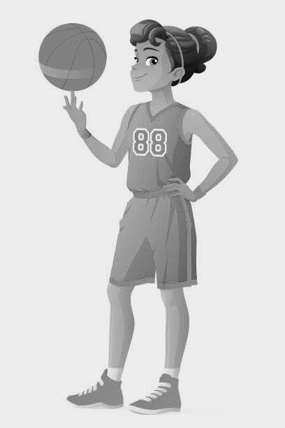
2019 JCHS GIRLS BASKETBALL CAMP
DRILLS FOR SKILLS
WHEN: JUNE 10th – 14th 8 AM TO 2PM WHERE: JONES COUNTY HIGH SCHOOL GYM
COST: $80 BEFORE JUNE 3RD , $85 AFTER / PARTICIPANT - $10 OFF FOR SIBLINGS AGES: 5 - 18
WHO WILL BE TEACHING: JONES COUNTY HEAD GIRLS BASKETBALL COACH, CURRENT AND PAST COLLEGE BASKETBALL PLAYERS
WHAT WILL SHE GET FROM CAMP: PRIZES, T-SHIRT, A BASIC UNDERSTANDING OF THE FUNDAMENTALS, FUN GAMES AND COMPETITION, MEETING NEW PEOPLE AND LEARNING NEW SKILLS
WHAT YOU NEED TO BRING T-SHIRT, SHORTS, SOCKS, TENNIS SHOES, MONEY FOR CONCESSION STAND, HAND TOWEL, A BAG LUNCH
Contact: ChoRhonda Gwaltney-Harris (336)-392-3133 / cgwaltney@jones.k12.ga.us
Participation Waiver I hereby authorize the Jones County High School Basketball Camp to act according to their best judgment in any emergency requiring medical attention and I hereby waive and release Jones County BOE, JCHS, JCHS Camp and all staff, employees, and participants from any and all liabilities and negligence which cause injury and/or illness while attending the camp. I have no knowledge of any physical impairment that would affect the below named participant. As parent/guardian of the below named participant, I agree to these terms by completing and submitting the registration form and fees.
NAME_______________________________________________________ Age___________________
SCHOOL YOU ATTEND _________________
ADDRESS__________________________________________________ CITY_________________ STATE_____________ ZIP_______________
EMERGENCY CONTACT______________________________________ PHONE#1____________________PHONE#2_____________________
PARENTS NAME_______________________________________ WORK PHONE#______________________ CELL#______________________
INSURANCE COMPANY_____________________________________________________________________
POLICY #__________________________________________ GROUP#_________________________________
T-Shirt SIZE: (circle one) Youth Small, Youth Medium, Youth Large, Adult Small, Adult Medium,
Adult Large, Adult X Large, Adult XX Large
Make checks payable to: JCHS Girls Basketball

