<Organization Name>

<Process Name>

Last Updated: February 1, 2022

Contents
1 Overview 3
1.1 Introduction 3
1.2 Process Description 3
2 Core Applications 4
2.1 Application Access 4
2.2 Pre-Requisites 4
3 To-Be Process 5
3.1 Solution Pattern 5
3.2 Input & Output 6
3.2.1 Input #1 6
3.2.2 Output #1 6
3.3 Process Flow Diagram 7
3.4 Process Steps 7
3.4.1 Step #1 7
3.4.2 Step #2 7
4 Event / Exception Management 8
5 Configuration 9
5.1 Control Room 9
5.1.1 Folder Structure 9
5.1.2 Global Values 9
5.1.3 Credential Vault Variables 10
5.2 Automation 11
5.2.1 Folder Structure – Shared Drive/NAS 11
5.2.2 Use-Case Values 11
6 Bot Summary 12
6.1 Existing Reusable/Library Modules To Be Used 12
6.2 New Bots 12
7 Assumptions 13
7.1 Out of Scope Assumptions 13
7.2 General Assumptions 13
8 Questionnaire 14

Overview

Introduction

This document contains solution design details to automate the ‘To be/Automated’ process using the Automation Anywhere platform. The target audience for this document is Developers/Engineers who will be building the automation.

Process Description

(From PDD): …

High-level process includes:

Core Applications

The ‘To be’ process depends on the following core applications.

Application Access

Application | Description | Tech | Environment | Credentials or SSO? | Application Role for BOT

Pre-Requisites

Bot Runner Device VDI/VM Setup:

- Complete device registration / bot agent installation, ensuring successful connection to Control Room
- Install your preferred Browser (ex. Internet Explorer, Chrome, etc.), and related Automation Anywhere plugin
- What browser to use as standard for Control Room access? For use by Bots in RPA automations?
- Disable Automatic Updates: Windows, Java, etc.
- Standard Windows Resolution: XYZxABC, 100% Zoom
- Browser Zoom %: 100%

As part of Best Practices, it is critical that appropriate Change Management be applied to all Bot Runner Devices/Virtual Machines, regardless of lifecycle/environment stage (Development, Testing, Production). Changes to those instances should only be accepted/implemented once understood, and any impact on current/future RPA automation evaluated.

To-Be Process

Solution Pattern

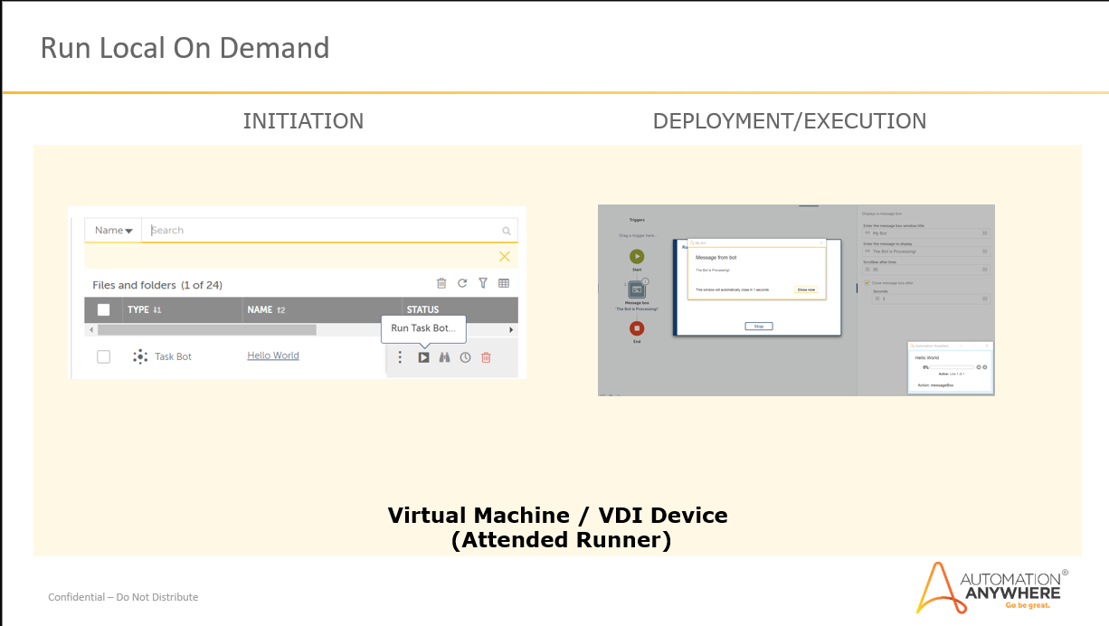

Input & Output

Input #1

Output #1

Process Flow Diagram

Process Steps

Step #1

- Execute desktop clean-up
Close residual windows – browsers, Microsoft Excel, etc.

- …

- …

Step #2

- …

- …

- …

Event / Exception Management

Process and System Exceptions are abnormal conditions that could occur within the automation, that may require specific Bot behavior and/or email notification.

Process & System Exceptions

High Level Process Step | Event Code | Description | Action
FIRST STEP | EXCEPTION_101 |  | - Log the exception.  - Exit the Bot  - Depending on Event Type, send email to appropriate email distribution
 | EXCEPTION_102
 | EXCEPTION_103
 | EXCEPTION_104
 | EXCEPTION_105
SECOND STEP | EXCEPTION_201
 | EXCEPTION_202
THIRD STEP | EXCEPTION_301
 | EXCEPTION_302
 | EXCEPTION_303

Configuration – Control Room

Folder Structure

All Bots and related Assets (ex. Image files, configuration files) will be stored on the Control Room, in a specific folder structure. This folder structure will also be implemented on a NAS/Shared Drive, where log files will be written by the Bot during execution.

Define the ‘levels’:

Folder Level | Folder Name
0 | Bots
1 | Finance
2 | Payroll
3 | …

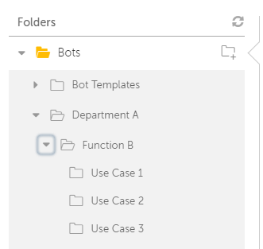
Figure 1 - Sample Control Room Folders

Global Values

Values that are ‘configurable’, and applicable across Use Cases, will be implemented using ‘Global Values’ functionality. These values will be configured in each Control Room environment, and accessed by Bots as required.

Global Value Name | Data Type | Description | Sample Value

Credential Vault Variables

Locker | Credential | System | Attribute | Type
 | CRMS |  | Username | User
 |  |  | Password | User
 | OMS |  | Username | User
 |  |  | Password | User

Users & Roles

What users/roles should have access to execute the automation?

Configuration - Automation

Folder Structure – Shared Drive/NAS

What folders will exist/be created, for use by the automation?

Folder Name | Description

Use-Case Values

Describe any additional values that will be configurable for the Use Case

Name | Description | Sample Value

Bot Summary

Existing Reusable/Library Modules To Be Used

Are there existing reusable Bots, available in a Private or Public Bot Store, that will be used by this solution?

If ‘Yes’, list the Bots in the following table.

Bot Name | Description | Source  (Private/Public Bot Store? Control Room?

New Bots

Are there Bots that will be developed for this Use Case? For which ones could then be designed/developed for reuse with other Use Cases (ie. Designed as ‘Library’ Bots?)

List the Bots to be developed in the following table.

Bot Name | Description | Reuse Potential?
 |  | Yes/No
 |  | Yes/No
 |  | Yes/No
 |  | Yes/No
 |  | Yes/No
 |  | Yes/No
 |  | Yes/No

Assumptions

This section will discuss any assumptions made as part of the design. This should also call out any use-case specific assumption clearly (e.g. will the solution support multiple users in parallel, etc.).

Out of Scope Assumptions

Assumptions related to any as-is process that are not within the scope of this automation.

General Assumptions

Some of the general assumptions that are made in automating the above process are

- Process Applications development environment and production environment should be identical.
- Process Applications and development environment would be available during the working hours.

Questionnaire

Question | Answer
What is the average volume of Transactions for given frequency?
What is the current cycle time to execute a transaction in the as-is process? | x minutes
How many Persons execute process concurrently currently? | y persons
Does process involve Personally Identifiable Information (PII)? | No
What are the main goals/targets? | ☒ Faster execution  ☒ Error Reduction/High Accuracy  ☐ Higher up time/Multiple executions  ☒ Timely completion

