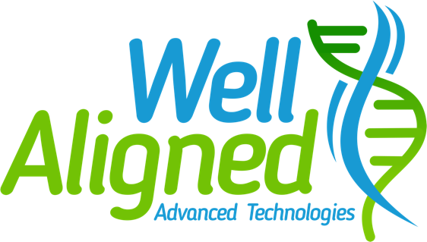

Nutrigenomics Testing

Patient Information

Last Name:___________________ First Name:_________________Male_____Female____

Street Address:_______________________________City:__________________State:______

Date of Birth___/___/___ Phone Number:______________________________

Caucasian_____Asian_____Hispanic_____African American______

Requested Test – Nutrigenomics Panel (NGX)

___X____NGX Health & Wellness

___X____NGX Diet

_______NGX Estrogen

_______NGX Sport

I hereby acknowledge that Vitalleo and its partner labs will perform genetic testing for patients from my practice as indicated on individual patient nutrigenomic request forms.

No tests other than the specific DNA tests ordered shall be performed on the biological sample shall be destroyed no more than one year after the sample was taken. This time frame allows us to run additional testing as genes become available only per your consent.

Test performed by Vitalleo and partner lab (Resolve Molecular Diagnostics, LLC CLIA #44D2117788 as directed by Dr. David L. Smalley Ph.D.

I authorize the above ordered laboratory test(s)

Patient Signature:_________________________________ Date:____________________

