
Specification Rev. 01/17/2022
ALTA Condensing Boilers and Combis
with Gas-adaptive Technology

U.S. Boiler Company, Inc.
P.O.Box 3020 Lancaster, Pennsylvania 17604-3020
Phone: 888-432-8887
www.usboiler.net

1-GENERAL
1.1 Description
- Boiler. An appliance for space heating. A wall-hung, gas-fired, automatically-adapting, high efficiency, condensing watertube boiler including controls and required safety devices.
OR
- Boiler. A combination space heating and domestic hot water heating (DHW) appliance (Combi). A wall-hung, gas-fired, automatically-adapting, high efficiency, condensing watertube boiler including controls and required safety devices.
2-SOURCING
2-1 Approved Manufacturer and Models
- Boiler shall be manufactured by U.S. Boiler Company, Lancaster, PA
- Installed boiler model shall be an (select model from list at right) Heating-only models: ALTA-120, ALTA-150, ALTA-180. Combi models: ALTAC-136, ALTAC-200.
- The contractor shall insure that any substituted equipment is equivalent in fit, form and function to the equipment in this specification. The cost and responsibility of any additional work caused by the substitution of equipment shall be borne by the Contractor.
- Also refer to Equipment Schedule in the Contract Drawings.

3-DOCUMENTATION
3.1 Documentation
- This specification is accompanied by additional documents including a current submittal package with boiler literature, Installation, Operating and Service instructions, shop drawings, site application specifications, wiring diagrams, piping diagrams and other related work materials.
- This specification is not an instructions document, but refers to the “manual” which serves as the official INSTALLATION, OPERATING AND SERVICE INSTRUCTIONS (I,O&S) document.

4-PRODUCT SPECIFICATIONS
4-1 References and Requirements
- Boiler shall be used in forced circulation hot water heating systems requiring supply water temperatures of 180°F or less.
- Boiler shall be expertly installed by a qualified heating installer or service technician in accordance with the installation regulations and installer credentials enforced in the area of the installation site. The City of New York requires a Licensed Master Plumber to supervise the installation of this product. The Commonwealth of Massachusetts requires this product to be installed by a licensed Plumber or Gas fitter.
- Boiler shall comply with ANSI Z21.13 test standards for the United States and be AHRI-listed to verify compliance to the minimum efficiencies required by the U.S. Department of Energy (DOE).
- Installers shall consult authorities having jurisdiction at the installation site. Without an authority having jurisdiction, installation shall be per the manual and the National Fuel Gas Code, ANSI Z223.1/NFPA 54. In Canada, installation shall be in accordance with the CAN/CSA B149.1 Installation Code. Where required by authority having jurisdiction, this installation shall conform to the Standard for Controls and Safety Devices for Automatically Fired Boilers (ANSI/ASME CSD-1).
- Boiler shall be approved by the Massachusetts Board of Plumbers and Gas Fitters, if required by project.
- All wiring and grounding shall be done in accordance with the authority having jurisdiction and with the National Electrical Code (ANSI/NFPA 70. In Canada, all wiring and grounding must be done in accordance with the Canadian Electrical Code, Part 1 (CSA C22.1 - latest edition).
- Boiler shall meet the ENERGY STAR® guidelines for energy efficiency established by the United States Environmental Protection Agency (EPA).
- Boiler shall be mounted, vented, piped and wired properly per exact clearances, requirements and qualified materials documented in the manufacturer manual. Gas piping and connections shall also follow the manual and lawfully conform to safety requirements.
- A boiler installed above radiation level or as required by the authority having jurisdiction shall be installed with low water cutoff device (Select U.S. Boiler optional accessory item number at right) Auto reset LWCO- 105591-01 or Manual reset LWCO- 108182-01
- Boiler shall be capable of installation with exhaust venting made with either CPVC, PVC or Polypro material as specified, assembled and listed in the manufacturer instructions.
- PVC material shall never be used in exhaust venting, except for installations outside of Canada, when a field-supplied schedule 80 CPVC 90º elbow and a 30-inch length of schedule 40 CPVC pipe are installed, per manufacturer instructions, as a transition from the boiler vent connection to traditional solid core schedule 40 PVC vent material (ASTM D2665). CPVC starter vent kit from U.S. Boiler Company (Select either 107039-01 (2” diameter) or 107039-02 (3” diameter)) shall be used for this purpose or equivalent CPVC starter components shall be selected as substitutes all complying with manufacturer instructions and component listings.
- Cellular core PVC (ASTM F891), cellular core CPVC and Radel (polyphenolsulfone) are prohibited and shall never be used for exhaust or intake piping.
- Canadian jurisdictions that require venting be listed to ULC S636-2008 must use listed ULC S636 Class IIB venting.
- This boiler needs fresh air for safe operation and shall be installed with intake vent piping for adequate combustion and ventilation air. Intake vent terminations shall not be in an area exposed to chemicals or other contaminants on the avoidance list in the boiler installation manual.
- Boiler installation shall always include a safety relief valve installed in the boiler supply piping as specified in the manufacturer’s instruction manual.
- Boiler shall operate properly with a minimum gas pressure of 2.5 inch w.c. (0.62 kPa) for natural gas or 8.0 inch w.c (1.99 kPa) for LP gas and a maximum gas pressure of 14.0 inch w.c. (3.48 kPa) for natural gas or LP gas. Installing contractors should verify this gas pressure with and without appliance fuel draw.
- Boiler shall be listed for 0 to 2,000 ft. This boiler shall not be installed over 2000 feet.
- Boiler shall not be used in gravity hot water systems or systems containing significant amounts of dissolved oxygen.

4-2 Construction and Components

- Boiler shall be a high efficiency, gas-fired direct vent, sealed combustion heating boiler appliance conforming to the specifications and component listings described, pictured and in tables throughout this document.
- Boiler shall include a high efficiency, condensing, stainless steel, watertube pressure vessel as a primary heat exchanger bearing the ASME “H” stamp. It shall be a deep-cleaning, quick-access design. The maximum allowable working pressure (MAWP) for this heat exchanger shall be 50 PSI.
- Each combi model shall also include a DHW hydro block including a pre-installed boiler loop circulator with 3-way valve to switch the boiler loop to run through the boiler’s pre-installed domestic hot water flat-plate heat exchanger. This flat plate heat exchanger shall be detachable with two screws for easy service.
- Boiler shall have an intelligent, scalable Alta Boiler Control (ABC) configured on a fuse-protected printed circuit board that includes an LCD display and adjacent oversized user interface buttons.
- Boiler control shall monitor flame ionization to automatically set the gas valve to a correct air-fuel ratio and allow “No touch” adaptive combustion setup without manual throttle or offset adjustments. Automatic self-calibration shall also provide continuous, safe, clean combustion by adapting to many levels of component wear, variations in fuel, environment, and vent air pressure
- Boiler shall include an electronic gas valve and a variable speed blower system to precisely control fuel/air mixture for maximum efficiency and be capable of fully modulating firing rates exceeding 8.8:1 for Heating-only boilers and 10:1 turndown on DHW for Combi Boilers.
- Boiler shall be fabricated with a non-plastic metal jacket including a finished front panel. Boiler finish shall be a rust resistant powder coat on selected surfaces.
- Boiler shall include a sensor-less, rate-based reset function requiring no mechanical field installation. This feature shall assess necessary environmental conditions, and continually adjust boiler operation for comfort, efficiency, and to reduce boiler wear and tear caused by short-cycling.
- Boiler front and side panels shall be removable using a total of six fasteners to enable full-service access through the vacant panel space if recommended clearance is provided.
- Boiler protection shall include electrical component separation from incoming combustion air and gas, likely to contain excess humidity, dust and other contaminants brought through ducted combustion air.
- Boiler shall include a UL-353 listed heating water flow switch and high limit protection provided with the boiler. This limit causes boiler shutdown if the boiler water temperature exceeds the set point of the limit control.
- On each combi model, the boiler combi block shall include a precision DHW flow sensor to detect DHW demand quickly. A DHW flow switch shall not be used in place of this precision DHW flow sensor.
- Each combi model shall include an air vent to help remove air from the system.
- Boiler shall include an air pressure switch to prove that the exhaust vent is unobstructed.
- Boiler shall include a universal vent connector, heat exchanger gasket, and jacket vent gasket inside the boiler crate for attachment in the field by installation technicians. This universal vent shall be connectable to approved CPVC or Polypro venting.
- Boiler shall include an integral condensate trap.
- Boiler shall be shipped from the factory configured for natural gas. This factory-built boiler shall not require a conversion kit to complete a simple natural gas-to-LP conversion. Instead this conversion shall be completed in two steps with a: 1- 2.5mm hex wrench tool at the gas valve accompanied by a 2- Control display setting change.
- Combi boiler shall have an integral Flow Limiter (6 GPM) to limit an undesirable DHW water temperature drop during high DHW demand. .
- Boiler shall be equipped with a wiring diagram attached to the boiler jacket in a documentation packet.
- Boiler shall be factory-assembled, fire-tested and shipped as a factory-packaged unit.
- Boiler shall include these additional components in separate packaging inside the boiler crate for final field assembly or use by installation technicians.
  - Vent connector and test port
  - Wall-mounting bracket, retaining clips and hardware
  - Temperature/pressure gage
  - 30 psi safety relief valve
  - Drain valve
  - Gas connection adapter
  - Gas shutoff valve
  - (Heating-only models) Grundfos 26-99 circulator or equivalent.
  - (Combi only) Alta FastPipe pre-made primary/secondary manifold
  - (Combi only) Domestic hot water connectors, G 1/2” (BSSP) to 3/4” (Quantity: 2) (for use with field- supplied ¾” sweat elbows to turn water piping toward the boiler wall.)

4.3 Heating-only Boiler Product Specifications
- Ratings- Installed heating-only boiler models shall meet the performance characteristics shown in the rating table below:

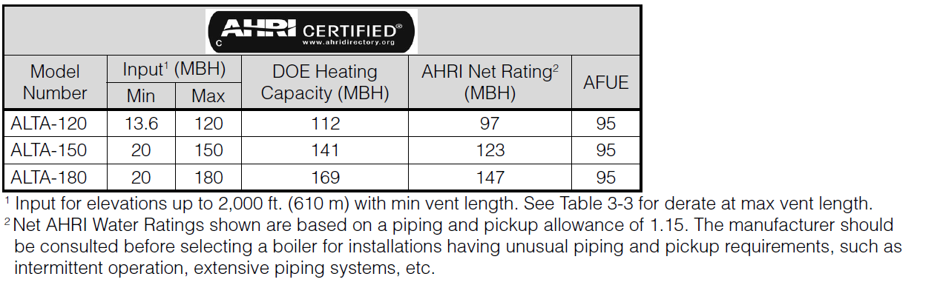

- Dimensions- Each heating-only boiler shall be installed per the manufacturer’s instructions and meet the corresponding criteria shown in the tables and figures below.
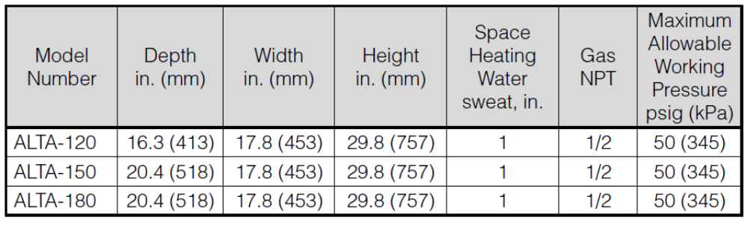
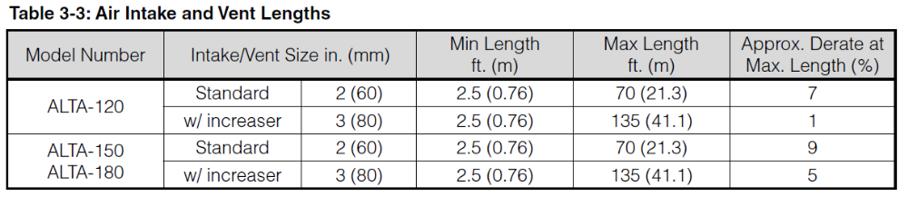
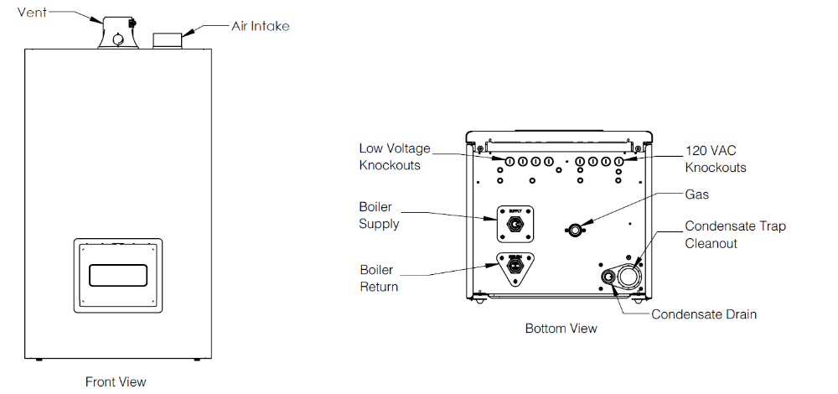

4.4 Combi Boiler Product Specifications
- Ratings-Installed combi boiler models shall meet the performance characteristics shown in the rating table below:

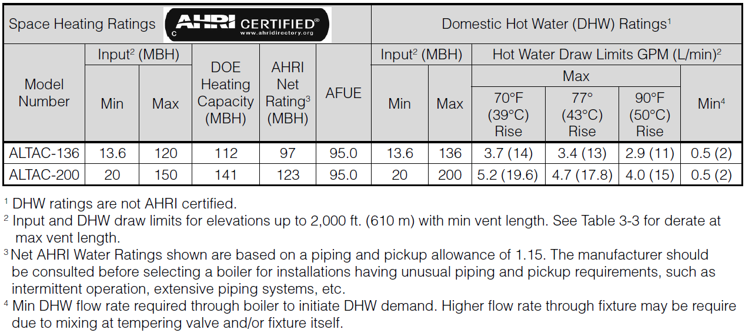

- Dimensions- Each combi boiler shall be installed per the manufacturer’s instructions and meet the corresponding criteria shown in the tables and figures below.

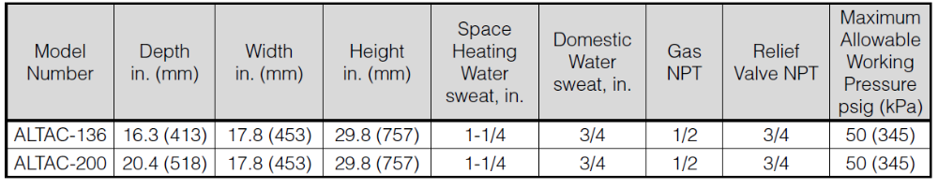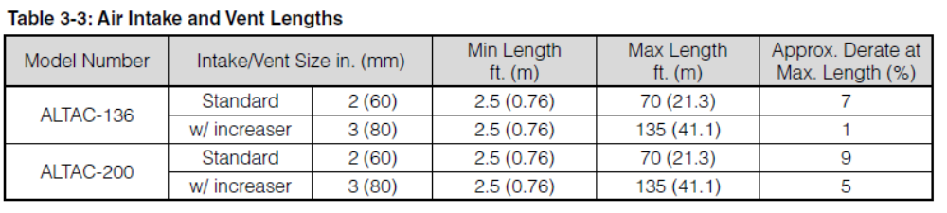
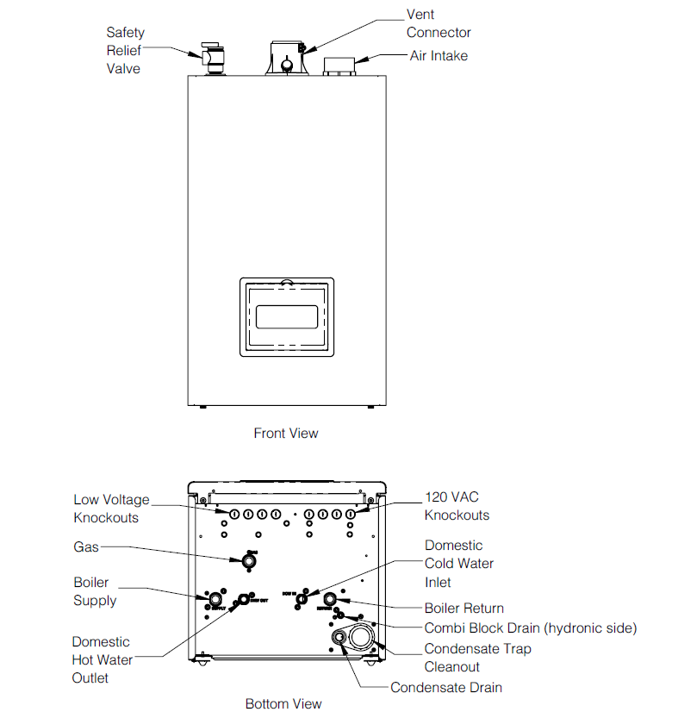

4.5 Wiring and Sensors

- 120 VAC Line Voltage Connection Board- All line voltage field connections shall be connected to "120VAC Connections" terminal strip pictured.
- Low Voltage Connection Board- Commonly used low voltage field connections shall be connected to the "Low Voltage Connections" terminal strip pictured on the left.

4.6 Boiler Control; Capability and Functionality
- The control shall have the functions outlined below.
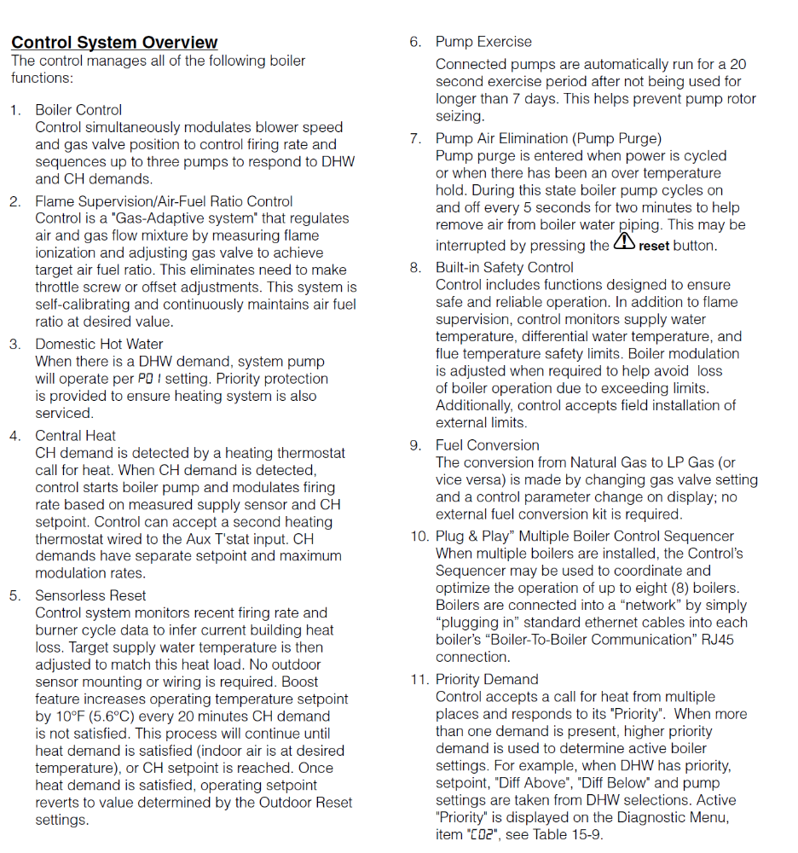
4.7 User Interface/Resident LCD Display
- The control display screen shall display these characteristics below:
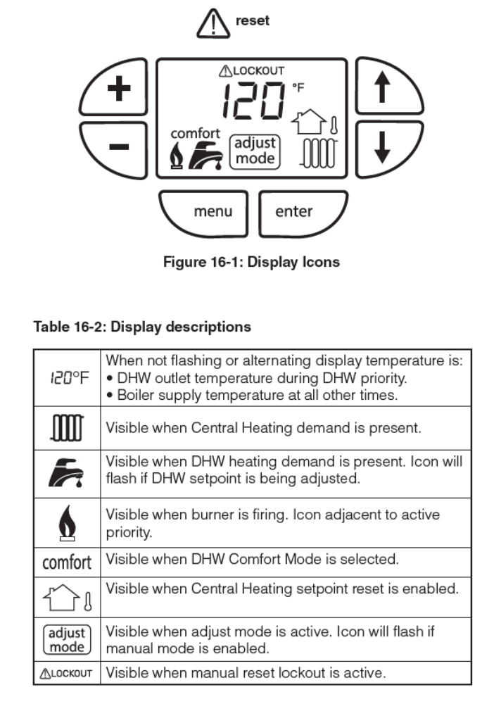

5- INSTALLATION SITE REQUIREMENTS
5-1 Clearance Requirements
- The boiler shall only be commissioned after satisfying the following ventilation air requirements and clearances.
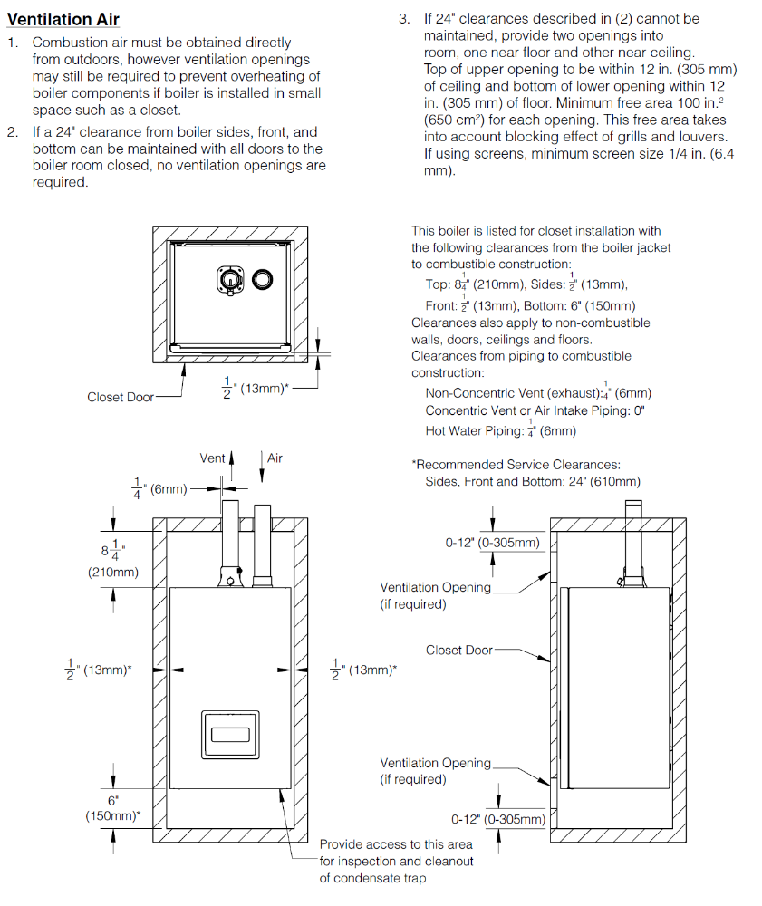
5-2 Water Chemistry Criteria and Recommendations.
- The boiler shall be installed and function using water with the following characteristics.
