
Specification Rev. 04/24/2020
Watertube Condensing Boiler
(High Efficiency)
U.S. Boiler Company
P.O.Box 3020 Lancaster, Pennsylvania 17604-3020
Phone: 888-432-8887
www.usboiler.net

1-GENERAL
1.1 Description
- Boiler. Space-heating, gas-fired, high efficiency condensing boiler with watertube heat exchanger, controls and required safety devices. Boiler is factory-built to provide space heating and support a separate indirect domestic hot water (DHW) heating option. This boiler shall be used in forced hot water heating systems requiring supply water temperatures of 180°F or less. Each boiler shall be vented vertically or horizontally from the building with combustion air supplied from outdoors. Boiler is not designed for use in gravity hot water systems or systems containing significant amounts of dissolved oxygen.
2-SOURCING
2-1 Approved Manufacturer and Models
- Boiler shall be manufactured by U.S. Boiler Company, Lancaster, PA
- Installed boiler model shall be a (select from right)- K2WT-080B, K2WT-100B, K2WT-120B, K2WT-150B, K2WT-180B, K2WT-180M.
- The contractor shall insure that any substituted equipment is equivalent in fit, form and function to the equipment in this specification. The cost and responsibility of any additional work caused by the substitution of equipment shall be borne by the Contractor.
- Also refer to Equipment Schedule in the Contract Drawings.

3-DOCUMENTATION
3.1 Documentation
- This specification is accompanied by additional documents including a current submittal package with boiler literature, Installation, Operation and Service instructions, shop drawings, site application specifications, wiring diagrams, piping diagrams and other related work materials.
- This specification is not an instructions document, but refers to the “manual” which serves as the official INSTALLATION, OPERATING AND SERVICE INSTRUCTIONS document.

4-PRODUCT SPECIFICATIONS
4.1 References and Requirements
- Boiler and other specified equipment shall be expertly installed by a professional heating contractor in accordance with the manufacturer’s installation regulations and installer credentials enforced in the area of the installation site.
- Boiler shall comply with ANSI Z21.13 test standards for the United States and be AHRI-listed to verify compliance to the minimum efficiencies required by the U.S. Department of Energy (DOE)
- Installers shall consult authorities having jurisdiction at the installation site. Without an authority having jurisdiction, installation shall be per the manual and the National Fuel Gas Code, ANSI Z223.1/NFPA 54. In Canada, installation shall be in accordance with the CAN/CSA B149.1 Installation Code. Where required by authority having jurisdiction, this installation shall conform to the Standard for Controls and Safety Devices for Automatically Fired Boilers (ANSI/ASME CSD-1).
- Boiler shall be approved by the Massachusetts Board of Plumbers and Gas Fitter, if required.
- All wiring and grounding shall be done in accordance with the authority having jurisdiction and with the National Electrical Code (ANSI/NFPA 70. In Canada, all wiring and grounding must be done in accordance with the Canadian Electrical Code, Part 1 (CSA C22.1 - latest edition).
- Boiler shall meet the ENERGY STAR® guidelines for energy efficiency established by the United States Environmental Protection Agency (EPA).
- Boiler shall be mounted, vented, piped and wired properly per exact clearances, requirements and qualified materials documented in the manufacturer manual. Gas piping and connections shall also follow the manual and lawfully conform to safety requirements.
  - A universal vent connection shall be factory-mounted on the top of the boiler for use with approved CPVC, Polypro and flexible stainless steel venting materials.
  - PVC material shall not be used in exhaust venting, except when a field-supplied schedule 80 CPVC 90º elbow and a 30-inch length of schedule 40 CPVC pipe shall be installed, per manufacturer instructions, as a transition from the boiler vent connection to traditional solid core schedule 40 PVC vent material (ASTM D2665). CPVC vent kits may be selected for this purpose per the manufacturer instructions, and purchased separately from U.S. Boiler Company: 2” Diameter CPVC Kit P/N- 107039-01, 3” Diameter CPVC Kit P/N- 107039-02)
  - Cellular core PVC (ASTM F891), cellular core CPVC and Radel (polyphenolsulfone) are prohibited and shall never be used for exhaust or intake piping.
  - Canadian jurisdictions that require venting be listed to ULC S636-2008 must use listed ULC S636 Class IIB venting.
- This boiler needs fresh air for safe operation and shall be installed with intake vent piping for adequate combustion and ventilation air.
- Boiler installation shall always include a safety relief valve installed in the boiler supply piping as specified in the manufacturer’s instruction manual.
- Boiler shall operate properly with a minimum gas pressure of 2.5 inch w.c. for natural gas or a minimum gas pressure of 11.0 inch w.c. for LP gas and a maximum gas pressure of 14.0 inch w.c. for natural gas or LP gas. Installing contractors should verify this gas pressure with and without appliance fuel draw.
- Natural Gas models shall be capable of operating up to an altitude of 10,100 feet subject to instructions and restrictions documented in the boiler manual and noted here: K2WT-080B (LP conversion) is not permitted over 2000’; K2WT-120B (LP conversion) is not permitted over 7800’, K2WT-180B (NG, LP conversion) is not permitted over 2000’.
- Boiler shall be factory-configured for use with natural gas and shall only be converted to LP gas (“propane”) where allowed in the manual. If this is an LP Installation, the contractor shall install LP Conversion kit item number (Select proper LP conversion kit item number from right based on boiler model): K2WT-080B and K2WT-100B require 107873-01, K2WT-120B and K2WT-150B require 107874-01, K2WT-180B requires 107875-01, K2WT-180M requires 108101-01.

4-2 Construction and Components

- Boiler shall be a high efficiency, gas-fired direct vent, sealed combustion heating boiler appliance conforming to the specifications and component listings described, pictured and in tables throughout this document.
- Boiler shall include a high efficiency, condensing, stainless steel, watertube pressure vessel as a primary heat exchanger bearing the ASME “H” stamp and including a cold burner door for immediate service access after power is turned off. The maximum allowable working pressure (MAWP) for this heat exchanger shall be 50 PSI.
- Boiler shall be for wall installation and adaptable to floor-standing with an accessory leg kit.
- Boiler shall be officially listed as 95% AFUE on K2WT-080B,-100B, -120B, -150B, -180B or 94% AFUE on K2WT-180M.
- Boiler shall be assembled, fire-tested and shipped as a factory-packaged unit, complete with jacket, burner, mounted and wired controls and boiler connection fittings. The boiler shall also include a factory pre-installed boiler loop circulator and supply-line flow switch.
- Boiler shall have an intelligent Sage boiler control compatible with HeatMatch software and Sage Zone Control. The boiler control shall support all required safety sensors and devices.
- Boiler shall be connectable at supply and return connections on bottom of boiler to optional U.S. Boiler FastPipe pre-made primary/secondary adapter accessory item number (Select correct FastPipe item number from right): Boiler Sizes 080, 100, 120-106259-01; Sizes 150, 180- 106259-02.
- Boiler shall have a boiler gas valve with zero pressure regulation and a variable speed blower system to precisely control a fuel/air mixture, providing fully modulating firing rates with 10:1 firing rate turndown for maximum efficiency.
- Boiler shall be fabricated with a non-plastic metal jacket including a pump-side service panel, finished front panel and sealed internal hinged control door. Finish shall be a rust resistant powder coat on selected surfaces.
- Boiler protection shall include electrical component separation from incoming combustion air and gas, likely to contain excess humidity, dust and other contaminants brought through ducted combustion air.
- Boiler model (select from left column in table below) shall be installed per the manufacturer’s instructions and meet the corresponding venting characteristics listed in the table below.
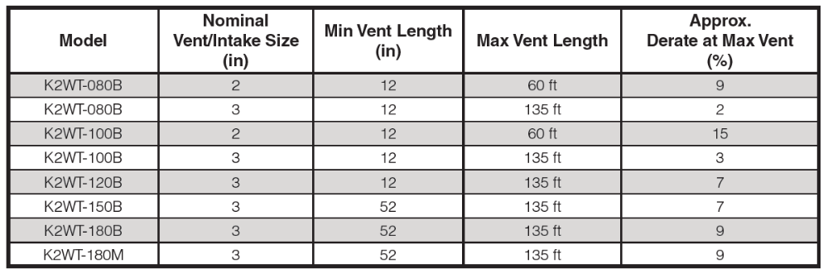

4.3 Performance Ratings and Physical Dimensions
Installed boiler model (select from left column in table below) shall meet the corresponding performance characteristics and physical dimensions shown in the table and figure below.
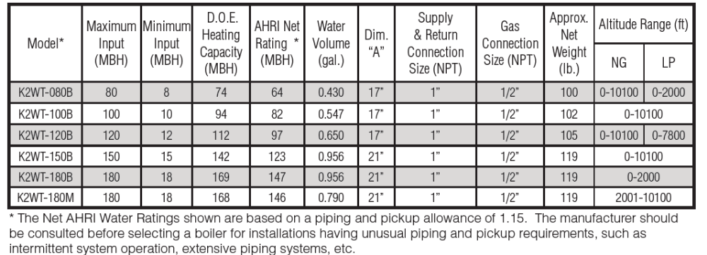
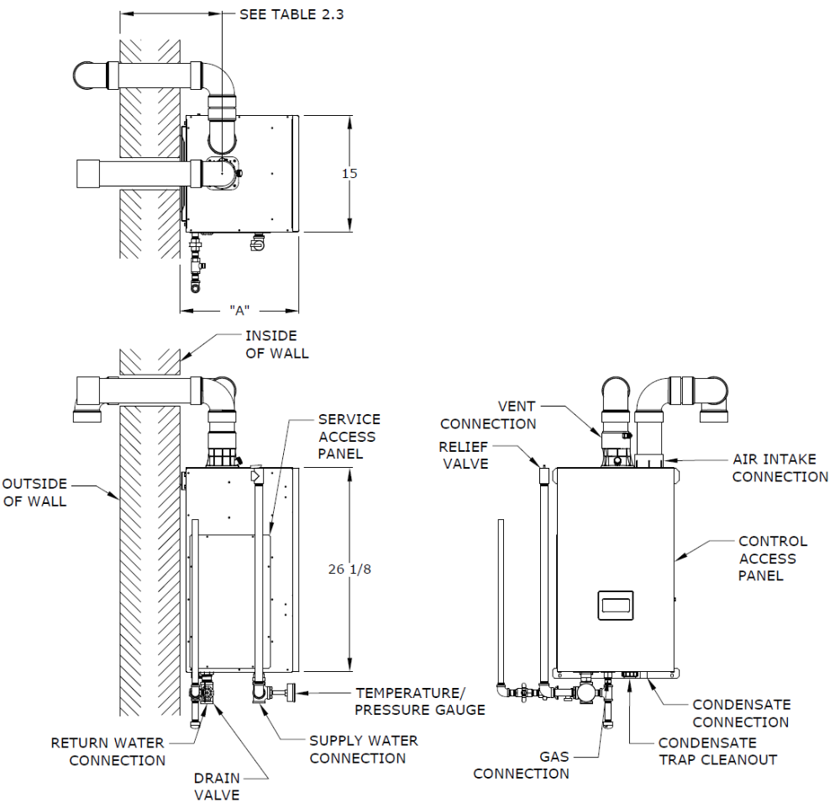

4.4 Wiring and Sensors
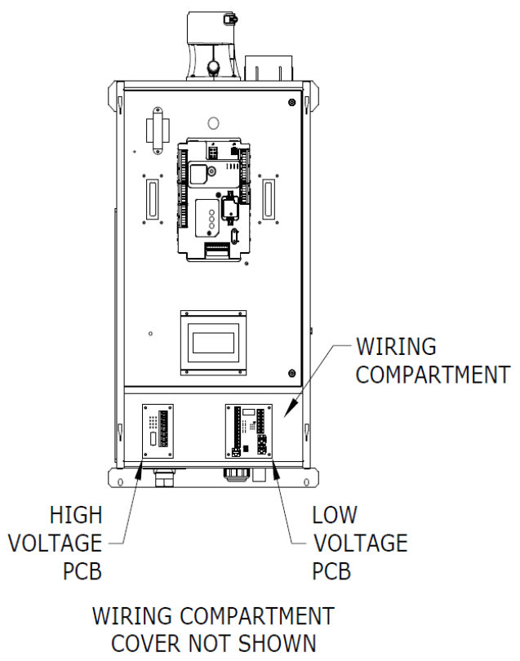
- Boiler shall have separate printed circuit connection boards as pictured in this section. These PCBs support easy connections inside the boiler jacket.
- Line Voltage (120 VAC) Field Connections- A dedicated circuit of 15A or greater shall be used for the boiler. A service switch is recommended and is required by many local codes. Locate this switch in accordance with local codes or, in the absence of any, in a location where it can be safely accessed in an emergency involving the boiler.
- Line voltage 120VAC connections to the boiler itself shall be made on the terminal strip on the high voltage PCB located on the left side if the wiring compartment. From top to bottom, the connections on the terminal strip are:
  - 120VAC Hot
  - 120VAC Neutral
  - Ground
  - System Pump Hot
  - System Pump Neutral
  - DHW Pump Hot
  - DHW Pump Neutral
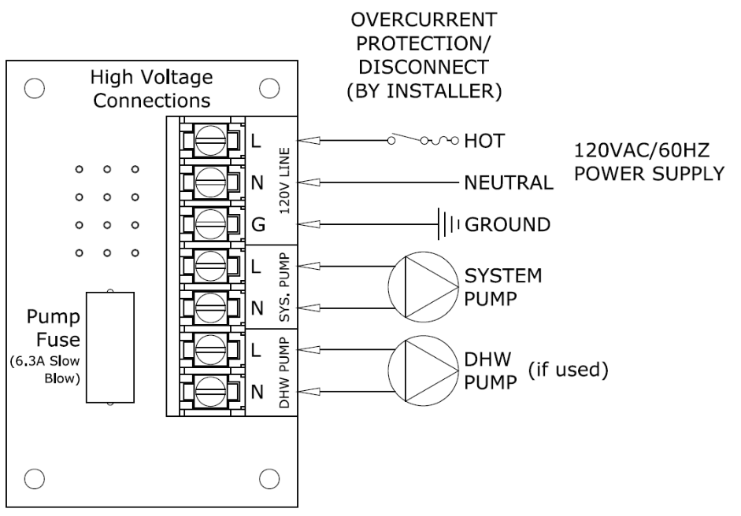
Pump Output details:
- System Pump - Pumps water through the radiation. This pump shall be hydraulically separated from the boiler pump, either by closely spaced tees, or by a hydraulic separator. The system pump is always on when the system is responding to a call for CH. Depending on the DHW configuration, it may also be on during a call for DHW.
- DHW Pump (“IWH Circulator”) - Pumps water directly through the indirect water heater.
- Maximum combined current draw for all circulators shall be 6.3 FLA.

- Low Voltage Connections shall be on the low voltage PCB:
- Heat T’Stat - 24VAC heating thermostat (R - 24V “Hot”)
- Heat T’Stat - 24VAC heating thermostat (W - Energized or Call for Heat)
- Heat T’Stat - 24VAC heating thermostat (C - 24V Common)
- DHW Stat - 24VAC domestic hot water thermostat (1)
- DHW Stat - 24VAC domestic hot water thermostat (2)
- External Limit - Field supplied low voltage safety limit contacts (1)
- External Limit - Field supplied low voltage safety limit contacts (2)
- Alarm Contact (1)
- Alarm Contact (2)
- EnviraCOM Device (D)
- EnviraCOM Device (R)
- EnviraCOM Device (C)
- Outdoor Sensor - Tasseron TSA00AA Outdoor Temperature Sensor (1)
- Outdoor Sensor - Tasseron TSA00AA Outdoor Temperature Sensor (2)
- Header Sensor - Optional Honeywell 32003971-003 (103104-01) Sensor (1)
- Header Sensor - Optional Honeywell 32003971-003 (103104-01) Sensor (2)
- MODBUS - (A)
- MODBUS - (B)
- MODBUS - (-V)

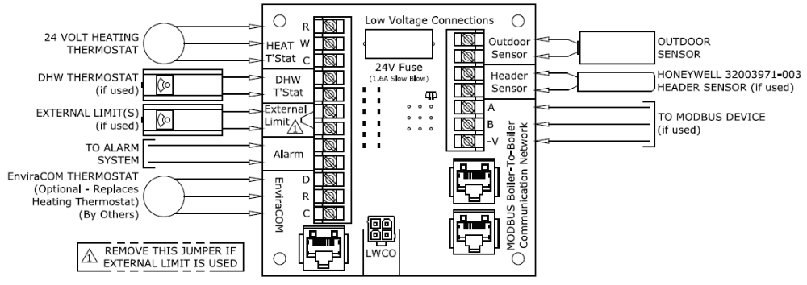Notes:
- Alarm Contacts shall close when the boiler enters a “hard” lockout (lockout requiring manual reset). They may be used as an input to a building alarm system. Contact rating is 24VAC, 0.63FLA. These shall not be used for line voltage applications.
- Outdoor Sensor shall be included as a separate part with the boiler. It shall be a Tasseron TSA00AA (10 KOhms). This sensor shall be installed, connected and enabled per the manufacturer instructions. It shall adjust the target supply water temperature downwards as the outdoor air temperature increases. Sensor wiring to the boiler shall be 22 gauge or larger wire routed away from sources of electrical noise. Where it is impossible to avoid such noise sources, the sensor shall be wired using a 2 conductor, UL Type CM, AWM Style 2092 shielded cable with the connection of one end of the shielding to ground.
- Each boiler product shall be equipped with a listed high water temperature limit function. This limit provides boiler shutdown in the event the boiler water temperature exceeds the set point of the limit control. Certain Local Codes require an additional water temperature limit. If necessary, install an additional water temperature limit (P/N 106056-01) or equivalent Honeywell L4006 Aquastat.
- The external limit terminals shall be intended for use with a field supplied safety device, such as a manual reset high limit. When an external limit is used, the jumper between these two terminals shall be removed. Failure to remove this jumper will render the external safety devices ineffective.
- Each boiler product shall be equipped with a wiring diagram attached to the boiler jacket.

4.5 Sage Boiler Control; Capability and Functionality
The boiler controls shall comply with the operational and functional capabilities described on the following pages.
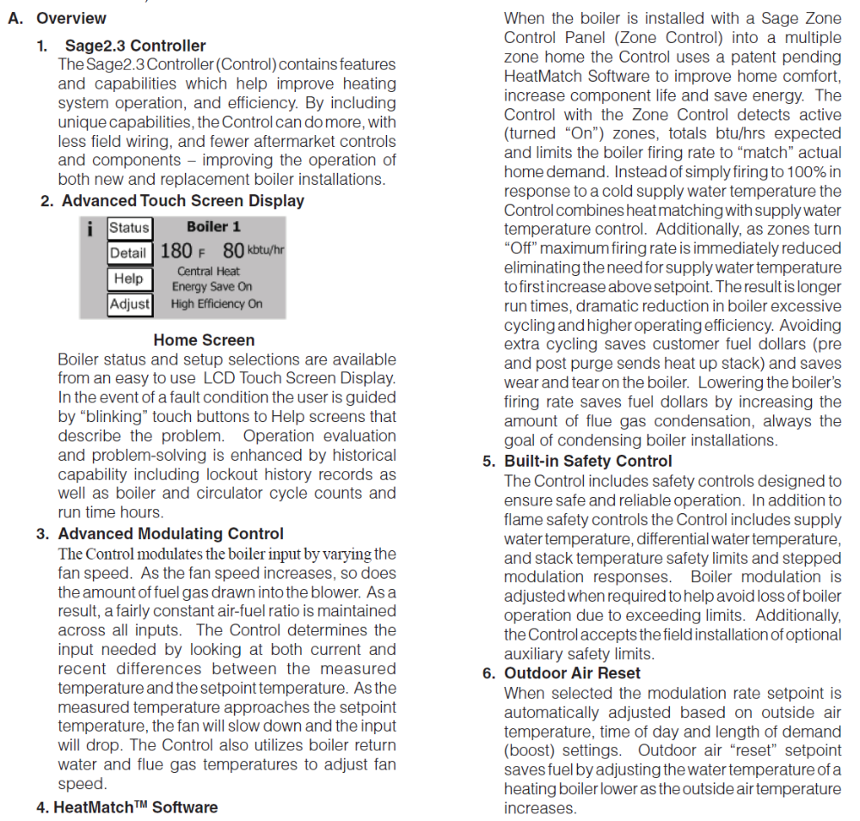
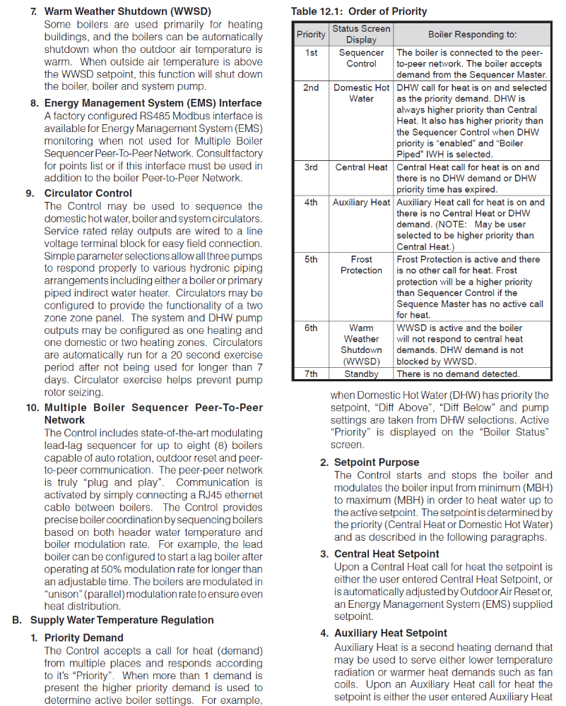

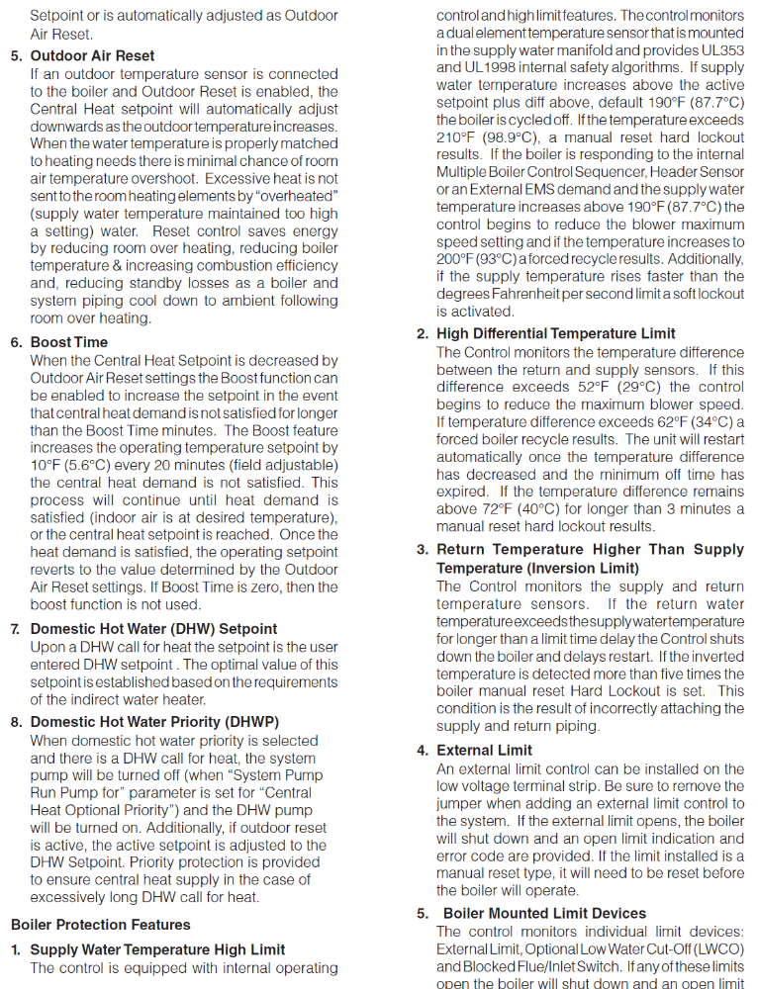

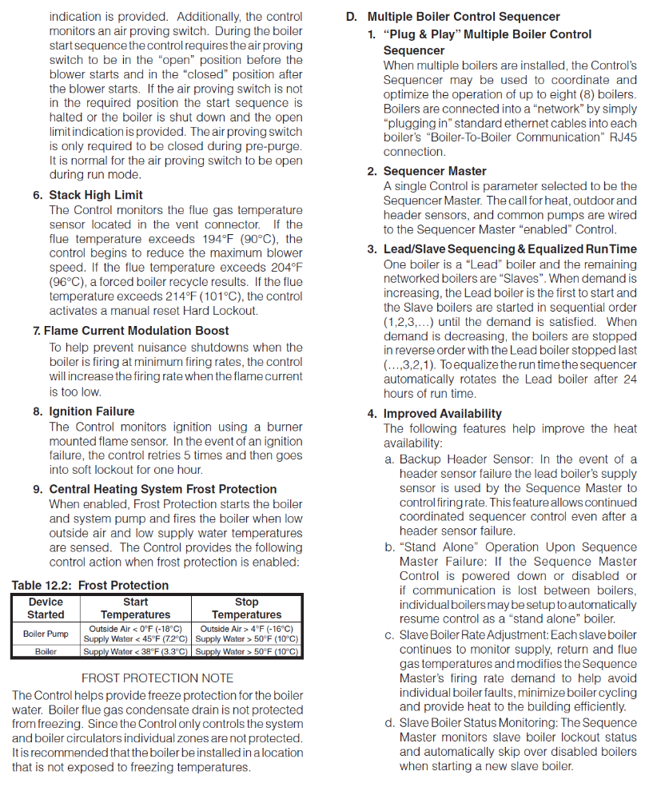
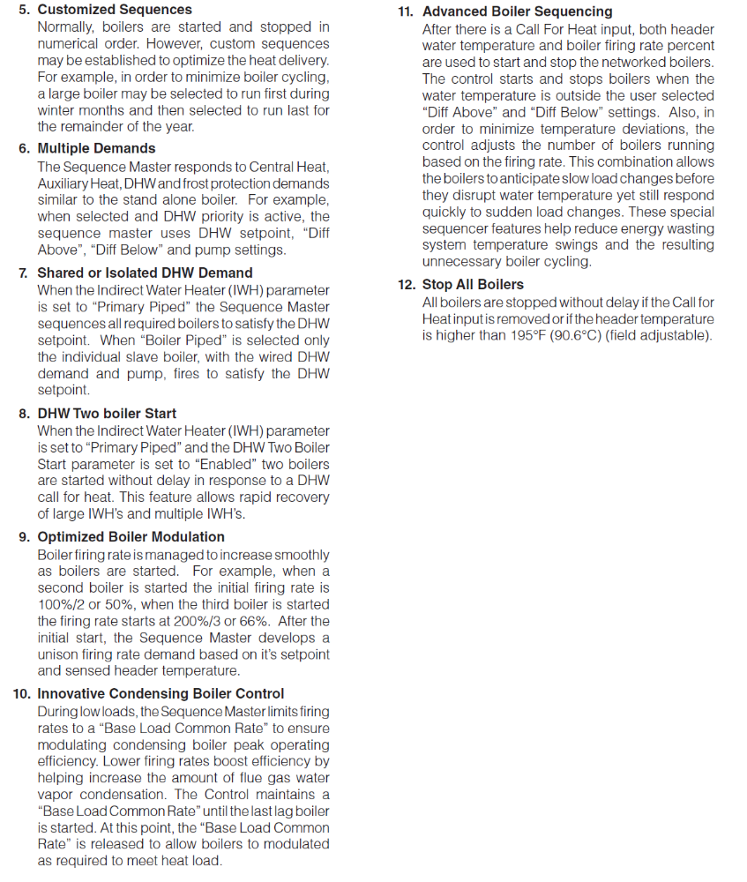
4.6 User Interface/Touch Screen Display
- A Panasonic touch screen LCD display shall be mounted on the boiler to operate and adjust the boiler through the Sage Boiler Control.
- The user shall be able to monitor and adjust boiler operation by selecting screen navigation “buttons” and symbols. The “Home Screen” shall provide boiler temperature, firing rate in KBTU/hr, boiler status, efficiency information and page links.
- When no selection is made on any screen the display will revert to the “Home Screen” after four idle minutes.
- The LCD touch screen shall display these characteristics below:
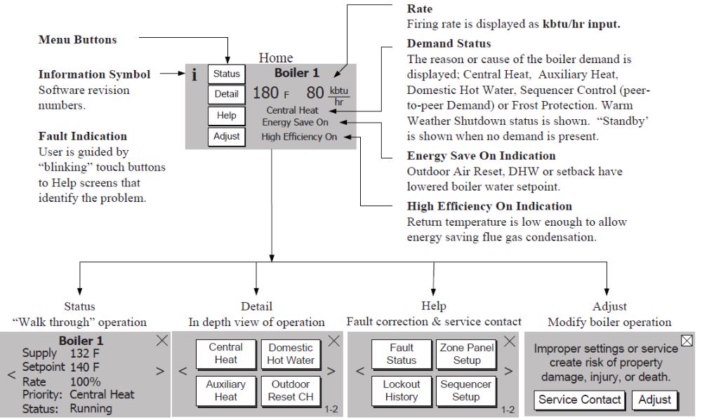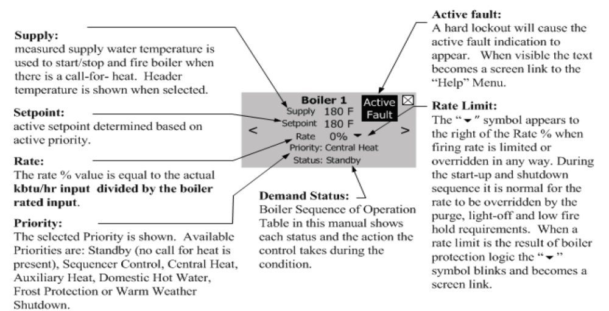
- A typical adjustment screen shall display these characteristics below :
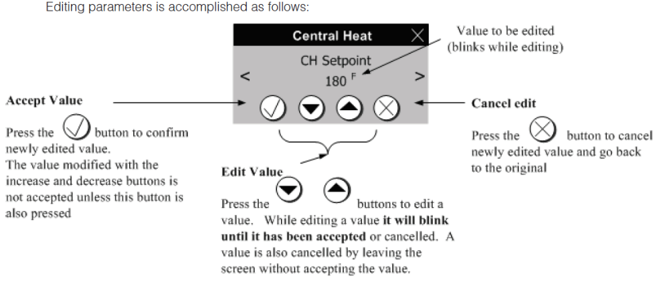

5- INSTALLATION
5-1 General Installation
- Boiler installation shall comply with contract documents and boiler manufacturer's printed instructions.
- Installer shall always use a combustion analyzer to complete gas valve combustion settings.
- Installer shall flush and clean the boiler upon completion of installation in accordance with manufacturer's start-up instructions. The boiler must be isolated when any cleaning or testing of system piping is being performed.
- Manufacturer-recommended clearances shall be maintained around and over equipment, and as required by local Code.
- All electrical conduit, piping, exhaust vent, and air intakes shall be installed with clearances for burner removal and service of all equipment.
- Exhaust vent shall always be connected to boiler vent connection.
- Fuel piping shall always be connected in accordance with NFPA 54. Pipe size to be the same, or greater, than the gas train inlet connection.
- Installer shall use full size (minimum) pipe/tubing on all gas vent connections.
- Installer shall connect water piping, full size, to supply and return connections.
- All piping accessories shall be installed per the details on the contract drawings.
- Installer shall install discharge piping from relief valves (open termination for viewing) and all drains to nearest floor drain while adhering to governing environmental requirements.
- Installer shall provide necessary water treatment to satisfy manufacturer’s specified water quality limits.

6- OTHER SPECIFICATIONS
6-1 Clearance Requirements
- The boiler shall be commissioned only after satisfying the following clearances.
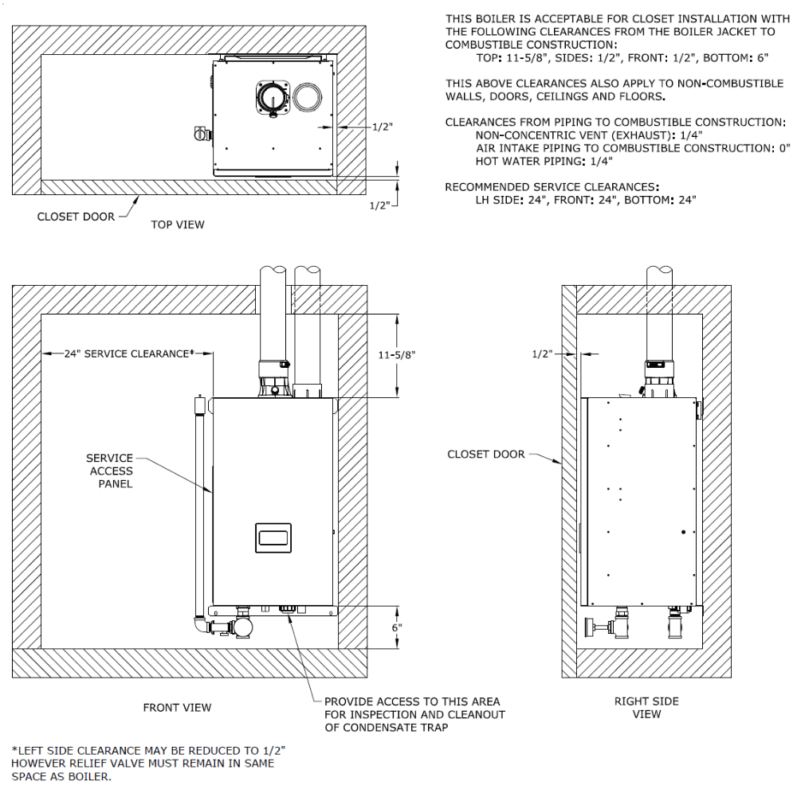
6-2 Water Chemistry Criteria and Recommendations.
- The boiler shall function using water with the following characteristics.
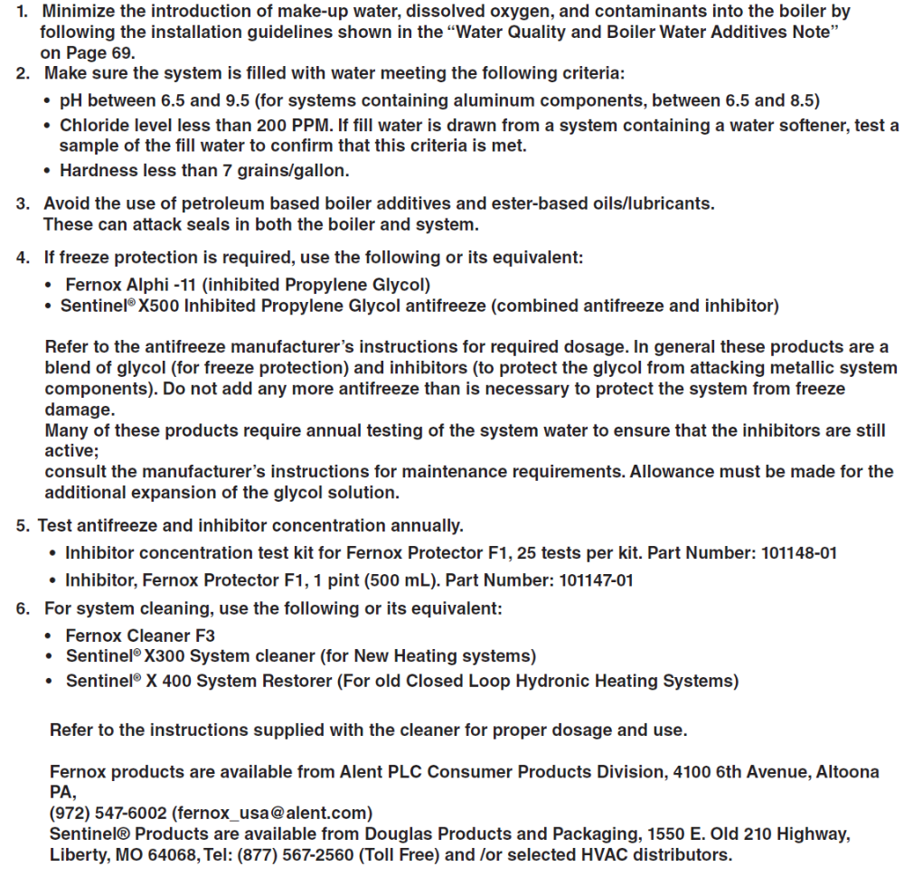

6-3 HeatMatch Software and Adjustments Compatible with Sage Zone Control
- The boiler control shall function, per below, with HeatMatch software when set properly for use with a Sage Zone Control.
