
Specification Rev. 04/21/2021
Cast Iron Gas, Steam Boiler
SteamMax
Maximum Installation Elevation: 2000 feet
Natural Gas Installations Only
Installations in USA Only

U.S. Boiler Company, Inc.
P.O.Box 3020 Lancaster, Pennsylvania 17604-3020
Phone: 888-432-8887
www.usboiler.net

- GENERAL

  - Description
- Boiler. Gas-fired, steam, space heating boiler appliance with a cast iron heat exchanger. Category I with a draft hood and a vent damper (299 MBH and smaller models only). Packaged boiler configurations are factory-assembled, packaged and tested to provide space heating and support a separate indirect domestic hot water (DHW) heating option. Knock-down boiler configurations are shipped to customers with all packaged components on skids for assembly by qualified technicians. Knock-down options include choices of assembled full-block heat exchangers, split-block heat exchangers for field-heat exchanger-assembly or individual sections for field-heat exchanger-assembly.

2-SOURCING
2-1 Approved Manufacturer and Models
- Boiler shall be manufactured by U.S. Boiler Company, Lancaster, PA
- Installed boiler model shall be (select from right where numbers indicate rated MBH input)- STMX075, STMX100, STMX125, STMX150, STMX175, STMX200, STMX250, STMX299, STMX350, STMX399, STMX450, STMX500, STMX550.
- The contractor shall insure that any substituted equipment is equivalent in fit, form and function to the equipment in this specification. The cost and responsibility of any additional work caused by the substitution of equipment shall be borne by the Contractor.
- Also refer to Equipment Schedule in the Contract Drawings.

3-DOCUMENTATION
3.1 Documentation
- This specification is accompanied by additional documents including a current submittal package with boiler literature, Installation, Operation and Service instructions, shop drawings, site application specifications, wiring diagrams, piping diagrams and other related work materials.
- This specification is not an instructions document, but refers to the official “I,O&S Instructions.”
4-PRODUCT SPECIFICATIONS
4.1 References and Requirements
- This boiler must only be installed, serviced and repaired by a qualified installer, service agency or gas supplier in accordance with the manufacturer’s Installation, Operating and Service Instructions (I, O&S) and associated warnings. Installer credentials should comply with those specified and enforced in the area of the installation site.
- Boiler shall comply with ANSI Z21.13 test standards for the United States and be AHRI-listed to verify compliance to the minimum efficiencies required by the U.S. Department of Energy (DOE)
- Boiler shall be mounted, vented, piped and wired properly per the instructions, exact clearances, requirements and qualified materials documented in the manufacturer’s I,O&S Instructions. Installations must conform to the requirements of the authority having jurisdiction, or in the absence of such requirements to National Fuel Gas Code ANSI Z223.1/NFPA 54.
- Where required by the authority having jurisdiction, installation must conform to the Standard for Controls and Safety Devices for Automatically Fired Boilers (ANSI/ASME CSD-1).
- Combustion and ventilation air shall be in accordance with the section "Air for Combustion and Ventilation," of the National Fuel Gas Code, ANSI Z223.1/NFPA 54, or applicable provisions of local building codes.
- All wiring must comply with the National Electrical Code ANSI/NFPA 70.
- Gas piping and connections shall follow the I,O&S Instructions and lawfully conform to safety requirements. Installations must conform to the requirements of the authority having jurisdiction, or in the absence of such requirements to National Fuel Gas Code ANSI Z223.1/NFPA 54. Pipe size shall be the same, or greater, than the gas train inlet connection.
- Boiler shall be approved by the Massachusetts Board of Plumbers and Gas Fitters.
- Boiler shall be listed for level installation on combustible flooring; It shall not be installed on carpeting.
- Boiler shall not be used or converted for use with LP gas
- Boiler shall not be used or converted for installation above an elevation of 2000 feet.
- Boiler shall not be installed outside of the USA.
4.2 Construction and Components
- Each packaged boiler shall be assembled, fire-tested, inspected, packed and shipped as a factory-packaged unit complete with jacket, burner and controls mounted and wired. All equipment shall be carefully manufactured and inspected before shipment.
- Knock-down boiler configurations are shipped to customers with all packaged components on skids for assembly by qualified technicians. (reference section 4.1.A)
- Knock-down options include choices of assembled full-block heat exchangers (KA), split-block heat exchangers for field-heat exchanger-assembly (KS) or individual sections for field-heat exchanger-assembly (KI).
- Boiler shall be equipped with a sectional cast iron primary heat exchanger bearing the ASME “H” stamp per the ASME Boiler and Pressure Vessel Code. Heat exchanger sections shall be factory-assembled or field-assembled together with cast iron push nipples for leak free operation during the fluctuating heat of the boiler’s service life. High temperature silicone RTV shall be used to seal flue way joints and base/section assembly joints during any field block assembly.
- Assembled cast iron heat exchanger blocks shall always be sealed to their bases before boiler start-up using high temperature silicone RTV or other seal material as specified by the I,O&S Instructions.
- Boiler heat exchanger shall have a maximum allowable working pressure (MAWP) of 15 psi and shall be hydrostatically pressure-tested in the factory at 150% of this MAWP before being accepted for factory final assembly and shipment.
- Boiler shall include a 15 psi safety relief valve that shall be installed into the boiler by the installing contractor.
- Boiler heat exchanger shall have no heat transfer pins above the steam water line and no crown sheet fins in order to optimize corrosion resistance in these critical areas.
- Boiler shall be built with a non-plastic, insulated steel jacket and a rust resistant powder coat finish on selected surfaces. The boiler assembly shall have a fabricated, heavy gauge, sheet metal base with 1” base insulation.
- Boiler sizes 075MBH through 299MBH shall each be a conventional, whole boiler unit. Boiler sizes 350MBH through 550MBH shall each be joined together with split sub-assemblies as a whole boiler unit by the field installer. These larger configurations operate with dual draft hoods, split bases, split gas trains and split jackets.
- Boiler shall be equipped from the manufacturer with a listed low-water-cut-off device (LWCO) with automatic reset for residential installations.
- (Select this phrase if the boiler is for commercial installations) Boilers for commercial installations shall also be equipped with a listed low-water-cut-off device, manual reset, provided with the boiler or as a component upgrade.
- LWCO devices shall be properly installed by the field installer to shut down boiler operation whenever there is a low water condition. Installing technicians shall test this function while auto reset pressure limit, thermostat or other controls are not in shut down condition. Water should be visible in the gauge glass when auto reset LWCO shuts down both pilot and main burners.
- Boiler system shall be equipped with a listed auto-reset pressure limit provided by the boiler manufacturer for residential installations.
- (Select this phrase if the boiler is for commercial installations) Boilers for commercial installations shall also be equipped with a listed manual reset pressure limit provided with the boiler or as a component upgrade.
- Each boiler shall include a rear, low-profile draft hood to clear low overhead areas and ease installation and retrofits.
- Each boiler shall include these components as standard equipment:
  - Cast Iron Section assembly joined by metal push nipples; Auto-reset pressure limit, Honeywell L404F; LWCO- Probe type, Choice of: McDonnell & Miller PSE802 or Hydrolevel CG-400; Gas valve(s), Quiet, Step-opening; Base-burner manifold assembly; Flame roll-out switch (FRS); Flue Canopy; Standard 2” risers; Vent damper (075MBH to 299MBH only); Blocked vent switch; Insulated deluxe jacket 24V transformer; Junction box; Thermostat isolating relay; 15 PSI safety valve; Pressure gauge; Gauge glass; 3/4” drain valve.
- Each boiler shall also include these components as standard equipment as specified below (Select correct version 1, 2, or 3)
  - For Residential Builds 3 sections (75 MBH) to 7 Section (299 MBH)- Combustion Control, Auto Reset Ignition, Honeywell 8610M.
  - For Residential Builds 8 sections (350 MBH) to 12 Section (550 MBH)- Dual Combustion Controls, Auto Reset Ignition, Honeywell 8610M.
  - Commercial Builds 10 sec (450 MBH) to 12 Section (550 MBH)- Dual Combustion Controls, Manual Reset Ignition, Alarm Contracts, UTEC 1003 with UTEC 1145-2 Ignition PCB, Additional Auxiliary Pressuretrol, Manual Reset, Industrial, Anti-leak, Honeywell L4079B, Additional Auxiliary LWCO, Manual Reset, Choice of McDonnell & Miller PSE802M or Hydrolevel 500.
- U.S Boiler input conversion kit 111251-01 shall be used if converting STMX100 to STMX075.
- Near boiler piping kit is recommended and offered as an optional accessory for residential boiler sizes. (Select one- 111295-01 for STMX075-STMX150, or 111296-01 for 175MBH- 250MBH)
4.3 Physical Specifications
- Boiler model (select from left column in table below), shall have the corresponding physical characteristics listed in the tables below.
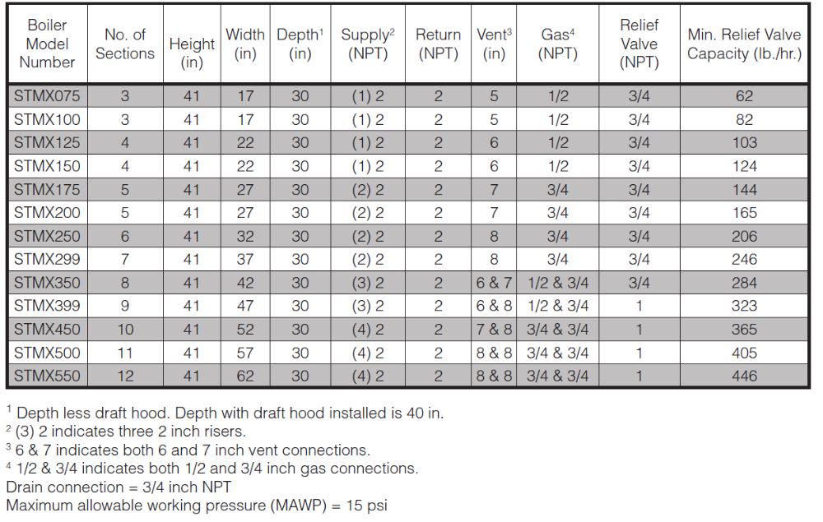
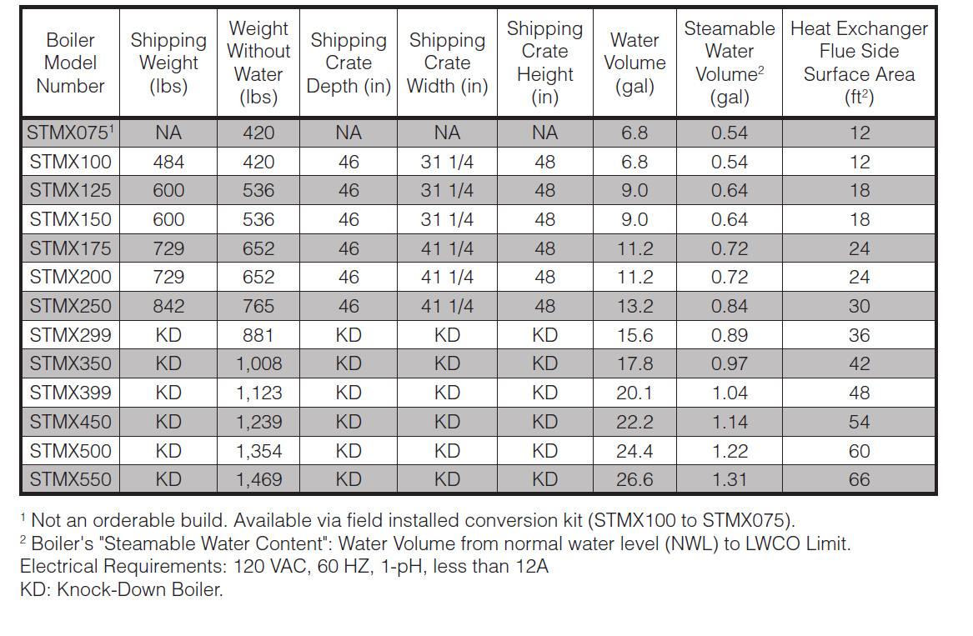
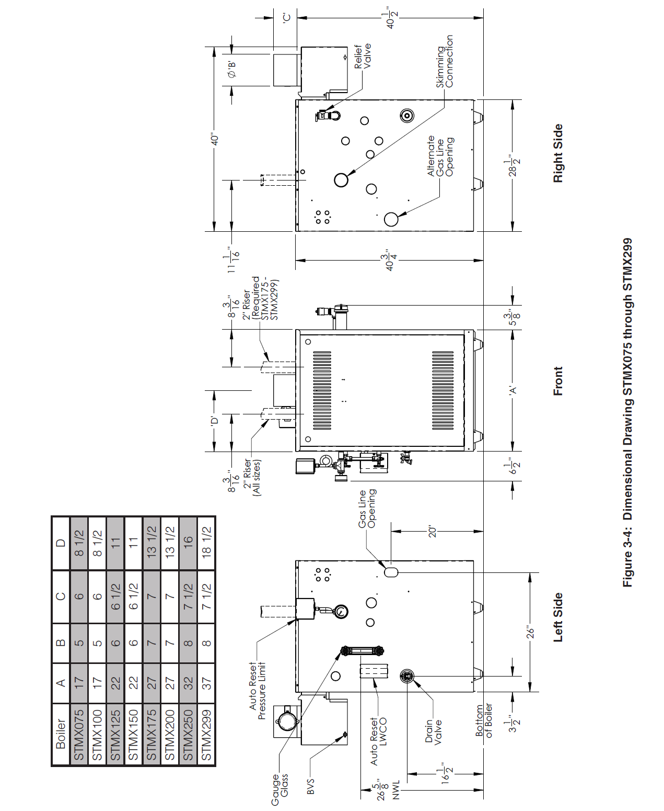
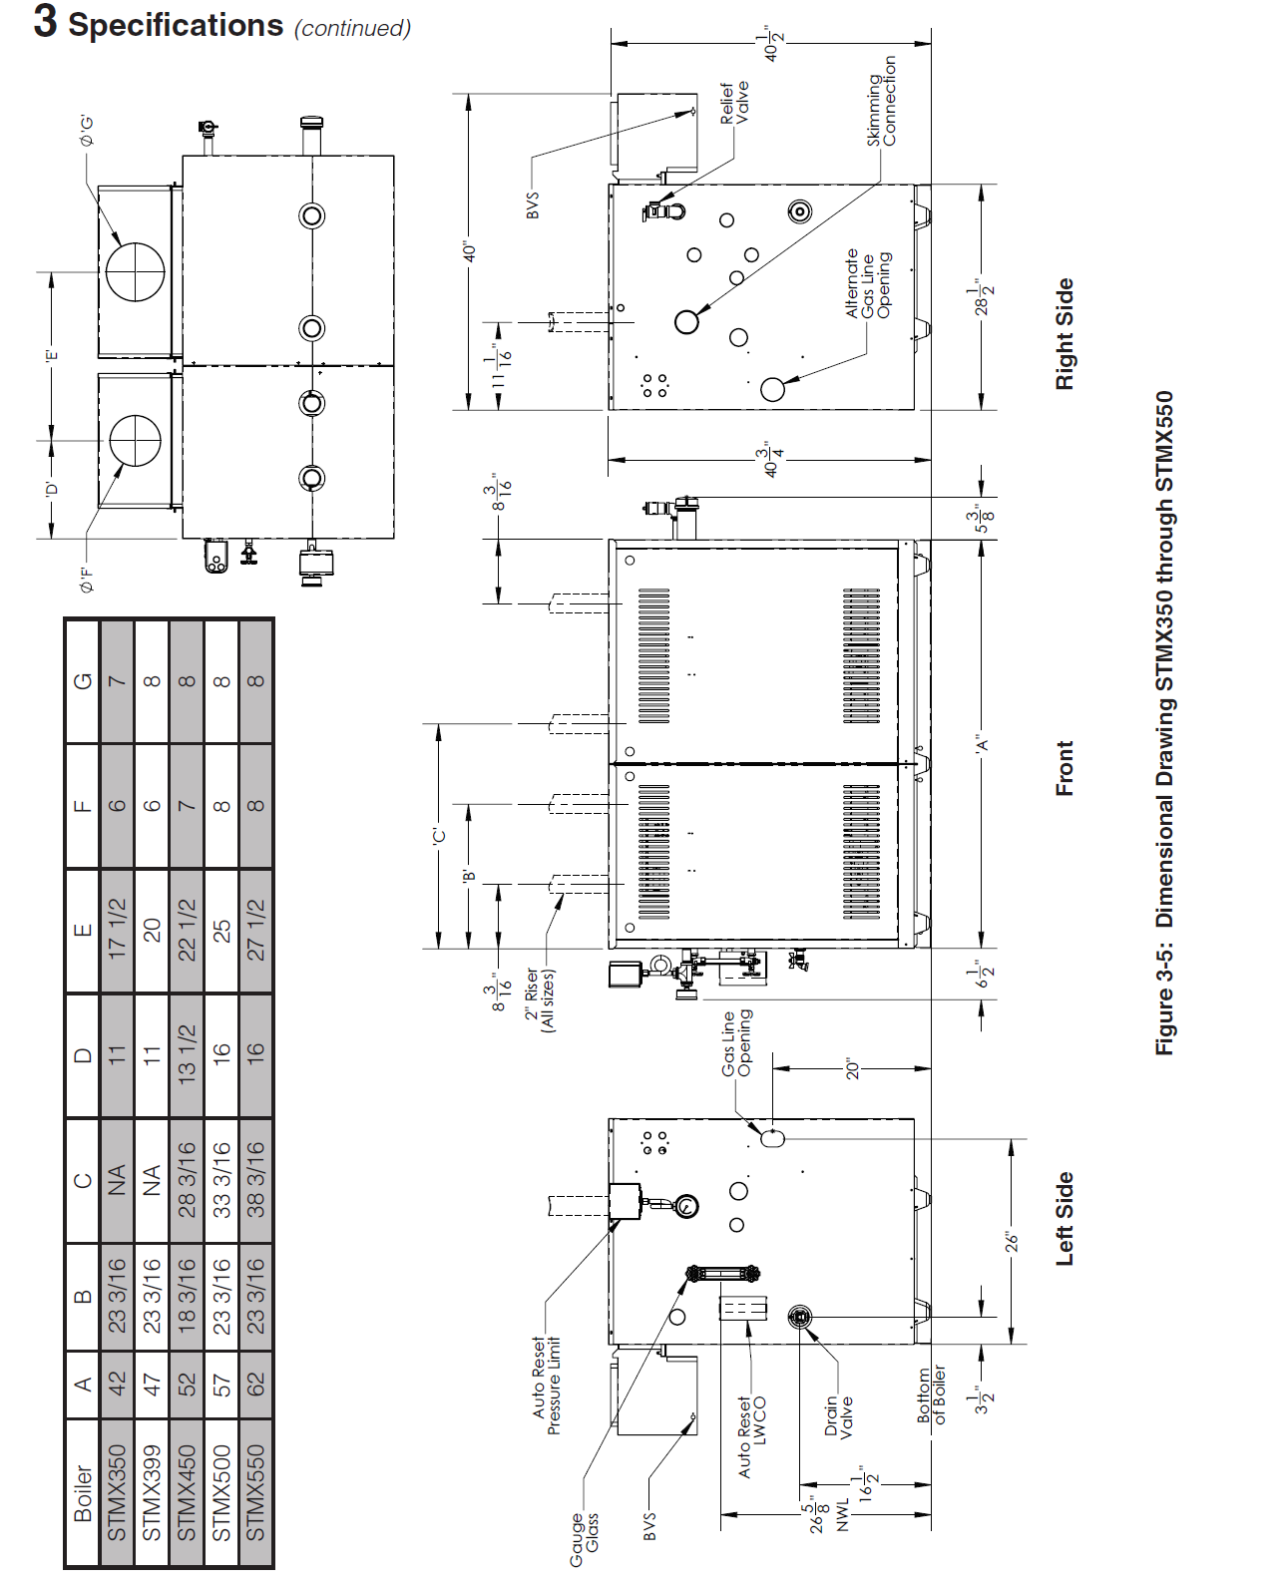
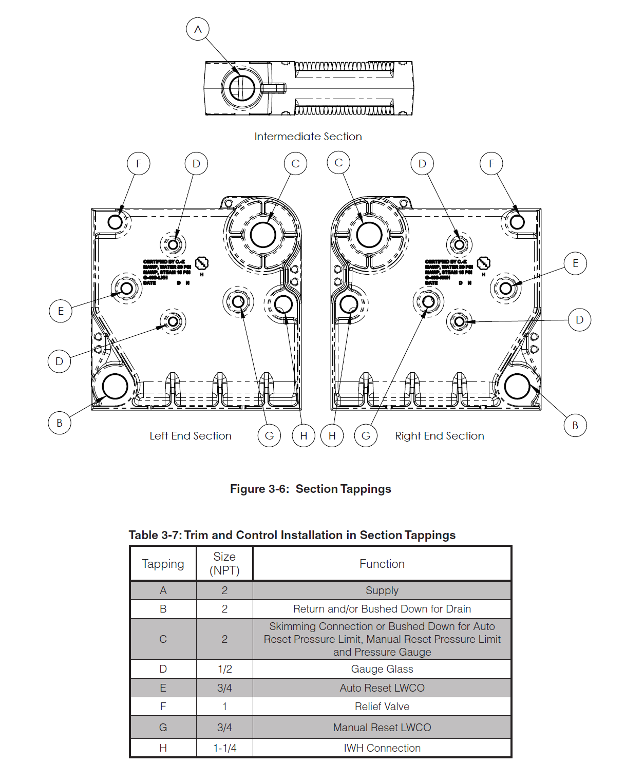

4.4 Performance Ratings
- Boiler model (select from left column in table below) shall meet the corresponding performance characteristics shown below.
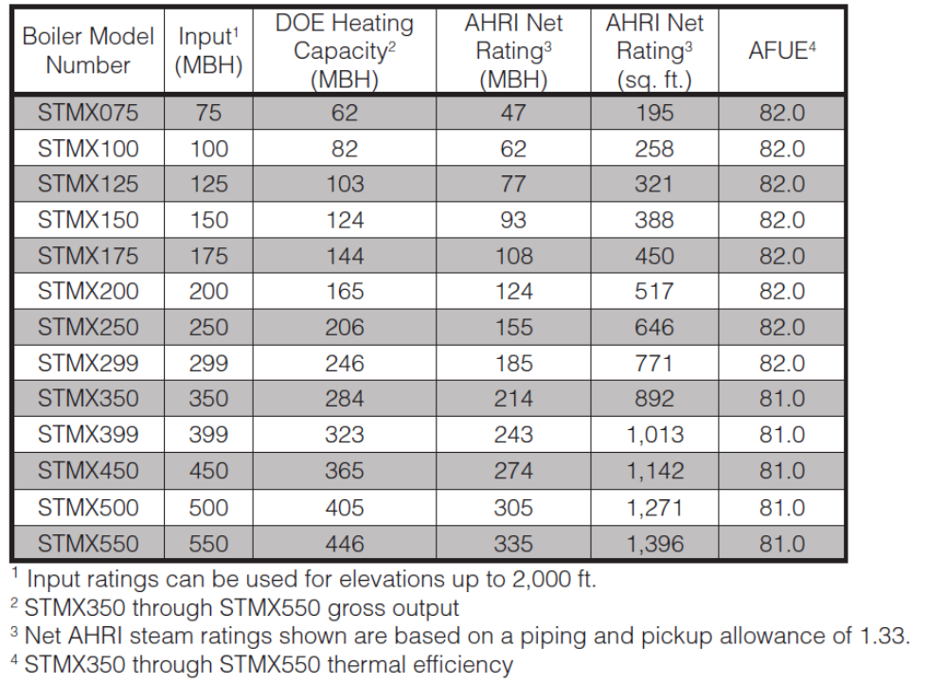
4.5 Electrical and Wiring
- Boiler shall be rated for 120 VAC, 60 hertz, 1- ph., less than 12 amperes.
- A separate electrical circuit shall be run from the main electrical service with an over-current device/disconnect in the circuit. A service switch is recommended and may be required by some local jurisdictions. This switch shall be located in accordance with local codes or, in the absence of any, in a location where it can be safely accessed in an emergency involving the boiler.
- Each boiler product shall be equipped with a wiring diagram attached to the boiler jacket.

4.6 Control Operation, Capability and Functionality
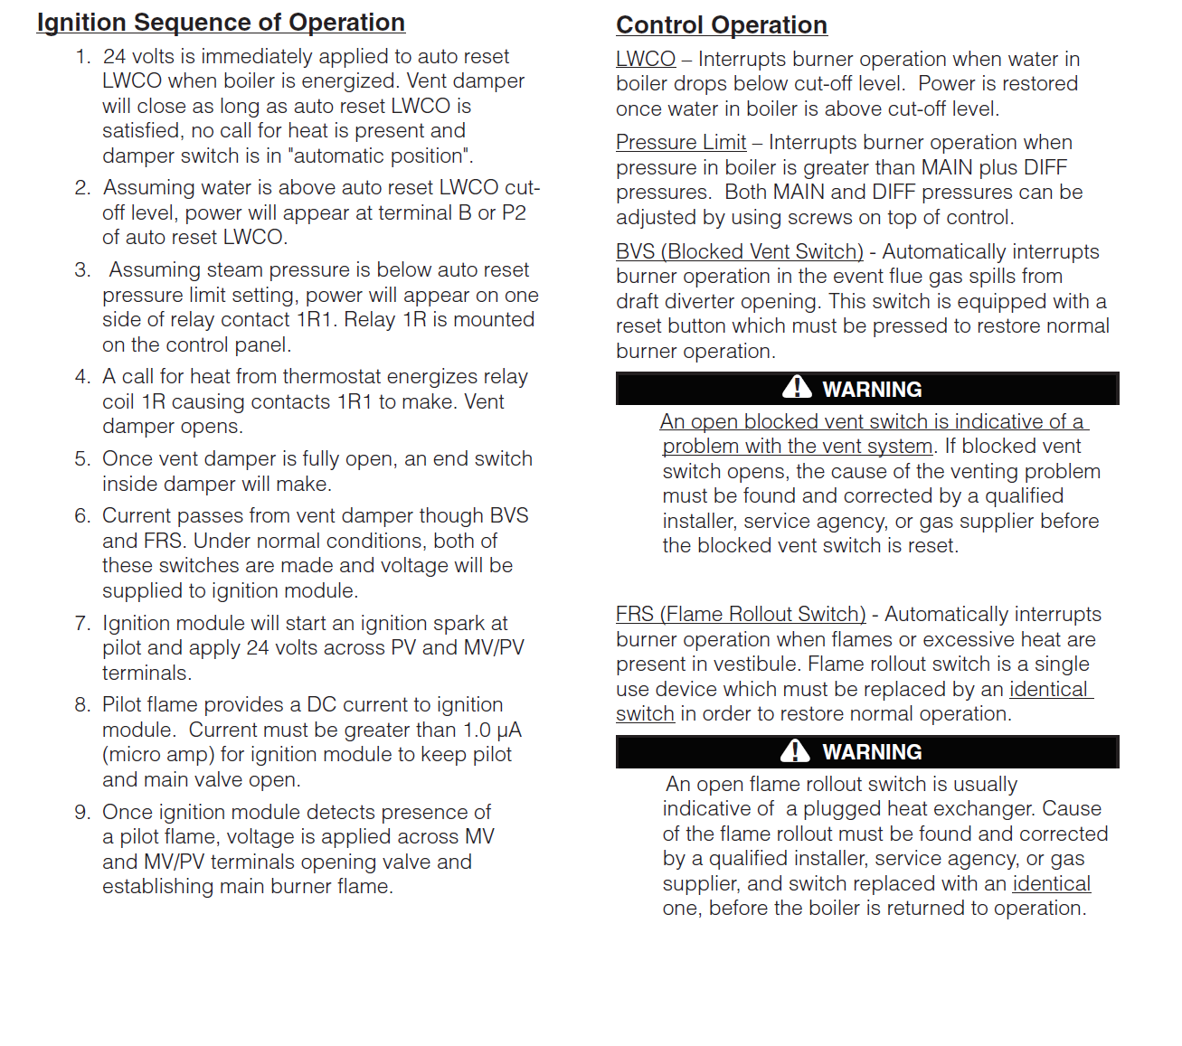
5-INSTALLATION
5-1 Installation Requirements
- Boiler and other specified equipment shall be expertly installed by a professional heating contractor.
- Manufacturer-recommended clearances shall be maintained around and over equipment, and as required by local Code.
- Boiler shall only be installed on a proper base surface. A level floor is required. A concrete base should be provided if a basement floor is not level or if water may accumulate on the floor around boiler. This heating appliance is listed for installation on combustible flooring, but it shall not be installed on carpeting.
- The installer shall never jump out or bypass any safety or operating control or component of this boiler.
- Installer shall never install boiler where gasoline or other flammable vapors or liquids are stored. Avoid areas near chemical products containing chlorine, chloride based salts, chloro/fluorocarbons, paint removers, cleaning solvent, and detergents.
- Boiler SHALL NOT be vented with CPVC, PVC, Polypropylene or any other non-metallic vent pipe.
- Installer shall isolate and protect gas ignition system components from water (dripping, spraying, rain, etc.) during boiler operation and service (circulator replacement, condensate trap, control replacement, etc.).
- All electrical conduit, piping, exhaust vent, and air intakes shall be installed with clearances for burner removal and service of all equipment.
- Boiler installation and startup shall comply with contract documents and boiler manufacturer's printed instructions.
- Softened water shall not be used in this steam boiler because it will cause accelerated boiler corrosion. Oxygen contamination of boiler water will cause corrosion of iron and steel boiler components, and can lead to boiler failure. Check for and correct system leaks. Tie in fresh water supply to boiler upstream of a water softener.
- Copper steam piping is not recommended
- Exhaust vent shall always be connected to boiler vent connection.
- Installer shall flush and clean the boiler upon completion of installation in accordance with manufacturer's start-up instructions. The boiler must be isolated when any cleaning or testing of system piping is being performed.
- Installer shall install discharge piping from relief valves (open termination for viewing) and all drains to nearest floor drain while adhering to governing environmental requirements.
- Fuel piping shall always be connected in accordance with NFPA 54. Pipe size shall be the same, or greater, than the gas train inlet connection.
- Installer shall use full size (minimum) pipe/tubing on all gas vent connections.
- All piping accessories shall be installed per the details on the contract drawings.
- Installer shall provide necessary water treatment to satisfy manufacturer’s specified water quality limits.

5.2 Connection Locations and Clearances
- The boiler shall connect at these locations with these clearances.
