
Specification Rev. 07/15/2020
Cast Iron Gas Boiler, X-PV
Power Vent with Direct Vent Option

U.S. Boiler Company, Inc.
P.O.Box 3020 Lancaster, Pennsylvania 17604-3020
Phone: 888-432-8887
www.usboiler.net

- GENERAL

  - Description
- Boiler. Gas-fired, hot water, space heating, boiler appliance with a cast iron heat exchanger for installations where a usable chimney is not available and exhaust can be routed horizontally or vertically through approved AL29-4C stainless steel venting. The boiler shall include an integrated primary and hydronic boiler control. The boiler shall be power-vented with room combustion air intake, or be adapted with an optional direct vent, sealed combustion kit for piped outdoor combustion air intake. The boiler main unit shall be factory-assembled, packaged and tested to provide space heating and support a separate indirect domestic hot water (DHW) heating option. Boiler is not designed for use in gravity hot water systems or systems containing significant amounts of dissolved oxygen.
2-SOURCING
2-1 Approved Manufacturer and Models
- Boiler shall be manufactured by U.S. Boiler Company, Lancaster, PA
- Installed boiler shall be a model (select from right; N suffix indicates natural gas models. P suffix indicates LP gas models) X-PV3N, X-PV4N, X-PV5N, X-PV6N, X-PV7N, X-PV8N, X-PV3P, X-PV4P, X-PV5P, X-PV6P, X-PV7P, X-PV8P.
- The contractor shall insure that any substituted equipment is equivalent in fit, form and function to the equipment in this specification. The cost and responsibility of any additional work caused by the substitution of equipment shall be borne by the Contractor.
- Also refer to Equipment Schedule in the Contract Drawings.

3-DOCUMENTATION
3.1 Documentation
- This specification is accompanied by additional documents including a current submittal package with boiler literature, Installation, Operation and Service instructions, shop drawings, site application specifications, wiring diagrams, piping diagrams and other related work materials.
- This specification is not an instructions document, but it refers to the “manual” which serves as the official INSTALLATION, OPERATING AND SERVICE INSTRUCTIONS document.
4-PRODUCT SPECIFICATIONS
4.1 References and Requirements
- Boiler and other specified equipment shall be expertly installed by a professional heating contractor in accordance with the manufacturer’s installation instructions as well as regulations and installer credentials enforced in the area of the installation site.
- Boiler shall comply with ANSI Z21.13 test standards for the United States and be AHRI-listed to verify compliance to the minimum efficiencies required by the U.S. Department of Energy (DOE)
- Boiler shall be mounted, vented, piped and wired properly per the instructions, exact clearances, requirements and qualified materials documented in the manufacturer manual. Installation must conform to the requirements of the authority having jurisdiction. In absence of such requirements, installation must conform to National Fuel Gas Code, ANSI Z223.1/NFPA 54. In Canada, installation must conform to CAN/CSA B149.1 (Natural Gas and Propane Installation Code). Where required by the authority having jurisdiction, this installation must conform to the Standard for Controls and Safety Devices for Automatically Fired Boilers (ANSI/ASME CSD-1).
- Combustion and ventilation air shall be in accordance with the section "Air for Combustion and Ventilation," of the National Fuel Gas Code, ANSI Z223.1/NFPA 54, or Clause 8.2, 8.3 or 8.4 of Natural Gas and Propane Installation Code, CAN/CSA B149.1 or applicable provisions of local building codes.
- All wiring and grounding shall be done in accordance with the authority having jurisdiction or, without such requirements, with the National Electrical Code ANSI/NFPA 70. In Canada, all wiring and grounding must be done in accordance with the Canadian Electrical Code, Part 1 (CSA C22.1 - latest edition).
- Gas piping and connections shall follow the manual and lawfully conform to safety requirements. Installers shall use methods and materials in accordance with local plumbing codes and requirements of gas supplier. In absence of such requirements in the USA, they shall follow National Fuel Gas Code, ANSI 223.1/NFPA 54. Pipe size shall be the same, or greater, than the gas train inlet connection.
- Boiler shall be approved by the Massachusetts Board of Plumbers and Gas Fitters.
- Boiler shall be listed for installation on combustible flooring; It shall not be installed on carpeting.

4.2 Construction and Components
- Boiler shall be equipped with an exhaust blower as a power vent system for venting through:________ (select one from two bullets below)
  - Horizontal (“side wall”) venting using an approved AL29-4C stainless steel vent system or
  - Vertical venting using an approved AL29-4C stainless steel vent system.
- The boiler shall have an adequate source of clean combustion air in the boiler room as specified by the exact manufacturer instructions, limitations and restrictions . Un-interrupted combustion air shall be supplied to the boiler with:_________ (Select one method of two methods from below) Method 1-Indoor Combustion Air shall be drawn into the boiler through the boiler room and other parts of the building and from outdoors through natural infiltration (cracks under doors, etc). This method cannot be used in all cases . Method 2-Direct Venting allowing combustion air to be pulled directly from outside the building with installer supplied PVC or galvanized air intake piping only by using the manufacturer’s Direct Vent Conversion Kit shown in Table 2.2 in section 4.4 of this specification.
- Boiler shall be assembled, fire-tested, inspected, packed and shipped as a factory-packaged unit complete with jacket, burner and controls mounted and wired with boiler connections. All equipment shall be carefully manufactured and inspected before shipment.
- Boiler shall be equipped with a sectional cast iron primary heat exchanger bearing the ASME “H” stamp per the ASME Boiler and Pressure Vessel Code. Sections shall be assembled together in the factory with metal push nipples for leak free operation during the fluctuating heat of the boiler’s service life. Boiler paste sealant shall be applied between sections during sectional assembly at the factory. This heat exchanger shall have a maximum allowable working pressure (MAWP) of 50 psi and shall be hydrostatically pressure-tested in the factory at 150% of this MAWP before being accepted for factory final assembly and shipment.
- Boiler heat exchanger shall be designed for a balanced water flow between cast iron sections from return to supply connections.
- Boiler shall include a 30 psi safety relief valve in a parts box that shall be field-installed into the supply piping. A 50 psi safety relief valve may be substituted.
- Boiler shall be built with a non-plastic, insulated steel jacket with a rust resistant powder coat finish on selected surfaces. The boiler assembly shall have a fabricated sheet metal base with heavy gauge 1” base insulation, flashed with additional sheet metal for moisture resistance.
- Boiler shall be equipped with a listed high water temperature limit device pre-installed in a dual purpose well in the cast iron heat exchanger. This limit provides boiler shutdown in the event the boiler water temperature exceeds the set point of the limit control. The limit control shall have a setting range between 140 to 220 degrees F. Certain Local Codes require an additional, auxiliary water temperature limit. U.S. Boiler P/N 103696-01 may be considered for use as this additional, auxiliary water temperature limit.
- Boiler shall be equipped with these other required components pre-installed and functional on the boiler:
  - Intelligent Hydronic Control integrating primary and hydronic control functions including simple self-diagnostics; Operated with a three button user interface; Monitored with a 3-digit readout for status settings and error readings. The integrated control PCB shall include two zone inputs and corresponding pump outputs.
  - Functioning IDL-1200 integral low-water-cut-off device with auto reset and test button pre-installed into the dual purpose heat exchanger well.
  - Step-opening redundant gas valve
  - Spark ignition with continuous retry
  - 120V J-box in vestibule; Ready for easy wiring.
  - Stainless steel burners
- Boiler shall include these other components in separate packaging inside the boiler crate for final field assembly or use by installation technicians.
  - ECM Circulator, Taco 007e
  - Drain valve
  - Safety relief valve, 30 psi
  - Cast iron supply manifold with safety relief valve tapping
  - Temperature/Pressure Gauge
  - Printed Installation, Operating and Service Instructions.
  - User Information Manual

  - Optional Direct Vent Function
- The boiler shall be adaptable to bring combustion air directly from outside to the boiler combustion chamber (direct venting) using the Direct Vent Conversion Kit number _________ (Select from far right column in rating table in Section 4.4 below) . This is very practical for installations in tightly constructed buildings. This kit shall include an air box and other components needed to route air directly to the combustion chamber, as well as an air intake terminal for a horizontal installation. This installed kit shall route combustion air directly from outside the building to the boiler combustion area and eliminate the need for combustion air from inside the structure. Figure A.1 shows the boiler with the Direct Vent Conversion Kit installed and the location of the air inlet connection.
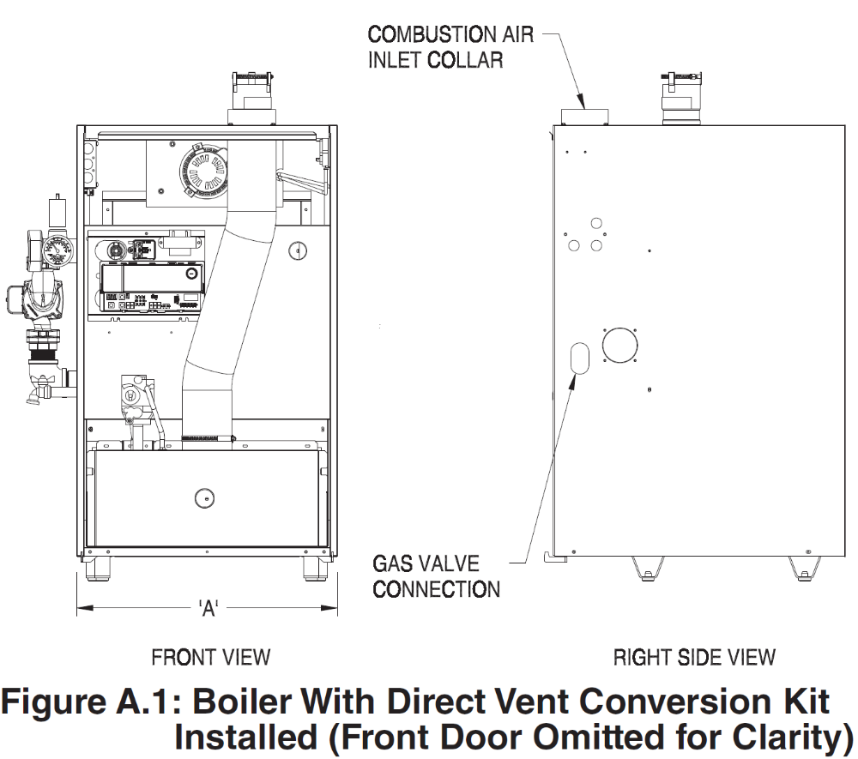
4.4 Physical Specifications and Ratings
- Boiler model (select from left column in table below), shall have the corresponding dimensional characteristics and ratings listed in the table below and shown in the product drawing below.

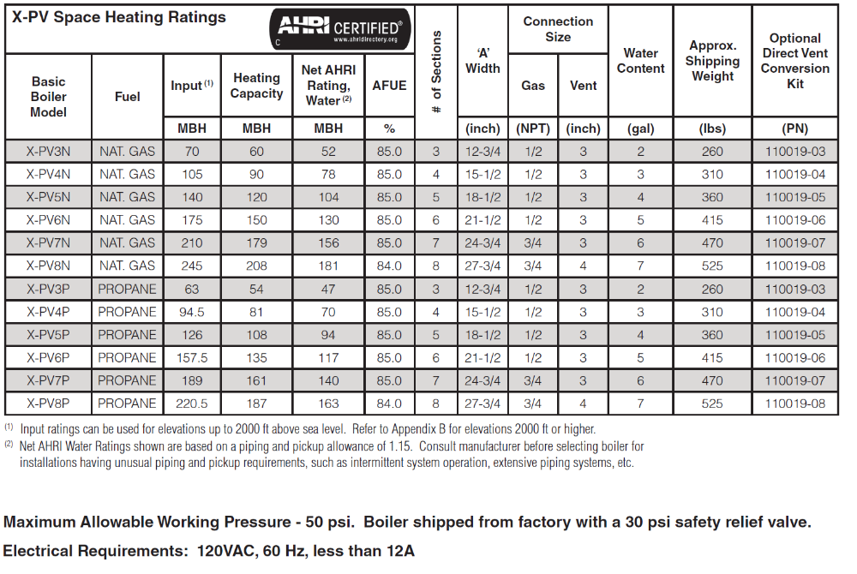
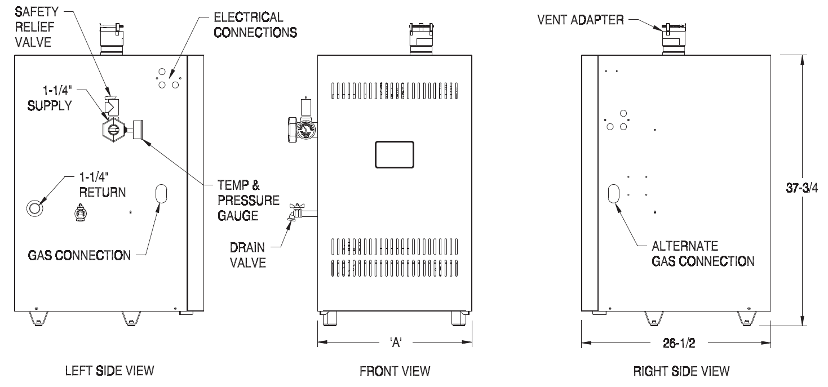
4.5 Fuel and Altitude Selection
- Boiler shall be shipped from the boiler manufacturer as a _________ (select either “natural gas-only model”, or “LP-gas-only model” consistent with models selected elsewhere in this specification.)
- If applicable, the boiler shall only be gas-converted with a correct manufacturer gas conversion kit installed per manufacturer instructions, therefore this boiler shall use the following gas conversion kit: ___________(Select a Gas Conversion Kit from the table below that corresponds to the boiler model and size specified in this document and the site altitude. (or enter “Not applicable” )).
Eight (8) gas conversion kits
- LP to Natural Gas, 3-6 section, 0-2000 feet
- LP to Natural Gas, 3-6 section, 2000-10,000 feet
- LP to Natural Gas, 7-8 section, 0-2000 feet
- LP to Natural Gas, 7-8 section, 2000-10,000 feet
- Natural Gas to LP, 3-6 section, 0-2000 feet
- Natural Gas to LP, 3-6 section, 2000-10,000 feet
- Natural Gas to LP, 7-8 section, 0-2000 feet
- Natural Gas to LP, 7-8 section, 2000-10,000 feet

4.5 Electrical, Wiring and Sensors
- Boiler shall be rated for 120 VAC, 60 hertz, 1- ph., less than 12 amperes.
- A separate electrical circuit shall be run from the main electrical service with an over-current device/disconnect in the circuit. A service switch is recommended and may be required by some local jurisdictions. This switch shall be located in accordance with local codes or, in the absence of any, in a location where it can be safely accessed in an emergency involving the boiler.
- All 120VAC connections to the boiler itself are made inside the junction box in the boiler vestibule.
- 120VAC connections shall be:
- Ground
- 120VAC Hot (Black)
- 120VAC Neutral (White)
- System Circulator Hot (Yellow)
- System Circulator Neutral (White)
- DHW Circulator Hot (Red)
- DHW Circulator Neutral (White)
- Low voltage Connections shall be:
- Heating Thermostat 1 (wired)
- Heating Thermostat 2 (wired)
- DHW/Zone 2 Thermostat 1
- DHW/Zone 2 Thermostat 2
- Aux Limit 1
- Aux Limit 2
- Aux Limit 3
- Enviracom 1
- Enviracom 2
- Enviracom 3
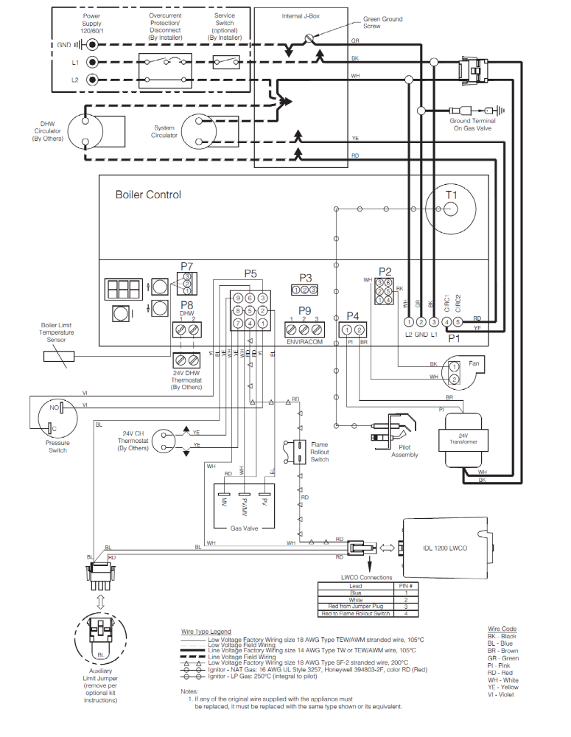
4.6 Control Operation, Capability and Functionality
The boiler controls shall comply with the operational and functional capabilities described on the following pages. 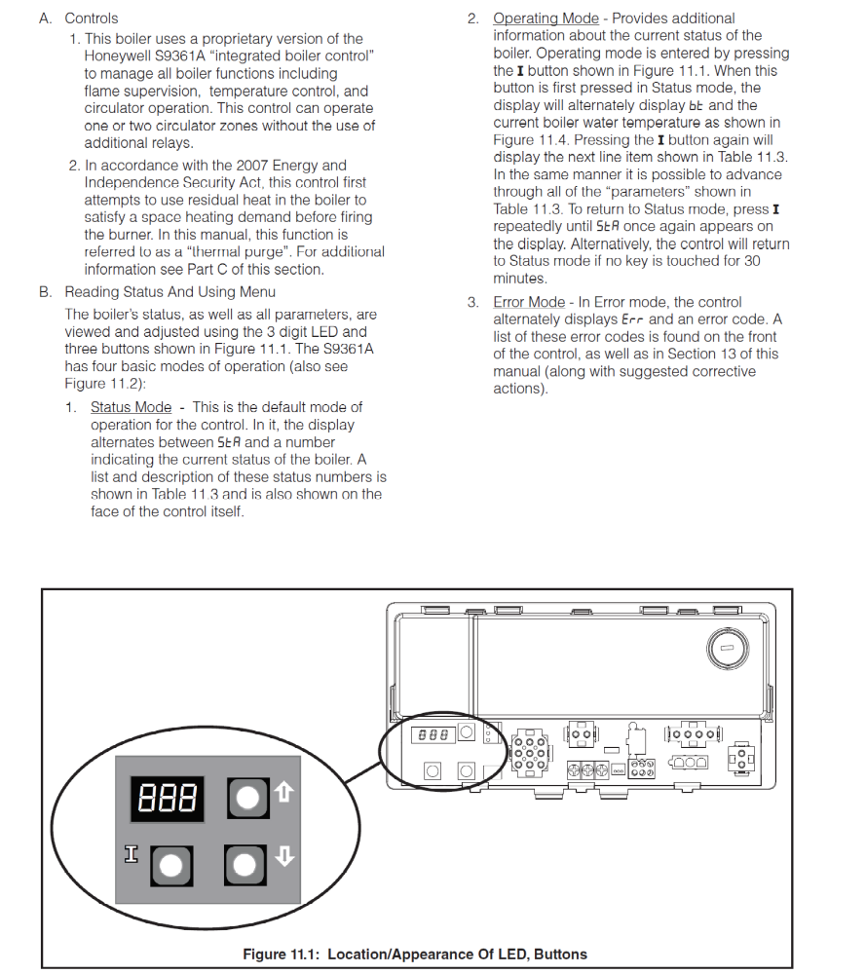
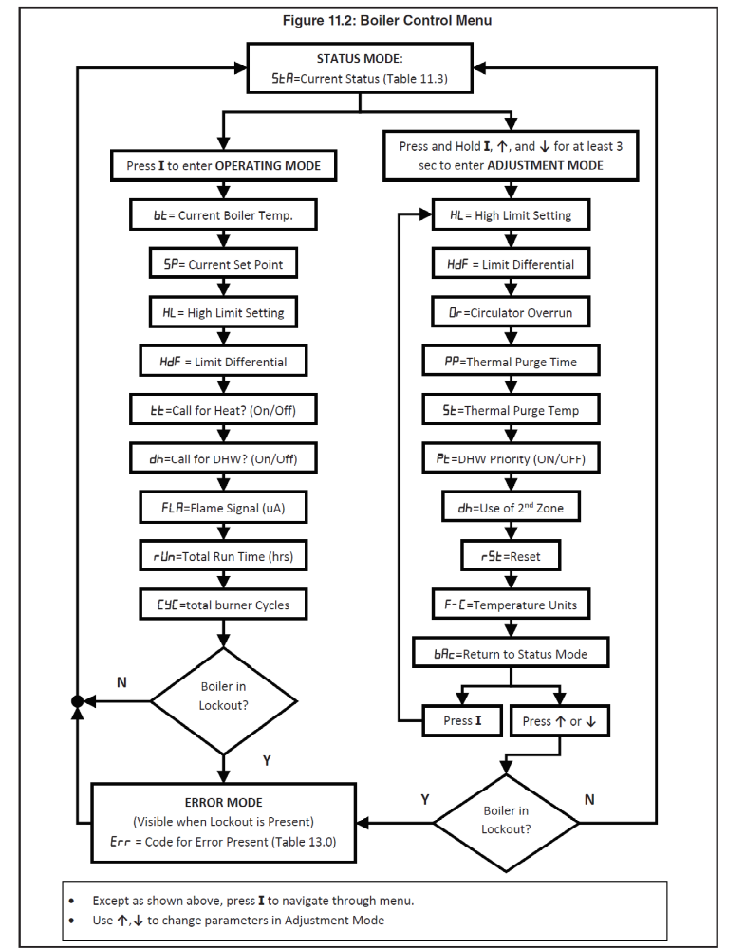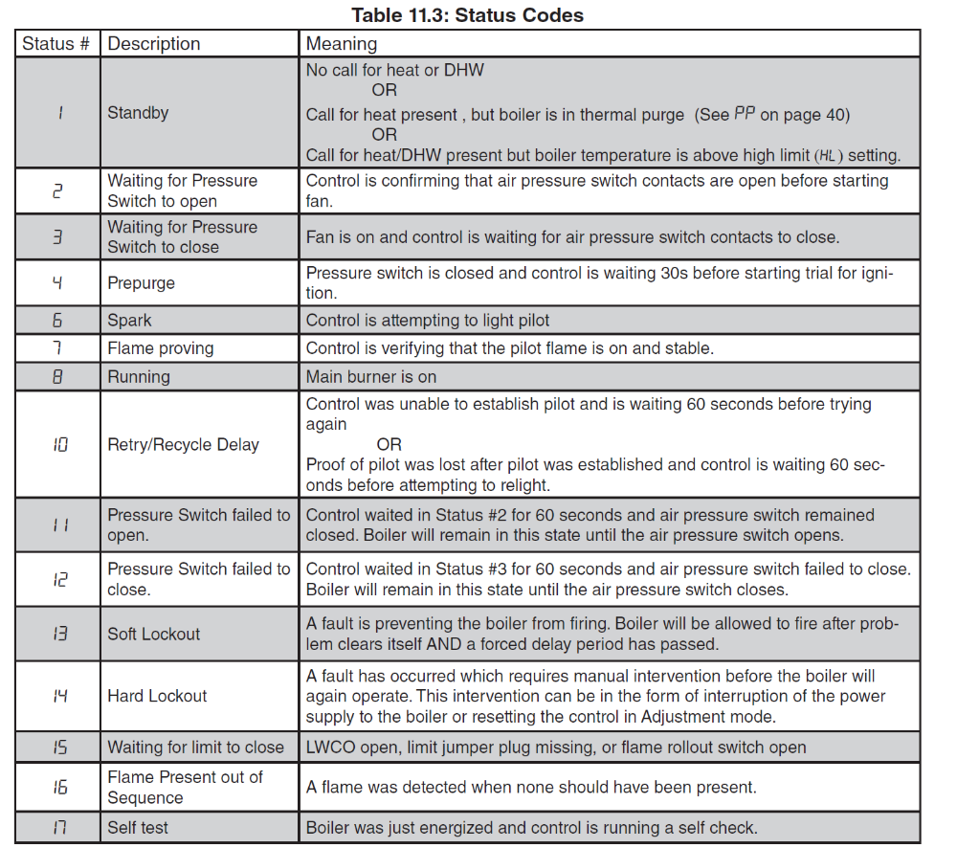

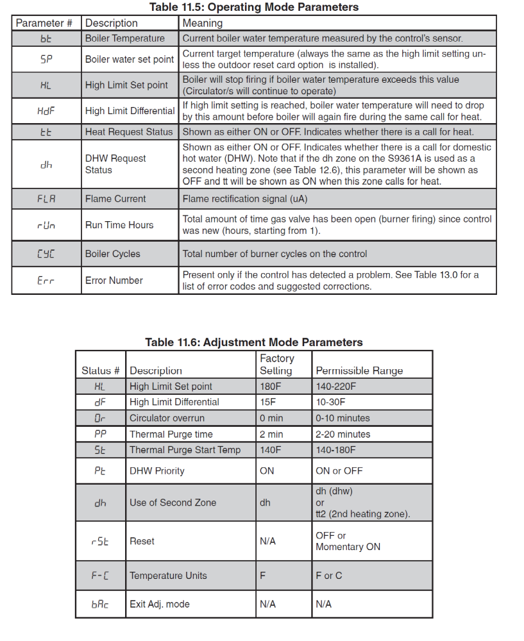
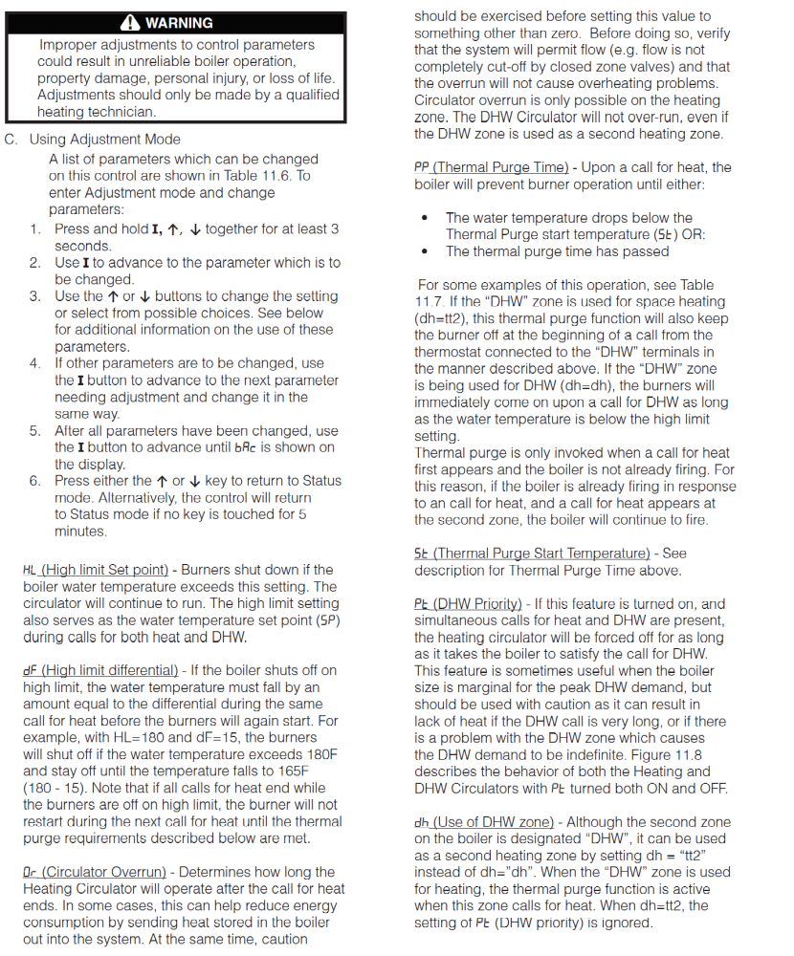

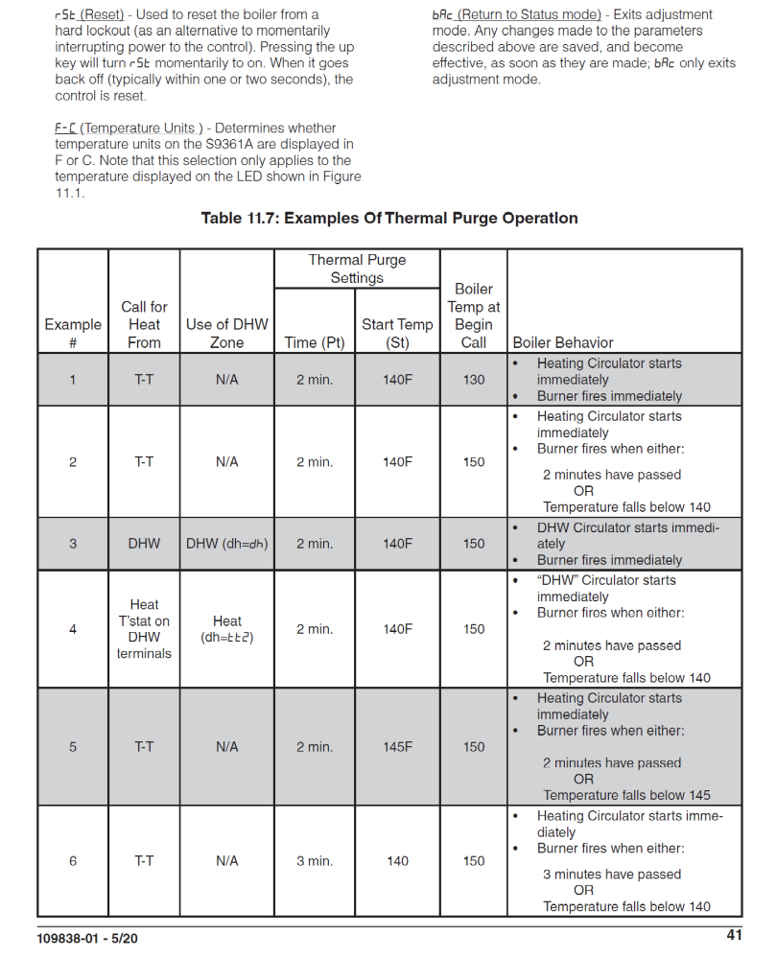

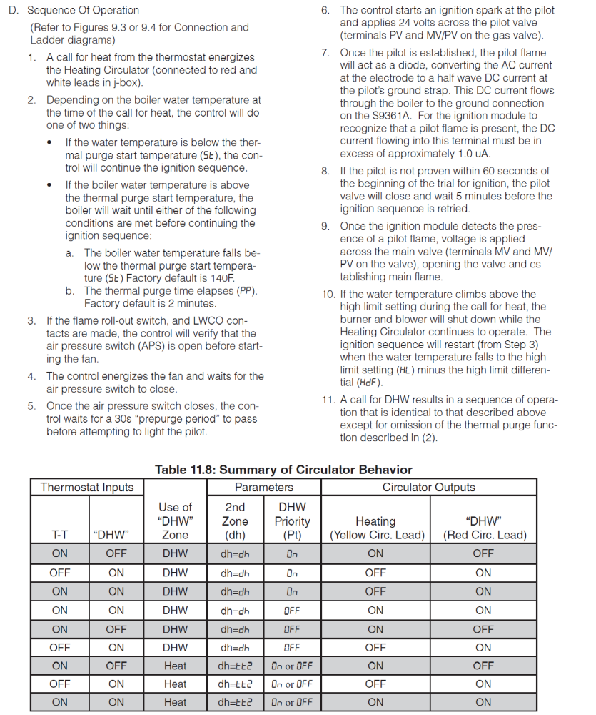

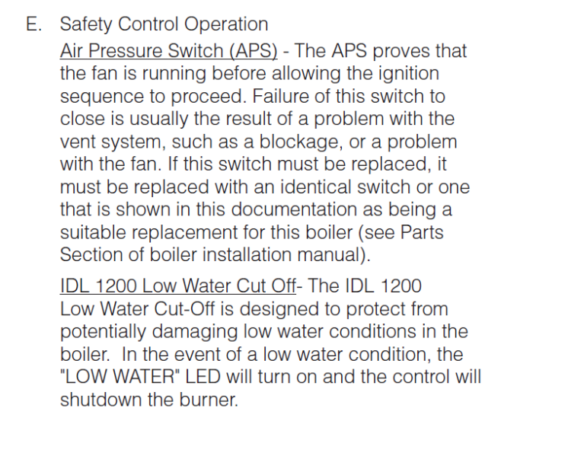

5-INSTALLATION
  - Installation Requirements
- Boiler and other specified equipment shall be expertly installed by a professional heating contractor.
- This boiler shall have an adequate source of clean combustion air in the boiler room. It shall be installed with one of the following two techniques to assure adequate combustion air unless the installer follows the exact instructions, limitations and restrictions for exceptions in the boiler manual: 1-Indoor Combustion Air shall be drawn into the boiler through the boiler room and other parts of the building and from outdoors through natural infiltration (cracks under doors, etc). This method cannot be used in all cases . 2-Direct Venting allowing combustion air to be pulled directly from outside the building with installer supplied PVC or galvanized air intake piping only by using the manufacturer’s Direct Vent Conversion Kit shown in Table 2.2 in section 4.4 of this specification.
- This boiler shall be vented using an approved vertical or horizontal AL29-4C stainless steel venting system, which is not included with the boiler.
- A boiler vent adaptor is included as a separate piece in the boiler crate and shall field-mounted to the fan outlet on the boiler using the stainless steel screws (included) as shown in the manufacturer instructions.
- Manufacturer-recommended clearances shall be maintained around and over equipment, and as required by local Code. Provide 1/2" clearance from water piping to combustible materials. (See Section 5.2)
- Boiler shall only be installed on a proper base surface. A level floor is required. A concrete base should be provided if a basement floor is not level or if water may accumulate on the floor around boiler. This heating appliance is listed for installation on combustible flooring, but it shall not be installed on carpeting.
- Installer shall never install boiler where gasoline or other flammable vapors or liquids are stored. Avoid areas near chemical products containing chlorine, chloride based salts, chloro/fluorocarbons, paint removers, cleaning solvent, and detergents.
- Boiler shall not be installed in an area where large amounts of airborne dust will be present, such as a workshop.
- Installer shall isolate and protect gas ignition system components from water (dripping, spraying, rain, etc.) during boiler operation and service (circulator replacement, condensate trap, control replacement, etc.).
- All 120VAC connections to the boiler itself are made inside the junction box in the boiler vestibule.
- The installer shall never jump out or bypass any safety or operating control or component of this boiler.
- All electrical conduit, piping, exhaust vent, and air intakes shall be installed with clearances for burner removal and service of all equipment.
- Boiler installation and startup shall comply with contract documents and boiler manufacturer's printed instructions.
- Installer shall install discharge piping from relief valves (open termination for viewing) and all drains to nearest floor drain while adhering to governing environmental requirements.
- Exhaust vent shall always be connected to boiler vent adaptor.
- Installer shall connect full size water piping to supply and return connections.
- All piping accessories shall be installed per the details on the contract drawings.
- Installer shall provide necessary water treatment to satisfy manufacturer’s specified water quality limits.
- Installer shall assemble and install a boiler bypass if the boiler is to be operated in a system which has a large volume or excessive radiation where low boiler water temperatures may be encountered. (i.e. converted gravity circulation system, etc.). U.S. Boiler system bypass kit with a Taco 007e circulator is item number 107795-01.

5.2 Connection Locations and Clearances
- The boiler shall connect at these locations with these clearances.

