Additional Information:
Cabin assignments are made according to date received; newest cabins are filled first.

__ I can sleep on an upper bunk.
__ I cannot use an upper bunk.
__ I wish to room with young adult women.
__ I wish to room with women from my congregation.
__ I wish to room with ________________.
__ This is my FIRST TIME at retreat.
__ I am registering my child/children for Weekend. (Separate registration required.)

Other special housing requests: ___________________________________________
__ I will be bringing a registered service animal
__ I am a nursing mother with a baby. (Please bring bed and all necessary supplies.)
Name and age of baby at time of retreat: ____________________________

*** Late registrants have no guarantee on room or bunk assignments. ***

Emergency information in case of serious illness or emergency:
Contact: ______________________________________________________
Relationship: ____________________ Phone: _________________

Allergies/ Special medical information: _________________________________________________________
_________________________________________________________

Mail registration and checks:
Christian Church in Kansas Online registration
2914 SW MacVicar www.kansasdisciples.org
Topeka, KS 66111 1-800-737-8130
*Registrations received after September 6th are transferable but not refundable. *

Faith That Overflows!

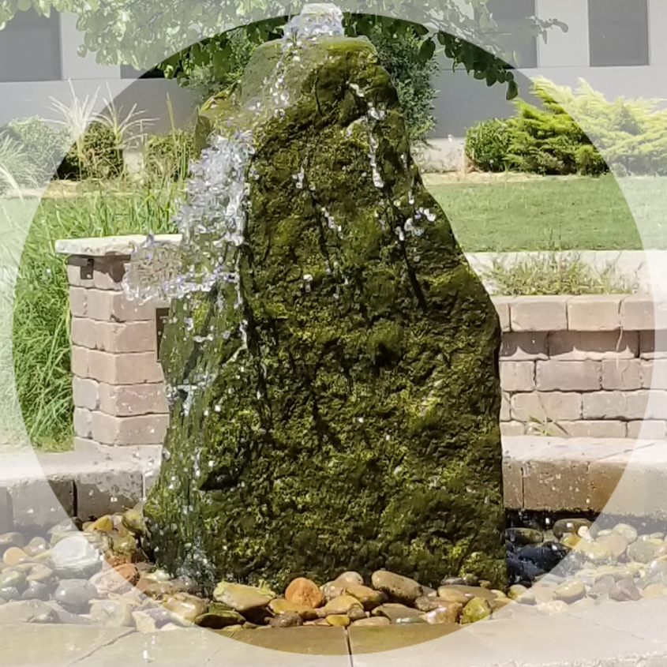

And the grace of our Lord overflowed to me, along with the faith and love that are in Christ Jesus.
~ 1 Timothy 1:14

Kansas Disciples Women Retreat
At the
Disciples Center at Tawakoni


October 2-4 and
4-6, 2019

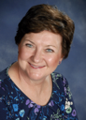
Our Speaker
Kirby Hughes
Gould

Kirby Gould serves as vice president for the North Central Zone of the Christian Church Foundation. She assists Disciples of Christ churches Kansas, Greater Kansas City, Mid-America, Upper Midwest, and Nebraska regions with endowments, permanent funds, investments, planned gifts, and bequests.
Kirby grew up in McPherson and was active in regional activities and youth leadership. She is a graduate of Phillips University with a degree in music therapy. She is a commissioned minister, and holds several certificates in the areas of fundraising, planned giving, and finance.
She and her husband John live in Olathe. Their older daughter Ginny and her husband Ben live in Denver and are the parents of their first grandchild, John, age 3. Daughter Katie has a career in Kansas City. John and Kirby are members of Hillcrest Christian Church in Overland Park where Kirby assists with outreach projects and mission trips, and occasionally sings with the church choir.

KDW Retreat Registration
October 2-4 (Midweek) October 4-6 (Weekend)
Name _______________________________________________
Address _____________________________________________
City ________________________ State _______ Zip ________
Email Address _________________________________________
Phone Number _________________________________________
Church Name/Town _____________________________________
I will attend: Midweek ____ or Weekend ____
___ Full Retreat: 2 nights/ 5 meals Wed-Fri or Fri-Sun
($85 includes meal on 1st night; received after Sept. 6th $100)
___ Partial Retreat: No lodging included
($50 includes 2 meals on Thurs or Sat; received after Sept. 6th $60)
Please include which meals you will be attending:
__ Breakfast __ Lunch __ Dinner
___ I want 1st night meal. (Add $8.50 to registration fee.)
___ I wish to join the Painting Workshop for an additional fee of $30.
(A minimum of 12 registrations must be received by September 6th for this workshop to be offered.)

Retreat registration table opens at 4pm on the first day of retreat.
First night meal is served from 5:30-6:30pm.
Opening session will begin at 7pm.

