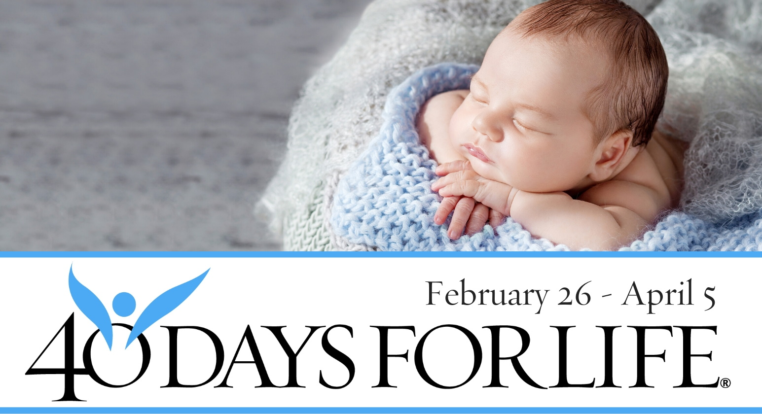

HELP SAVE LIVES IN SAN JOSE!

Here’s how to take part in 40 Days for Life in our community:
- Vigil location: Outside Planned Parenthood (1691 The Alameda)
- Vigil hours:7 am to 7 pm daily
- Local contact:Dzung (510) 938-2503 40dflsanjose@gmail.com
- Learn more … get involved … and sign up for prayer times by visiting our campaign at the web address shown below!
You can protect mothers and children by joining this worldwide mobilization to pray and fast for an end to abortion!
Through prayer and fasting, peaceful vigils and community outreach, 40 Days for Life has inspired 1,000,000 volunteers!
With God’s help, here are the proven results in 25 coordinated campaigns:
- 16,742 babies saved from abortion
- 196 abortion workers converted
- 104 abortion centers closed

40daysforlife.com/sanjose2

