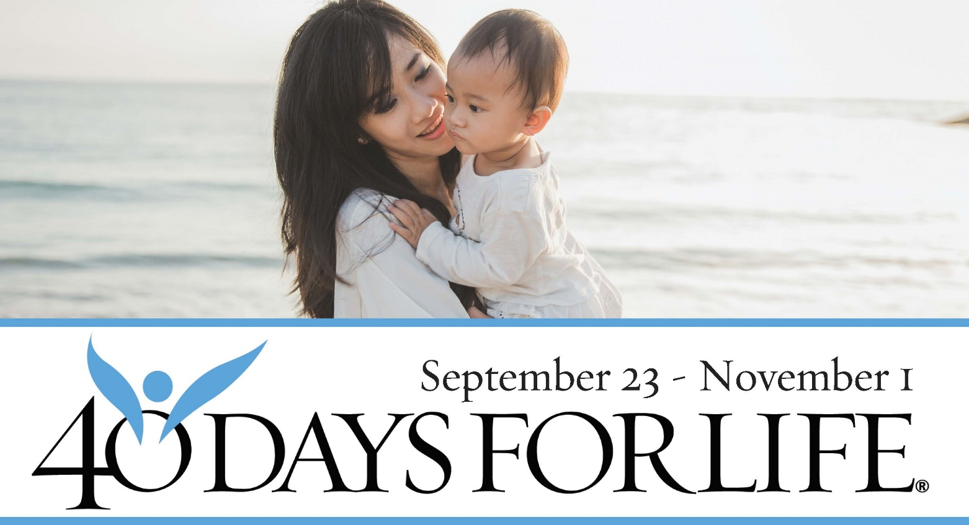

HELP SAVE LIVES IN LINCOLN, NE!

Here’s how to take part in 40 Days for Life in our community:
- Vigil location: Outside Planned Parenthood, (name of abortion center and street address, any pertinent info)
- Vigil hours: 6 am to 8 pm daily
- Local contact: Jeanne Kee, 402-413-9663
- Learn more … get involved … and sign up for prayer times by visiting our campaign at the web address shown below!
You can protect mothers and children by joining this worldwide mobilization to pray and fast for an end to abortion!
Through prayer and fasting, peaceful vigils and community outreach, 40 Days for Life has inspired 1,000,000+ volunteers!
With God’s help, here are the proven results in 26 coordinated campaigns:
- 17,226 babies saved from abortion
- 206 abortion workers converted
- 107 abortion centers closed

40daysforlife.com/Lincoln

