Dear 40 Days for Life Family,
Monday, Day 118, the 14th of June in Salem, according to the online SignUp Genius calendars: 2 hours were covered by 2 volunteers.
“Blessed is one who considers the helpless;
The Lord will save him on a day of trouble.
² The Lord will protect him and keep him alive,
And he will be called blessed upon the earth; (Psalm 41:1-2a NASB)
Please sign up for vigils! If you have a Signup Genius account, log in and sign up here. If not, register here or let me know (text to 503-480-9374), and I will email you an invitation for access.
Thank you, all of you who have been signing up and coming for prayer vigils! I think this summer is the best covered yet!
The prospect for Day 119, Tuesday, June 15, according to the calendars (W = woman, M = man). Planned Parenthood: MTh 9-4:30 | TuW 11-6:30 | F 8-3:30. SaSu CLOSED
7 am 0
8 am 0
9 am 0
10 am 1W
11 am (PP) 2W
12 pm (PP) 3W
1 pm (PP) 1W
2 pm (PP) 1W
3 pm (PP) 1W
4 pm (PP) 1W
5 pm (PP) 1W
6 pm (PP) 1W
9 of 12 hours covered. God bless your witness for life!

Live Action: First-ever pro-life men’s march to be held this weekend in Washington, DC

Live Action: TikTok influencer declares pro-life views to his 26 million followers

40 Days for Life Podcast: Fighting for Life with Lila Rose

Thomas More Society: Silenced Speech: David Daleiden’s update webcast recording.
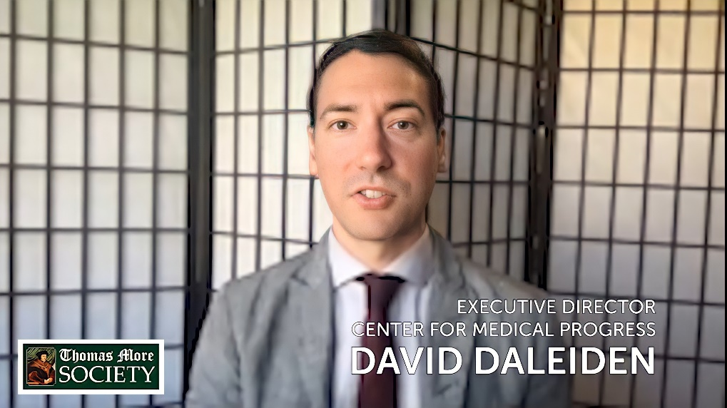

Life Chain: Life Chain Sunday is October 3, 2021, the day before the Supreme Court session begins. This session the Court will consider the Mississippi case that challenges and could overturn Roe v. Wade. URGENT: Marie Chinn reports a loss of significant funding which she has had in the past for her usual projects promoting Life Chain in the Salem area and beyond. The reduced funding would reduce an approximately 10,000 mailing to around 1,000. Please help! You may contact Marie at mchinn4life@gmail.com or (503) 999-9852

Sidewalk Advocates for Life: Train to become a sidewalk advocate by Lauren Muzyka, founder. Training in English and Spanish is available.
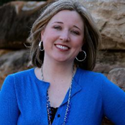

God bless you as you stand for the Little Ones and their parents!
Bob Snyder
Salem - Leader
bobwilli2@hotmail.com
This communication is generated by your local campaign coordinators. 40 Days for Life has not reviewed or contributed to this communication. If you have questions, comments, or concerns, please reply to this message or email bobwilli2@hotmail.com. You can also email 40 Days for Life HQ at: info@40daysforlife.com. If you would like to unsubscribe from receiving future emails click here, and write “unsubscribe” in the subject line.
40 Days for Life 4112 E 29th St. Bryan, Texas 77802 United States (888) LIFE-316

