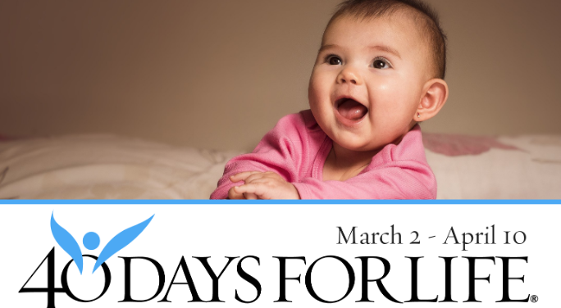

Help Save Lives In Cleveland, Painesville, Bedford Heights!

Here’s how to take part in 40 Days for Life:
- Vigil location: Preterm - 12000 Shaker Blvd - Cleveland-44120 Planned Parenthood - 25350 Rockside Road Bedford-44146 Family Planning -462 Chardon St. - Painesville-44077
- Vigil hours: 7 am – 7 pm daily at all sites
- Local contact: John Noall 216-245-9744 email: clevelandpraysforlife@gmail.com
- Learn more … get involved … and sign up for prayer times by visiting our campaigns at the web addresses shown below!

You can protect mothers and children by joining this worldwide mobilization to pray and fast for an end to abortion!
Through prayer and fasting, peaceful vigils and community outreach, 40 Days for Life has inspired 1,000,000+ volunteers!
With God’s help, here are the proven results in 26 coordinated campaigns:
- 20,689 babies saved from abortion
- 229 abortion workers converted
- 114 abortion centers closed

40daysforlife.com/cleveland
40daysforlife.com/painesville
40daysforlife.com/bedfordheights

