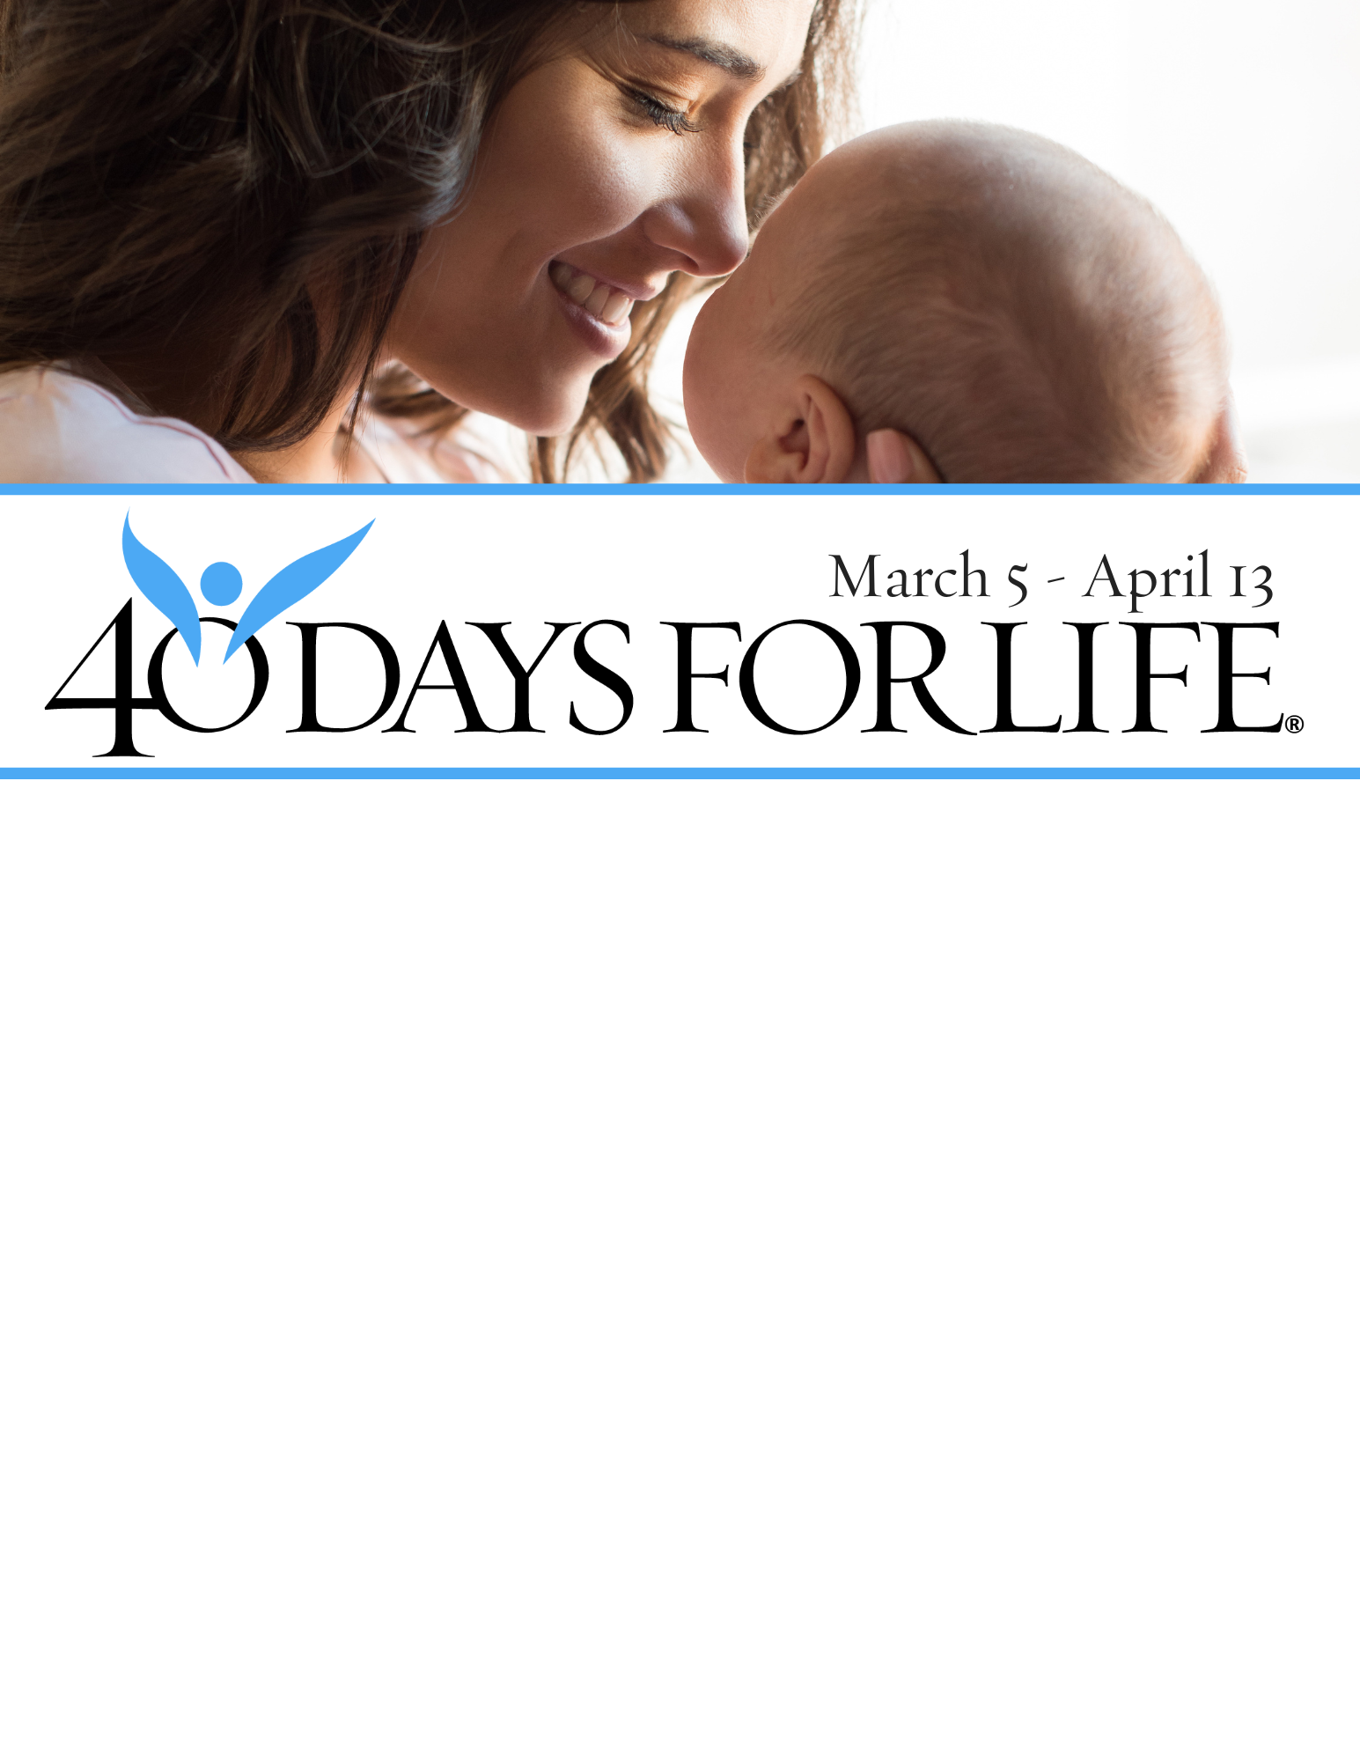

HELP SAVE LIVES IN REDDING!

You can protect mothers and children by joining this worldwide mobilization to pray and fast for an end to abortion!
Through prayer and fasting, peaceful vigils and community outreach, 40 Days for Life has inspired 1,000,000+ volunteers!
With God’s help, here are the proven results in 30 coordinated campaigns:
- Over 25,000 saved babies
- More than 150 closed facilities
- More than 250 converted workers
Here’s how to take part in 40 Days for Life in our community:
Vigil location: Public areas outside of Women’s Health Specialists, 1901 Victor Ave., Redding
Vigil hours: 7 am to 7 pm daily)
Local contact:
Paul Henke, , 530-870-4325
Redding40Days@yahoo.com,
Learn more … get involved … and sign up for prayer times by visiting our campaign at the web address shown below!

40daysforlife.com/Redding

