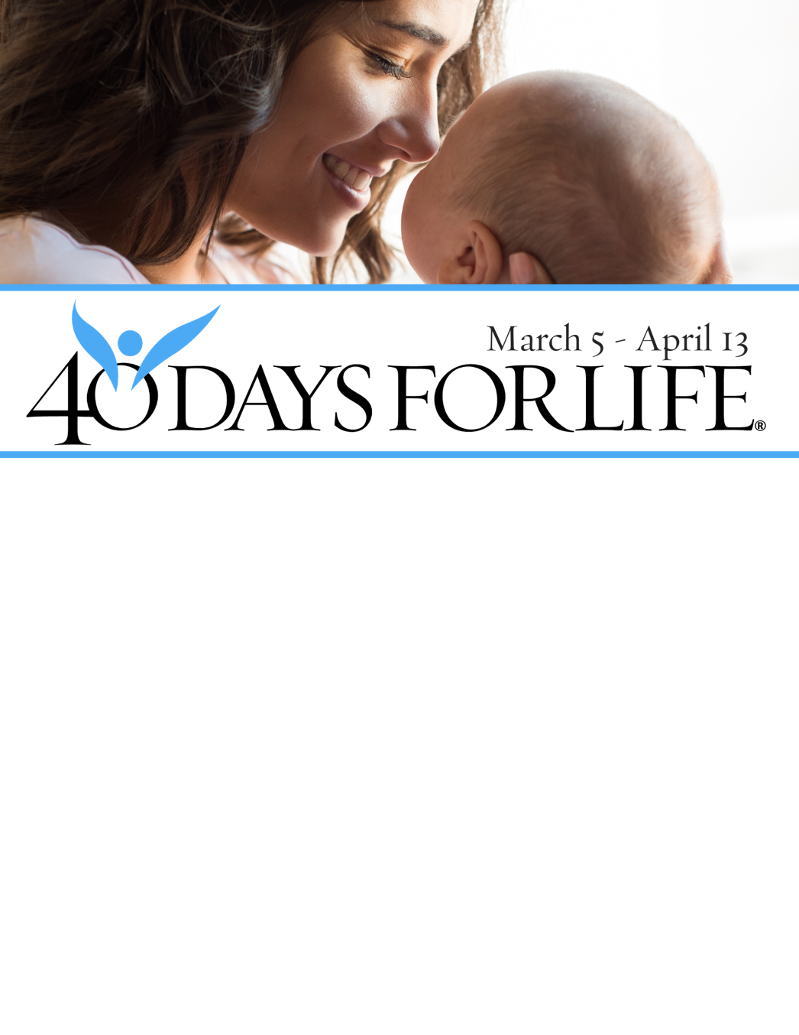

**HELP SAVE LIVES IN REDDING**

**You can protect mothers and children** by joining this worldwide mobilization! Through prayer and fasting, peaceful vigils and community outreach, 40 Days for Life has inspired 1,000,000+ volunteers!

**Here’s how to take part:**

* **Vigil location:** Public areas outside of Women’s Health Specialists, 1901 Victor Ave, Redding
* **Vigil hours:** 7 am to 7 pm daily
* **Local contact:** Paul Henke, 530-870-4325 Redding40Days@yahoo.com

**Learn more** and get involved by visiting our campaign:

**40daysforlife.com/Redding**

**HELP SAVE LIVES IN REDDING**

**You can protect mothers and children** by joining this worldwide mobilization! Through prayer and fasting, peaceful vigils and community outreach, 40 Days for Life has inspired 1,000,000+ volunteers!

**Here’s how to take part:**

* **Vigil location:** Public areas outside of Women’s Health Specialists, 1901 Victor Ave, Redding
* **Vigil hours:** 7 am to 7 pm daily
* **Local contact:** Paul Henke, 530-870-4325 Redding40Days@yahoo.com

**Learn more** and get involved by visiting our campaign:

**40daysforlife.com/Redding**