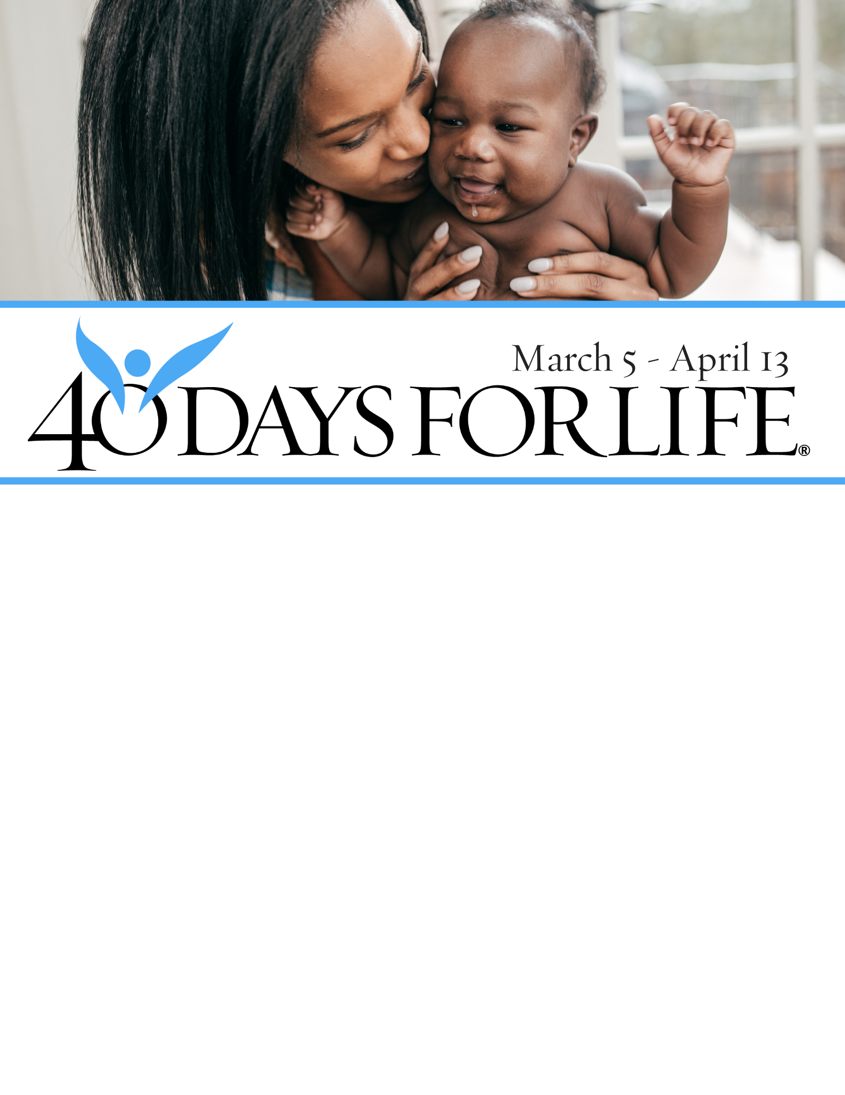

MARCH 5 - APRIL 13

**HELP SAVE LIVES IN THE BRONX!**

**You can protect mothers and children** by joining this worldwide mobilization to pray and fast for an end to abortion!

Through prayer and fasting, peaceful vigils and community outreach, 40 Days for Life has inspired 1,000,000+ volunteers!

**With God’s help,** here are the proven results in 30 coordinated campaigns:

* Over **20,000 babies** saved from abortion
* Over **200 abortion** workers converted
* Over **100 abortion** centers closed

**Here’s how to take part in 40 Days for Life in our community:**

**Vigil location:** Outside

Tower at Montefiore Medical Park

1695 EASTCHESTER ROAD

near Waters Place

**Vigil hours:** 7 am to 7 pm daily

**Local contact:** Cecile, 347-880-0138,

ebronx40daysforlife@gmail.com

**Learn more** … get involved … and sign up for prayer times by visiting our website at the web address shown below or call/email Cecile!

[**40daysforlife.com**](http://www.40daysforlife.com/cityname)**/Bronx**