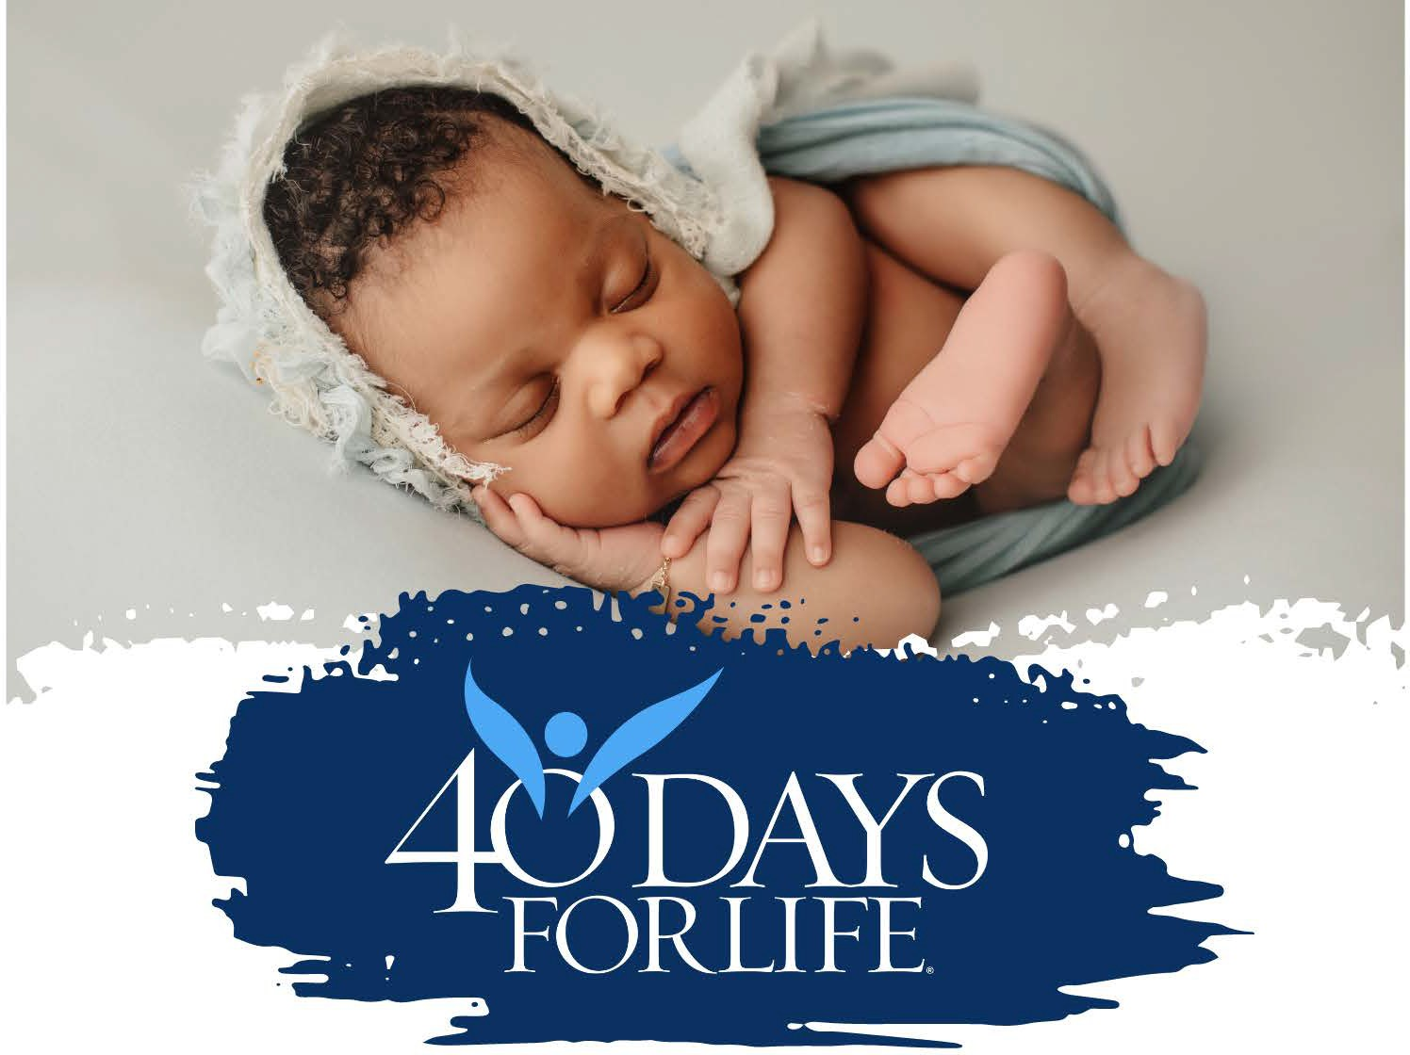

CHURCH OF THE HOLY ROSARY – NATIVITY OF OUR BLESSED LADY

**SUNDAY, MARCH 9, 2025**

**IN FATHER WINTERS HALL 2:30 – 3:30 PM**

**Join us for the kickoff of our spring 40 Days for Life campaign.**

**Fr. Pat Rossi will speak on “The Importance of Protecting Life”.**

**Come to pray and be informed.**

**BRONX KICK-OFF**