Well, that didn't take long! Shortly after this fall's 40 Days for Life vigil began yesterday morning, we received notification of the campaign's first saved baby!

Fort Lauderdale campaign leader Linda was wrapping up her prayer shift when she noticed a couple leaving the abortion facility.

"I observed them having an intense discussion right by the door," Linda said. "I prayed to the Holy Spirit to help them choose to keep their baby and to build a strong family."

Linda's prayer was answered by the unexpected arrival of a sidewalk counselor named Jonathan, who offered the couple encouragement and information about a local pregnancy resource center.

"They told him they were keeping the baby!" Linda exclaimed. "We celebrated the way God timed the opportunity for that couple to receive our help."
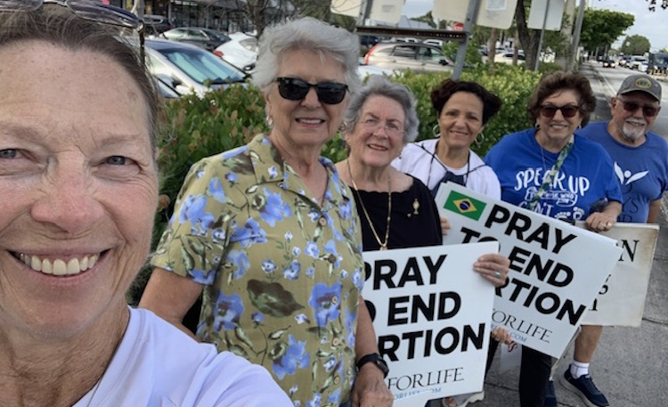
Reports of saved babies came in fast and furious yesterday...

...and, God willing, they'll continue to do so for the next 39 days!

You can save a life from abortion simply by showing up and asking the Lord to touch an abortion-bound mother's heart.

