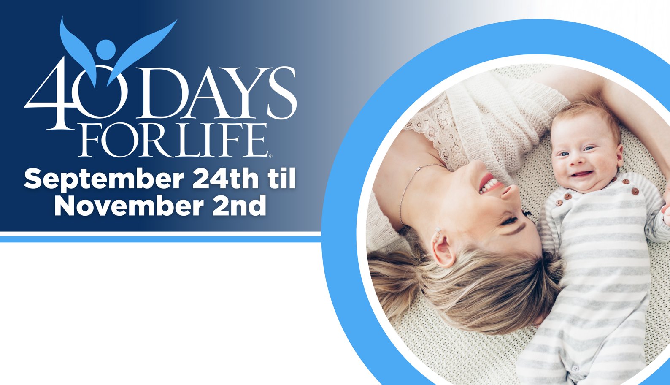

HELP SAVE LIVES IN CHAPEL HILL!
Here’s how to take part in 40 Days for Life in our community:
Vigil location: Public right-of-way outside Chapel Hill Planned Parenthood, 1765 Dobbins Drive, Chapel Hill 27514
Vigil hours: 7 am to 7 pm daily
Local contact: kathleen.m.siemer@gmail.com;
919-259-1209
Learn more … get involved … and sign up for prayer times by visiting our campaign at the web address shown below!
You can protect mothers and children by joining this worldwide mobilization to pray and fast for an end to abortion!
Through prayer and fasting, peaceful vigils and community outreach, 40 Days for Life has inspired 1,000,000+ volunteers!
With God’s help, here are the proven results in 30 coordinated campaigns:
- Over 25,000 saved babies
- More than 170 closed facilities
- More than 270 converted workers

40daysforlife.com/en/chapelhill

