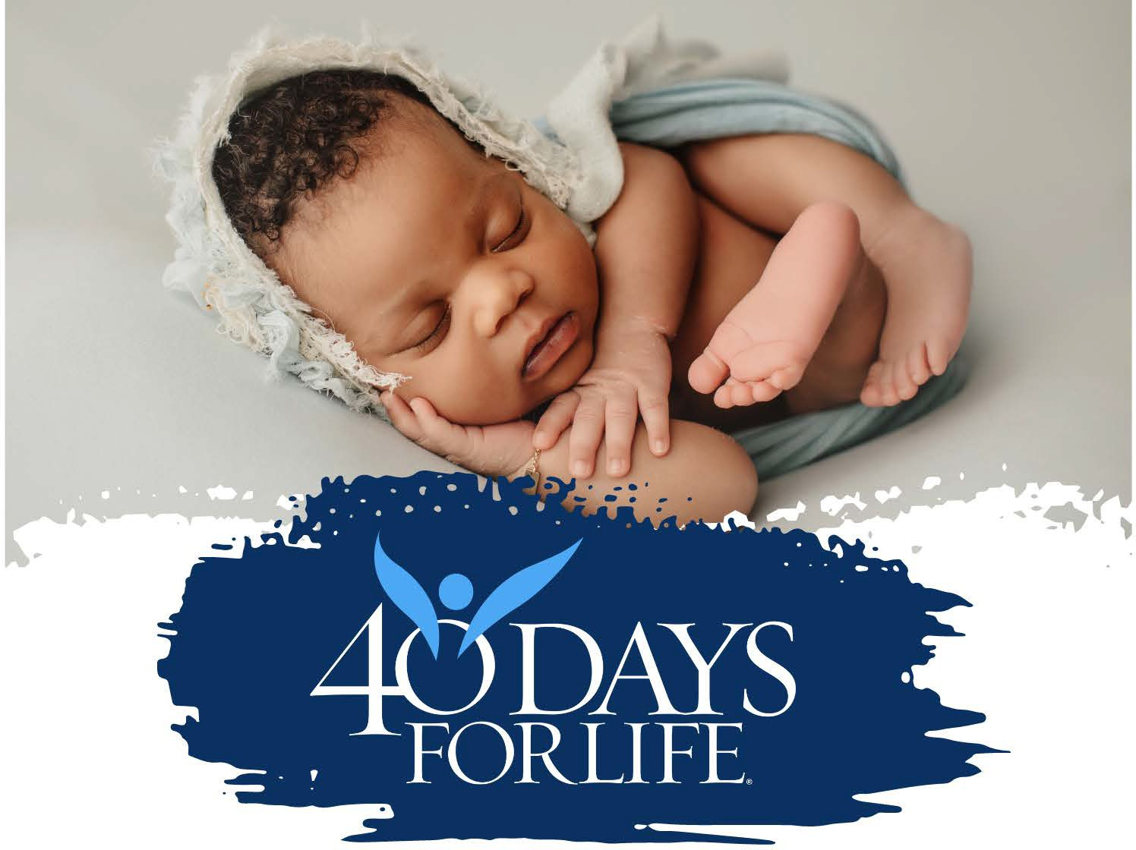
Jericho March
Wednesday Sept 24, 2025 at Noon

40 Days for Life Rally Event on Wednesday September 24th from 12 – 1 pm at Planned Parenthood located at 2226 E. Central.
Join us – All are welcome – volunteers, friends, and families.
We will walk in silent prayer six times around the building, down the alley and sidewalk along Central and on the seventh time – we will sing songs and finish the MARCH with prayers. Please plan to attend, even if you can’t walk the distance, bring a chair and you can be part of the event.
Questions – Call 316-617-5660

