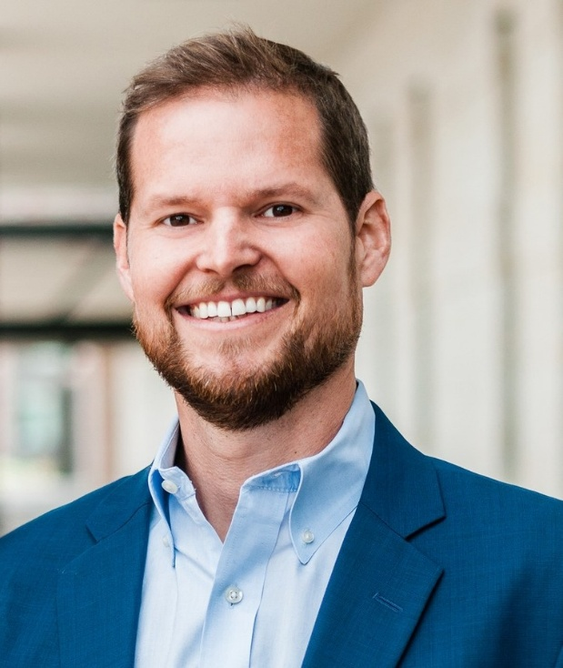

Shawn Carney is coming to Ft. Pierce!

2025 Fall Vigil Campaign Kick-off Event:
Location: St. Anastasia Catholic Church Parish Hall. 407 South 33rd Street, Fort Pierce, FL 34947
Time: Event starts at 6pm. Shawn Carney to speak at 6:30pm
Local contact: Campaign Leader: Mike Semanie (semaniequartet@whidbey.com)
Learn more … get involved … and sign up for prayer times by visiting our campaign at the web address shown below!
Shawn Carney, president and CEO of 40 Days for Life is coming to Ft. Pierce!
Shawn Carney will be our guest speaker at the upcoming 2025 Fall Vigil Campaign Kick-off event on Monday, September 22nd, 2025
Light refreshments will be provided by St. Anastasia Catholic parish
2025 Fall Vigil Campaign sign-up sheets will be available for everyone to sign up for one-hour prayer vigils
Additional materials will also be available at the sigh-up table

http://40daysforlife.com/fortpierce

