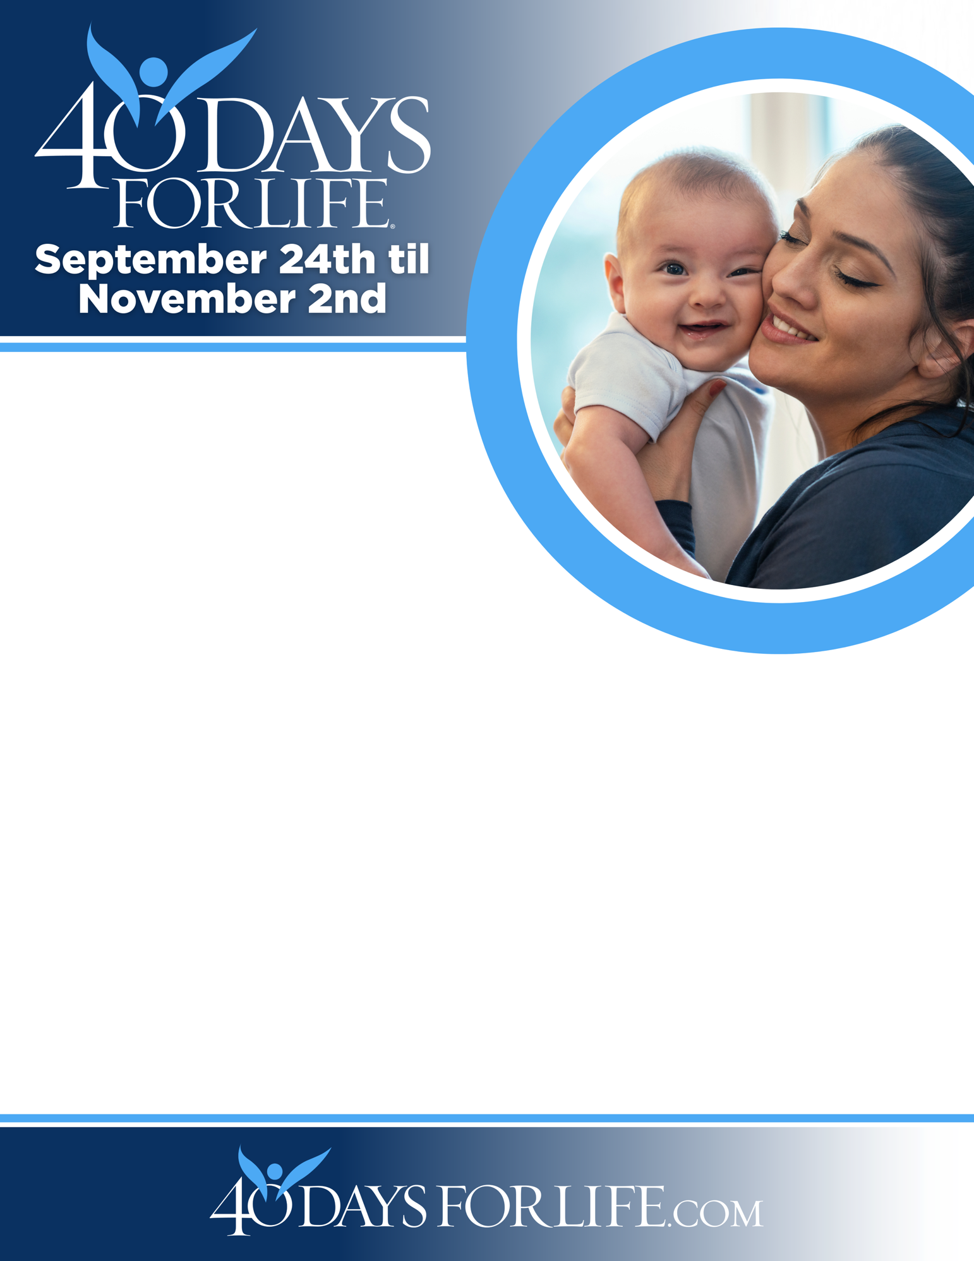

HELP SAVE LIVES IN SAN ANTONIO!

You can protect mothers and children by joining this worldwide mobilization to pray and fast for an end to abortion!
Through prayer and fasting, peaceful vigils and community outreach, 40 Days for Life has inspired 1,000,000+ volunteers!
With God’s help, here are the proven results in 30 coordinated campaigns:
- Over 25,000 saved babies
- More than 170 closed facilities
- More than 270 converted workers
Here’s how to take part in 40 Days for Life in our community:
Vigil location: Outside Planned Parenthood 2140 Babcock Rd
Vigil hours: 7am -7pm Mon - Sat
Local contact: Cindi Serna 210-410-9424 cindi@sacfl.org
Learn more … get involved … and sign up for prayer times by visiting our campaign at the web address shown below!

40daysforlife.com/sanantonio

