

**September 24 to November 2, 2025**

**HELP SAVE LIVES IN ANNAPOLIS!**

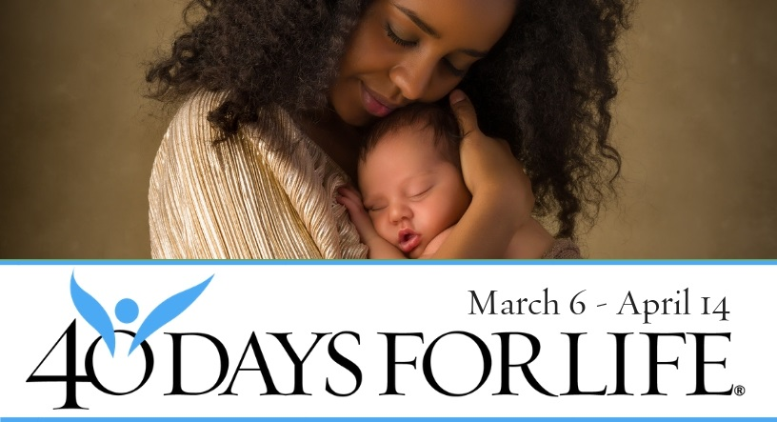

**You can protect mothers and babies**! Mothers entering abortion clinics respond to peaceful, prayerful vigils with positive signs offering help, hope, and life for their pre-born baby.

**With God’s help**, 40 Days for Life prayer vigils and fasting saved over 25,500 babies from abortion, encouraged over 270 abortion workers to quit, and closed over 170 abortion centers.

**How To Participate in 40 Days for Life in Our Community**

**•** Vigil location: Planned Parenthood, 929 West St., Annapolis

• Primary vigil hours: Mon 10AM to 7 PM; Tues-Fri 8 AM to 5 PM

but participants may also stand 7AM to 7PM daily.

* For more information or to sign up: see your church/organization notices or go to [www.40daysforlife.com/en/annapolis](http://www.40daysforlife.com/en/annapolis) .

• Local contact: see your church/organization vigil coordinator or contact [annapolisvigil@gmail.com](mailto:annapolisvigil@gmail.com).

**Pray at the vigil just one time or 1 hour per week.**

***Be A Voice For The Voiceless And Save A Life!***