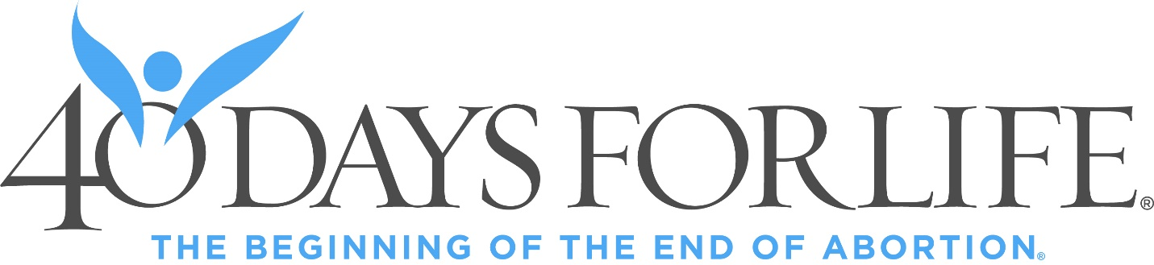

Come celebrate what God has done with our 40 days of faithful prayers and fasting.

Singing, stories from the sidewalk, and prayer.

Please bring a donation for the Women’s Care Center if you are able.

Closing Celebration
Nov 2nd at 1:30 pm
Red River Women’s Clinic, 302 Highway 75 in Moorhead.

