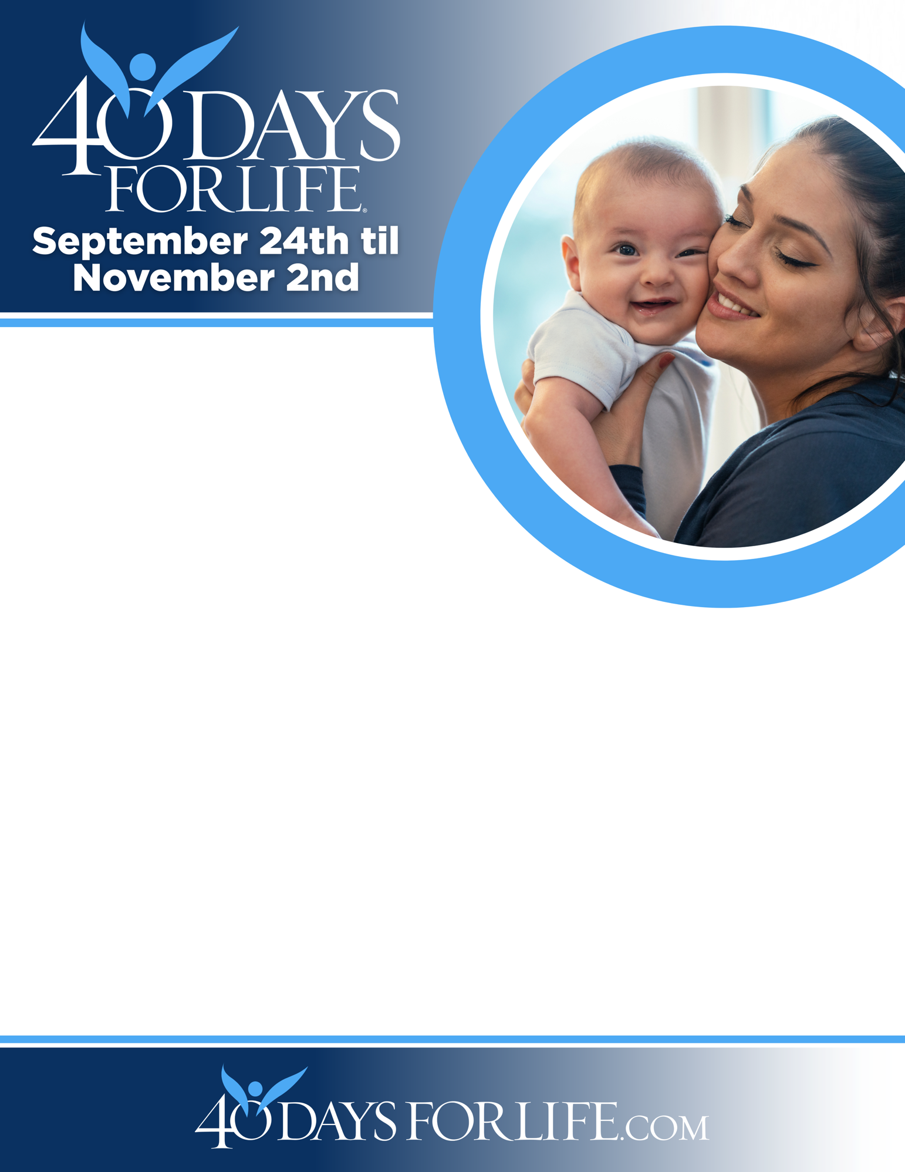

HELP SAVE LIVES IN Prince George’s County, MD!
You can protect mothers and children by joining this worldwide mobilization to pray and fast for an end to abortion!
Through prayer and fasting, peaceful vigils and community outreach, 40 Days for Life has inspired 1,000,000+ volunteers!
With God’s help, here are the proven results in 30 coordinated campaigns:
- Over 25,000 saved babies
- More than 170 closed facilities
- More than 270 converted workers
Here’s how to take part in 40 Days for Life in our community:
Vigil location: Metropolitan Family Planning; 5915 Greenbelt Road, Berwyn Heights, MD
Vigil hours: 7 am to 9 pm daily
Local contact: Robert Goldschmidt rgold.40daysforlife@yahoo.com
Learn more … get involved … and sign up for prayer times by visiting our campaign at the web address shown below!

40daysforlife.com/berwynheights

