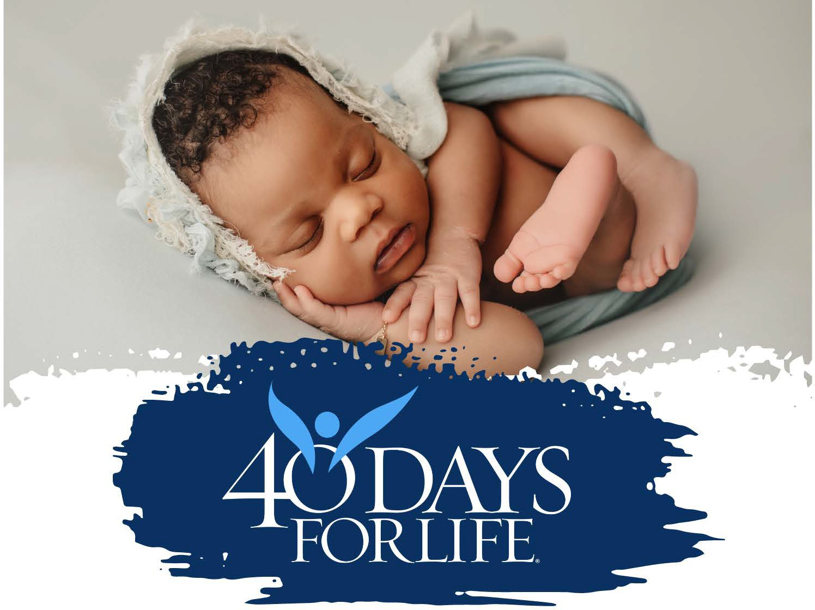
OPENING EVENT : CALLING THE HOLY SPIRIT
Wednesday February 18th at 1230 pm
40 Days for Life Rally Event
Wednesday February 18th from 1230 pm
at Planned Parenthood located at 2212 E. Central Avenue, Wichita
Join us – All are welcome – volunteers, friends, and families.
We will pray for the Holy Spirit to join us during these 40 days.
Let us be filled with the fruits of the Holy Spirit.
Praying for the protection of the unborn and an end to abortion.
Questions – Call 316-617-5660

