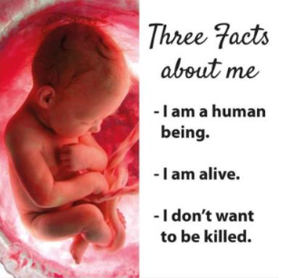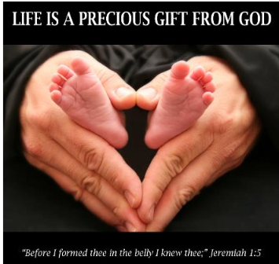
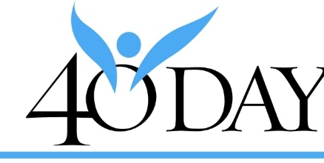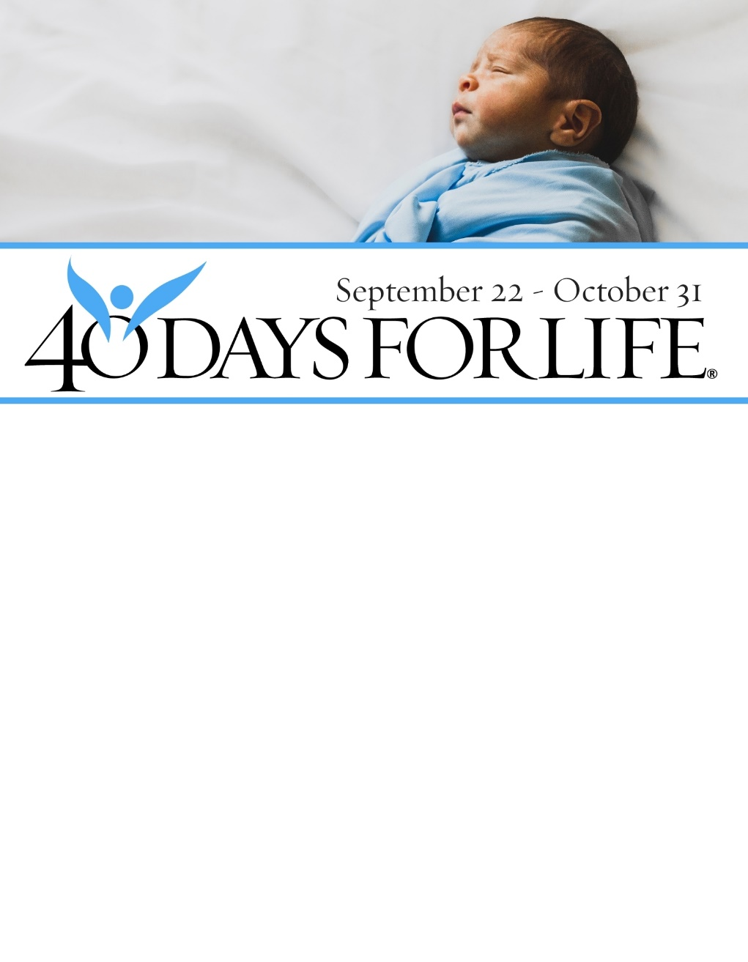

HELPS TO SAVE LIVES IN WHITEFISH!

Through prayer and fasting, peaceful prayer vigils, and community outreach, and
with God’s help, here are the proven results from 37 coordinated campaigns:
- 26,144 babies saved from abortion
- 275 abortion workers quit
- 184 abortion centers closed
PRAYER VIGIL
Dates: Wednesday, February 18th through Saturday, March 28th
Days: Monday – Saturday
Times: 7am – 7pm
Location: Sidewalk outside All Families Healthcare abortion facility,
737 Spokane Avenue, Whitefish
Parking: While driving north on Spokane Avenue, turn right (east) at 8th St.
and drive one block to Kalispell Ave.
During the winter months, park on the even-numbered
(west side) of the street on even-numbered days;
park on the odd-numbered (east side) on odd-numbered days.
Weekly Prayer Services will be held on Saturdays at the vigil site from 3-5 pm.
Point of Contact: Mike Hanson at (406) 314-7826 or mikester55@hotmail.com.

Visit our website at:
40daysforlife.com/whitefish

