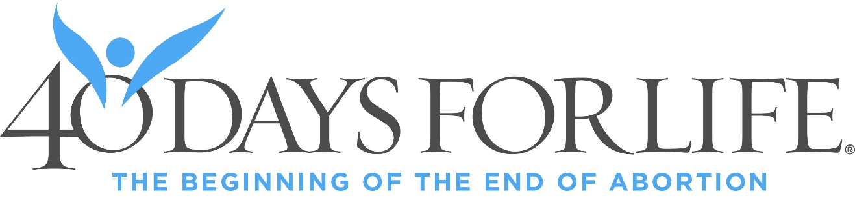

From February 18 – March 29 you are invited to join with other Christians for 40 Days for Life – 40 days of prayer and fasting for an end to abortion. Additionally, you are invited to stand and peacefully pray anytime between 7am to 7pm during the 40-day vigil in the public right-of-way outside Preterm - 12000 Shaker Blvd, Cleveland, 44120 or Planned Parenthood - 25350 Rockside Rd, Bedford Hts, 44146, or Signature Health – 54 South State St, Painesville, 44077.
Join us at the Kickoff Rally at St. Anthony of Padua Church Gym on Sunday, February 15, at 2pm, 6750 State Road, Parma, 44134. The speaker is Peter Range, Senior Fellow for Startegic Initiatives, from the Center for Christian Virtue.
Contact John Noall @ clevelandpraysforlife@gmail.com or 216-245-9744 for more information.
WEBSITES:
www.40daysforlife.com/cleveland
www.40daysforlife.com/painesville
www.40daysforlife.com/bedfordheights

Please publish in Bulletin weeks of January 31, February 8, 15

Thank you - John Noall - Campaign Director - 40 Days for Life
Cleveland – Painesville – Bedford Hts

