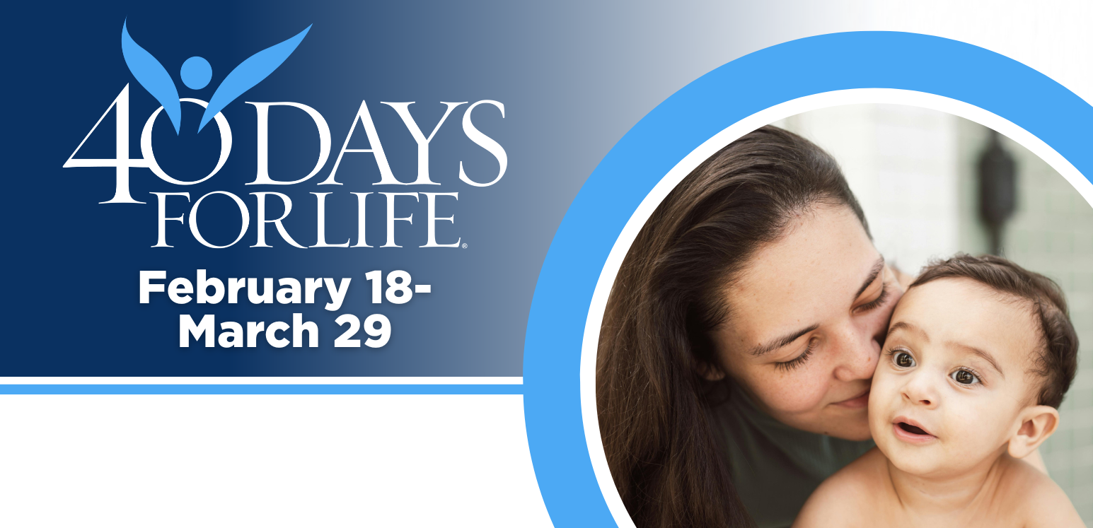

HELP SAVE LIVES IN EDMONTON!

You can protect mothers and children by joining this worldwide mobilization to pray and fast for an end to abortion!
Through prayer and fasting, peaceful vigils and community outreach, 40 Days for Life has inspired 1,000,000+ volunteers!
With God’s help, here are the proven results in 30 coordinated campaigns:
- Over 26,000 saved babies
- More than 180 closed facilities
- More than 275 converted workers

Here’s how to take part in 40 Days for Life in our community:
Vigil location: 50 m from Woman’s Health Options (12409 109A Ave., Edmonton) – see access zone map on website
Vigil hours: 7 am to 7 pm daily
Local contact: Edmonton Prolife, 780-425-1637, info@edmontonprolife.org
Learn more … get involved … and sign up for prayer times by visiting our campaign at the web address shown below!

40daysforlife.com/edmonton

