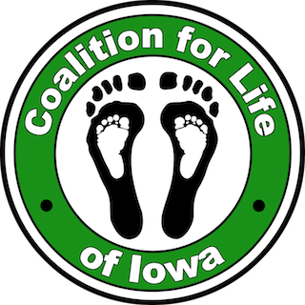
PRAYER VIGIL
^{Guidelines for Participants}

The Coalition for Life of Iowa (CFLI) joins our community together (through 40 Days for Life) to support the end of abortion through prayer vigils outside the Cedar Rapids Planned Parenthood (PP) site at 3425 First Avenue SE. Our spring and fall vigils run from 7am-7pm.

PP’s Hours of Operation: The Cedar Rapids physical location site has been closed due to federal funding cuts. They remain open for business through tele-health and continue to offer abortions in Des Moines and Iowa City. We will continue praying on the sidewalk until the CR building is sold.

Days for Life Prayer Vigil Dates
2026: Feb 18 – Mar 29 & Sept 23 – Nov 1

Statement of Peace
All those on the sidewalk are asked to sign a Statement of Peace and to sign up on the calendar at https://www.40daysforlife.com/en/cedarrapids
This ensures legal protection should anything arise and establishes that we are committed to being a peaceful and prayerful presence.

Can’t Pray Onsite?
Prayer and fasting support the effort to end abortion. Anyone can participate. Most people come pray weekly. If you cannot pray at the vigil site, you can pray and/or fast wherever you are – at home, at church, while driving, alone, with family, or with others.

Weather
Dress appropriately and bring gear for any weather: rain, snow, hot, or cold, based on the forecast for the time you plan to be there. The vigil continues regardless of weather, since evil never takes a break. If weather makes it unsafe or impractical to pray outside, you may pray, warm up, or dry off in your car. Carpet squares can insulate and keep your feet warmer.

Safety
We keep the police aware of our activities.
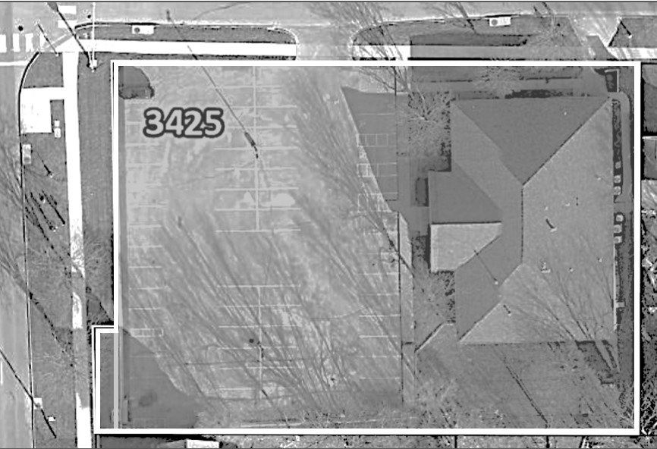
- Bring a cell phone: At least one onsite at all times. In case of an emergency, call 911. Camera is useful for some concerns. Notify us of big developments. Legal guardians must accompany minors
- NEVER BE THERE ALONE!
- Always have at least 1 adult with you. Can’t make your time slot? Try to find a replacement person. Notify a Prayer Vigil Leader
- No one else shows up? Pray within your vehicle You may pray elsewhere (home). Notify a Prayer Vigil Leader

Where to Park & Stand
Parking restrictions:
- Park along 35th, 34th St. Dr. or Elm Ave SE
- Avoid PP’s lot, other lots, & any driveway
City zoning confirmed where we can stand.
- Only stand on public property, along 1st Ave and 35th St Dr SE, Public sidewalks to the curb, Not the private one nearest PP, map shows property line in white
- Let Drivers See (safety/visibility), Don’t linger < 30 ft. of the intersection
- Avoid private/business properties
- Don’t block traffic/pedestrian flow, traffic, driveways, or sidewalks

1/3/2026
What about posters/signs?
We go onsite to offer hope. Our peaceful vigil shows women that we are NOT critical, nor judgmental. We want what is best for them.
- Adds Visibility (Good)
- Positive and Not Graphic
- Hold the signs while on public property • Don’t place into or on ground
- Don’t attach to anything you don’t own

Prayer
The Prayer Vigil’s objectives include asking God’s forgiveness for the sins of abortion, infanticide, and euthanasia, and seeking God’s grace to turn hearts and souls from the culture of death to the culture of life. We pray for:
- Mother, father, & family of unborn children
- All staff at PP and the abortion industry
- People who pass by
- The end of abortion, especially locally
We pray for a conversion of hearts and minds, and that people learn the truth. The truth will set them free.
Upon arriving at the vigil, show up a little early and take time to pray with anyone about to leave. We encourage reciting the following prayers at the prayer vigil: 40 Days for Life devotional, Scripture, personal prayers of your choice, the Our Father, the Rosary, the Divine Mercy Chaplet, the Prayer to St. Michael, the Memorare, or the Litany to the Blessed Virgin. You may also encourage each other and share your faith with one another.

Thank you!
May God bless you for taking time out of your busy lives to pray in support of the
unborn and in opposition to abortion.

Attitude
Your attitude leaves a more lasting impression than even your most brilliant pro-life arguments.
- Be prayerful
- Be in control; stay calm
- Be nonviolent in thought, action, & word
- Be truthful, yet compassionate, Eph. 4:15: “Let us profess the truth in love.”
- Be open to talking to PP staff; don’t taunt
- Be gentle
- Be willing to sacrifice (bad weather, etc.)
- Be yourself and let God lead

Keep in mind the words of Jesus, Mt. 5:11-12: “Blest are you when they insult you and persecute you and utter every kind of slander against you because of Me. Be glad and rejoice, for your reward is great in heaven.”

What to Say and NOT Say
We are here in a peaceful, prayerful presence. Avoid loud/abusive language, force, and violence. You may talk to anyone or hand prolife materials to willing recipients.
People may judge us by your actions and attitude. Make sure you state that what you say are your views, and not those of CFLI or 40 Days for Life. Always refer the media to us by saying, “I am not an official spokesperson, but you may contact the Coalition for Life of Iowa for answers.” Our email address is: coalitionforlife@gmail.com
Our goal is to make abortion “unthinkable” by providing education and resources to mothers and families in need.
If you are not comfortable talking with those who ask questions, you may decline a conversation and may always contact a Prayer Vigil Leader for support.

1/3/2026

