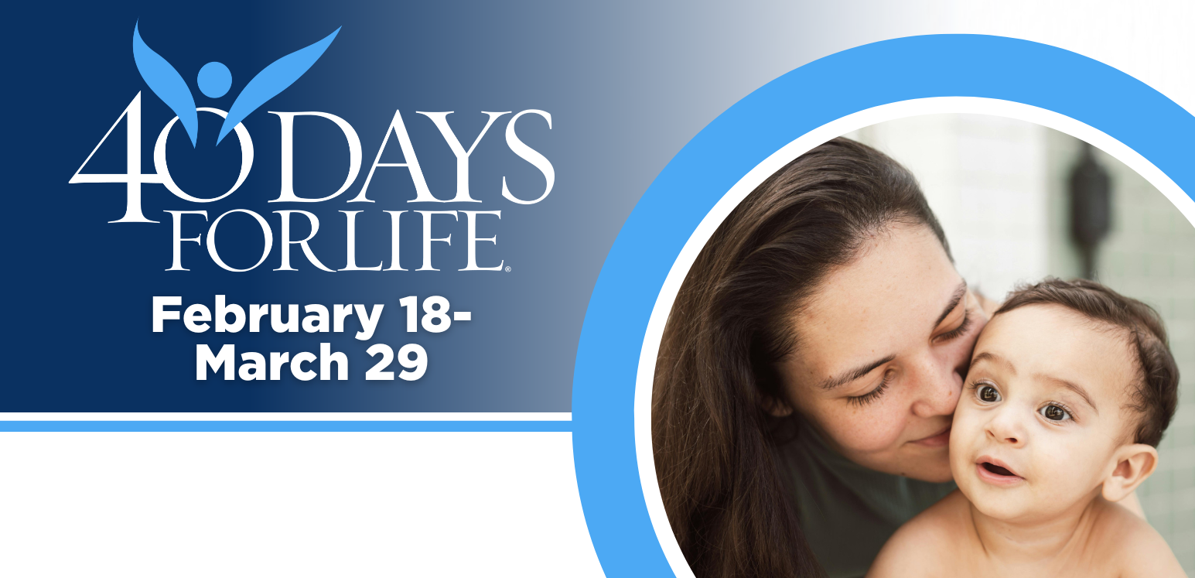

HELP SAVE LIVES IN REDDING!

You can protect mothers and children by joining this worldwide mobilization to pray and fast for an end to abortion!
Through prayer and fasting, peaceful vigils and community outreach, 40 Days for Life has inspired 1,000,000+ volunteers!
With God’s help, here are the proven results in 30 coordinated campaigns:
- Over 26,000 saved babies
- More than 180 closed facilities
- More than 275 converted workers

Here’s how to take part in 40 Days for Life in our community:
Vigil location: Outside Women’s Health Specialists, 1901 Victor Ave., Redding.
Vigil hours: 7 am to 7 pm daily
Local contact: Paul Henke, Redding40Days@yahoo.com, 530-870-4325
Learn more … get involved … and sign up for prayer times by visiting our campaign at the web address shown below!

40daysforlife.com/Redding

