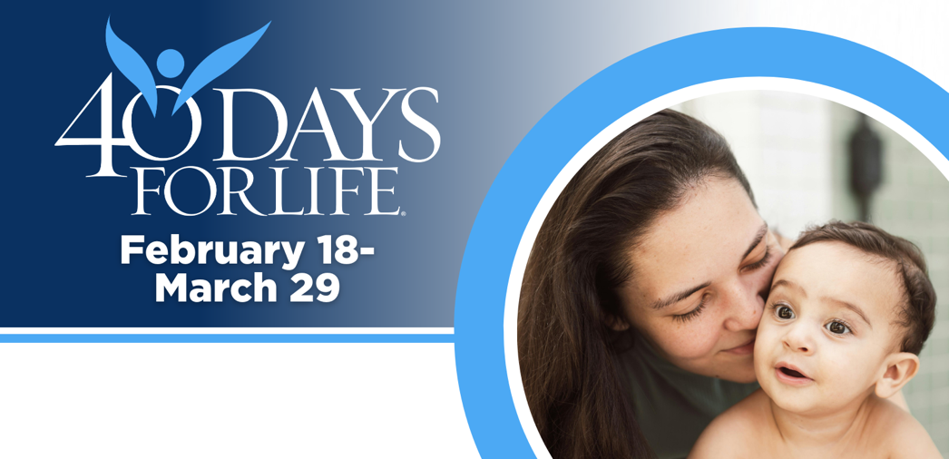

HELP SAVE LIVES IN REDDING
You can protect mothers and children by joining this worldwide mobilization! Through prayer and fasting, peaceful vigils and community outreach, 40 Days for Life has inspired 1,000,000+ volunteers!
Here’s how to take part:
- Vigil location: Outside Women’s Health Specialists, 1901 Victor Ave., Redding
- Vigil hours: 7 am to 7 pm daily
- Local contact: Paul Henke, Redding40Days@yahoo.com, 530-870-4325
Learn more and get involved by visiting our campaign:

40daysforlife.com/Redding

HELP SAVE LIVES IN REDDING
You can protect mothers and children by joining this worldwide mobilization! Through prayer and fasting, peaceful vigils and community outreach, 40 Days for Life has inspired 1,000,000+ volunteers!
Here’s how to take part:
- Vigil location: Outside Women’s Health Specialists, 1901 Victor Ave., Redding
- Vigil hours: 7 am to 7 pm daily
- Local contact: Paul Henke, Redding40Days@yahoo.com, 530-870-4325
Learn more and get involved by visiting our campaign:

40daysforlife.com/Redding

