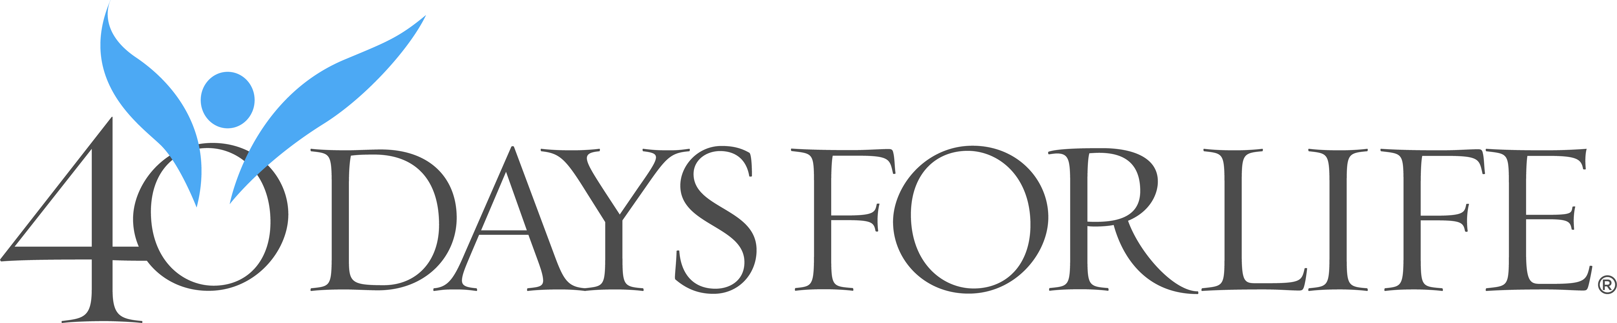

February 18 to March 29, 2026


HELP SAVE LIVES IN ANNAPOLIS!

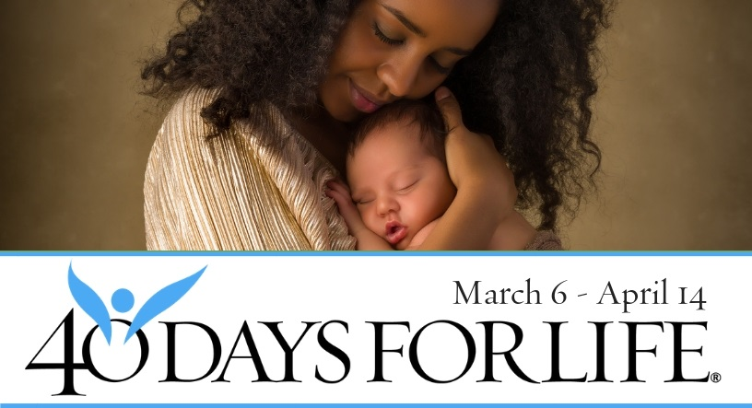

You can protect mothers and babies! Mothers entering abortion clinics respond to peaceful, prayerful vigils with positive signs offering help, hope, and life for their pre-born baby.

With God’s help, 40 Days for Life prayer vigils and fasting saved over 26,000 babies from abortion, encouraged 275 abortion workers to quit, and closed 184 abortion centers.

How To Participate in 40 Days for Life in Our Community
• Vigil location: Planned Parenthood, 929 West St., Annapolis
• Primary vigil hours: Mon 10AM to 7 PM; Tues-Fri 8 AM to 5 PM
but participants may also stand 7AM to 7PM daily.
- For more information or to sign up: see your church/organization notices or go to www.40daysforlife.com/en/annapolis .
• Local contact: see your church/organization vigil coordinator or contact annapolisvigil@gmail.com.
Pray at the vigil just one time or 1 hour per week.
Be A Voice For The Voiceless And Save A Life!

