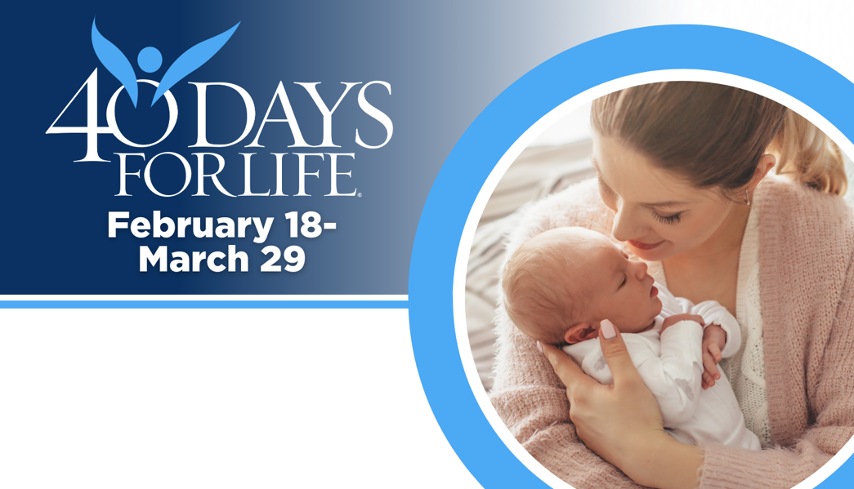

HELP SAVE LIVES IN ORLANDO
You can protect mothers and children by joining this worldwide mobilization! Through prayer and fasting, peaceful vigils and community outreach, 40 Days for Life has inspired 1,000,000+ volunteers!
Here’s how to take part:
- Vigil location: Outside Planned Parenthood at 11500 University Blvd Orlando, FL 32817
- Vigil hours: 7 am to 7 pm daily
- Local contact: Stephen Myler 734-646-7730 slothbear23@yahoo.com
Learn more and get involved by visiting our campaign:

40daysforlife.com/orlando

HELP SAVE LIVES IN ORLANDO
You can protect mothers and children by joining this worldwide mobilization! Through prayer and fasting, peaceful vigils and community outreach, 40 Days for Life has inspired 1,000,000+ volunteers!
Here’s how to take part:
- Vigil location: Outside Planned Parenthood at 11500 University Blvd Orlando, FL 32817
- Vigil hours: 7 am to 7 pm daily
- Local contact: Stephen Myler 734-646-7730 slothbear23@yahoo.com
Learn more and get involved by visiting our campaign:

40daysforlife.com/orlando

