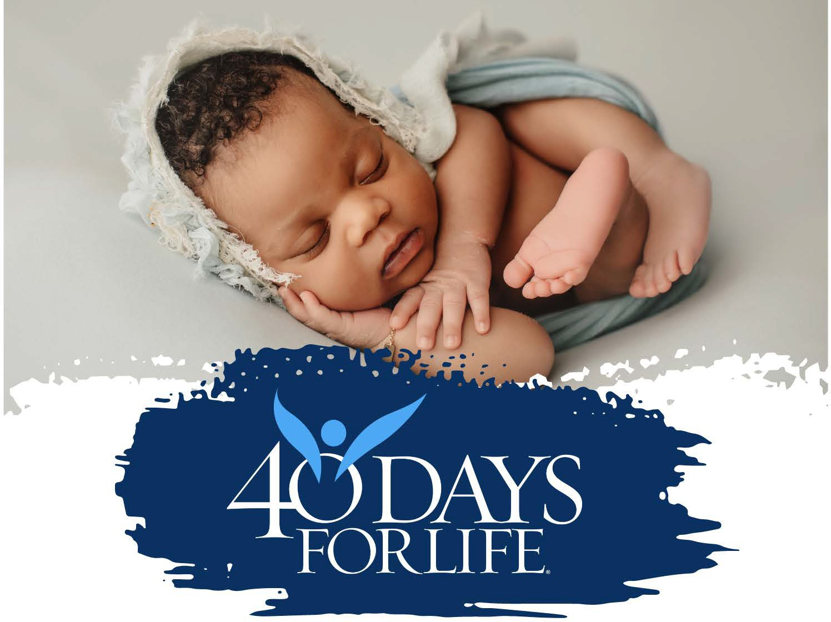
When: February 17, 2026, 6:30pm-7:30pm
Where: Sidewalk in front of Planned Parenthood, 11500 University Blvd Orlando, FL 32817
Who: Dr. Haywood Robinson & your fellow pro-life prayer warriors
What: Learn all about the upcoming campaign from 2/18-3/29
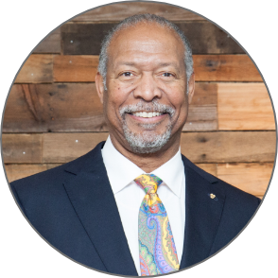
SPRING VIGIL KICK-OFF RALLY!!

