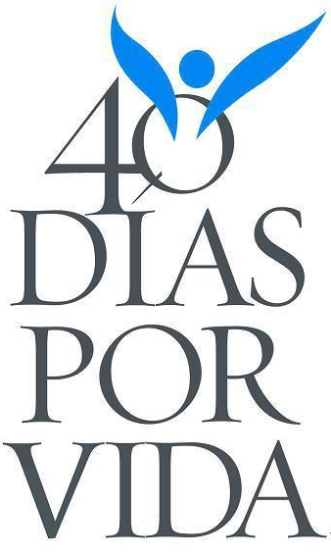
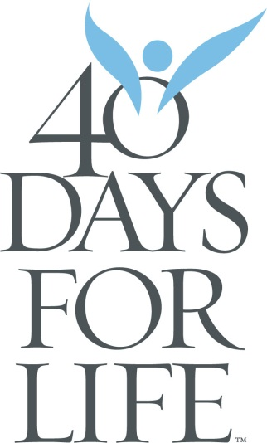
Let’s hit the ground Praying be proactive and Pro-life in Butte County, be informed and inspired to save lives!
40 Days For Life
Come to the Kick Off!
Share Information
Come and get involved by praying and fasting at our peaceful vigil
Sunday, February 15th
2:00 AM – 3:00 PM
Our Divine Savior Church
Social Hall
566 E. Lassen Ave, Chico
Come get informed
Pick up Literature
Hear our speakers about what
is happening with our young people during this
40 Days for Life event!

Sign up for vigil times at 40daysforlife.com/chiconorth

February 18th - March 29th
Mary 530-519-8818 or Diane at 530-519-9749
40 Days for Life Chico Team

