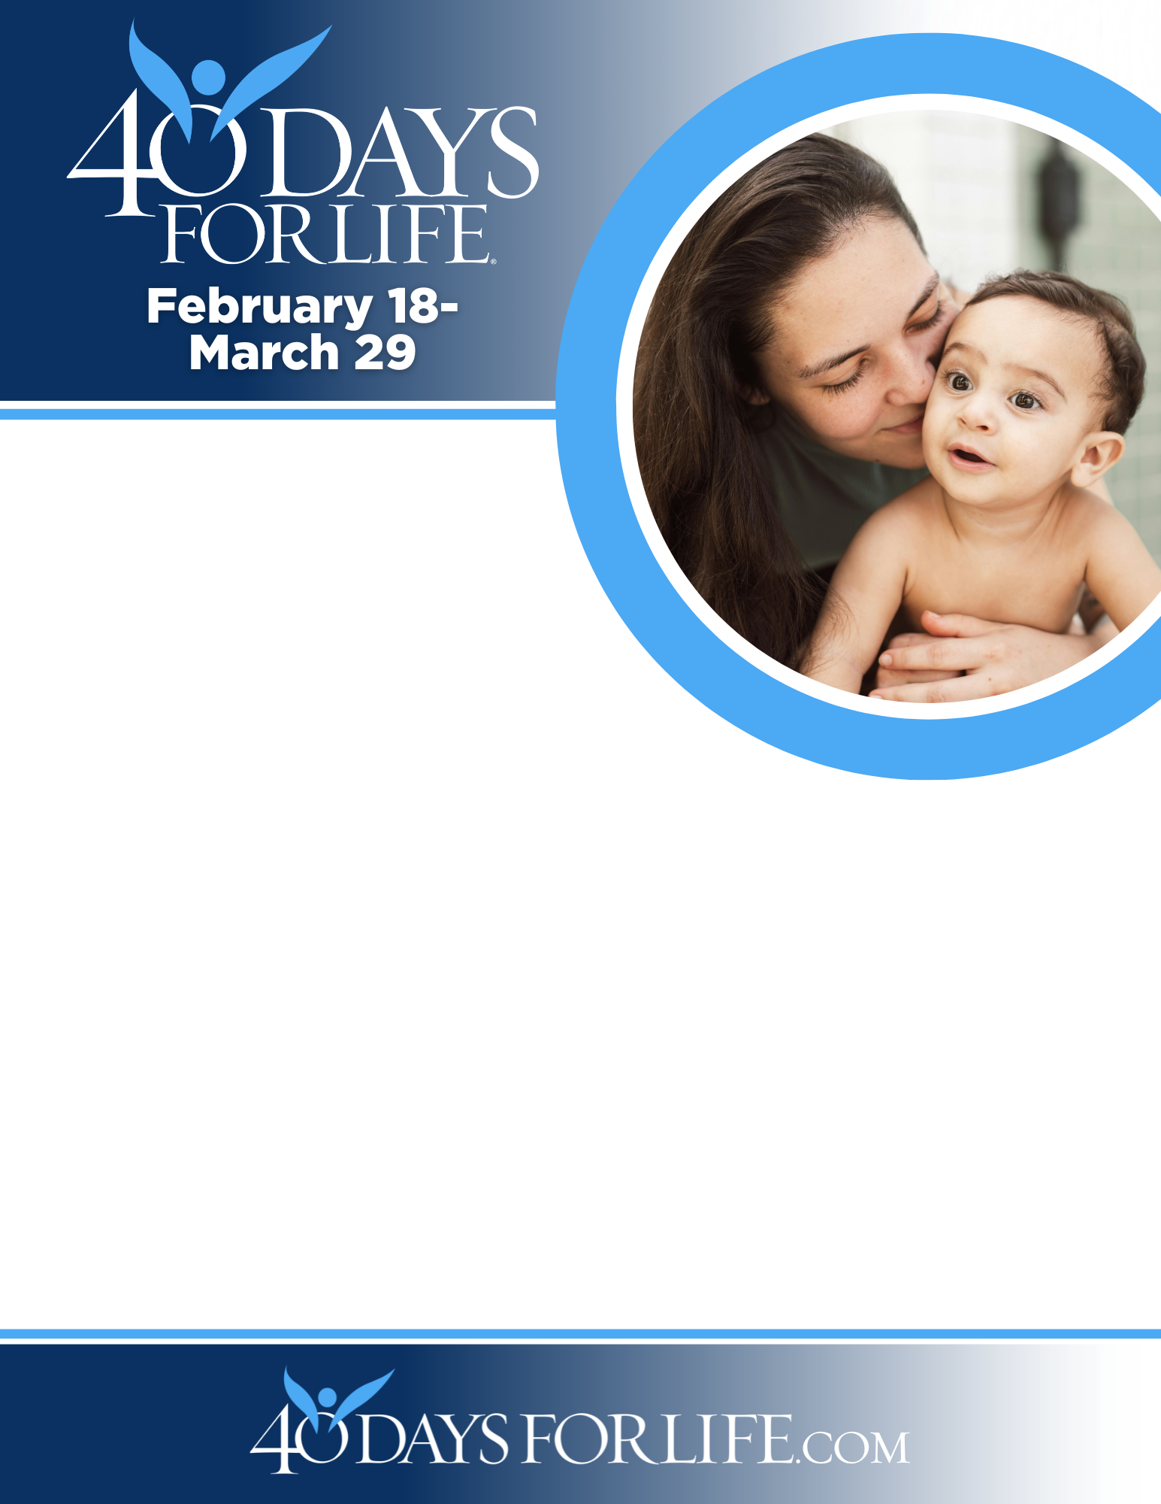
HELP SAVE LIVES IN CHICO!
Here’s how to take part in 40 Days for Life in our community:
Vigil location: Outside Enloe Hospital on the Esplanade between 5th and 6th Ave.
Vigil hours: 6 am to 9 pm Mon-Sat
Local contact: Mary 530-519-8818 or Diane 530-519-9749, 40dayschico@gmail.com
Learn more … get involved … and sign up for prayer times by visiting our campaign at the web address shown below!
You can protect mothers and children by joining this worldwide mobilization to pray and fast for an end to abortion!
Through prayer and fasting, peaceful vigils and community outreach, 40 Days for Life has inspired 1,000,000+ volunteers!
With God’s help, here are the proven results in 30 coordinated campaigns:
- Over 26,000 saved babies
- More than 180 closed facilities
- More than 275 converted workers

40daysforlife.com/en/chiconorth
Intercessions:
Ideally say The Lords Prayer and meditate on Psalm 139 as well as keeping the intentions below in mind.

1) May the tragic practice of abortion end.
2) May each person suffering from participation in abortion find forgiveness, hope and healing in Christ.
3) May all who defend life find strength and renewal in the Holy Spirit.
4) May all who support or participate in abortion experience a conversion of heart to seek and receive the Lord’s boundless mercy.
5) May all unborn children be protected in law and welcomed in love.
6) May every expectant mother receive compassionate care and support as she nurtures the life in her womb.
7) May expectant fathers lovingly support the mothers of their children in welcoming new life.
8) May expectant mothers choosing adoption receive grace and support in embracing this loving option.
9) May civic leaders work for the protection of all human life, in every stage and circumstance.

Prayer Pledge for the Unborn

Lord God,
I thank you today for the gift of my life and the gift of all my brothers and sisters.

Grant that all people who believe in Your Son, proclaim the Gospel of Life with honesty and love to the people of our time.

I rejoice that You have conquered death by the Resurrection of Your Son. I am ready to do my part to save lives.

Today I commit myself never to be silent, never to be passive, never to be forgetful of the unborn. I commit myself to be active in the pro-life movement, and never stop defending life until all my brothers and sisters are protected, and our nation once again becomes a nation with liberty and justice, not just for some, but for all, through Christ Our Lord.

Amen.

Prayer for Life

Eternal Father, Source of life, open our hearts to see and desire the beauty of your plan for life and love. Fill us with Your Holy Spirit so that our love will be generous and self-giving and we may be blessed with joy. Grant us great trust in Your Mercy. Forgive us for not receiving your gift of life and heal us from the effects of the culture of death. Instill in us and in all people a sense of the sacredness of every human life. Inspire our efforts to protect and care for the most vulnerable; especially women who are pregnant and their unborn children, the sick, and the elderly. Strengthen us in the hope that with you nothing is impossible. We ask this in the name of Jesus, who by his Cross and Precious Blood makes all things new. Amen.

SISTERS OF LIFE / sistersoflife.org

