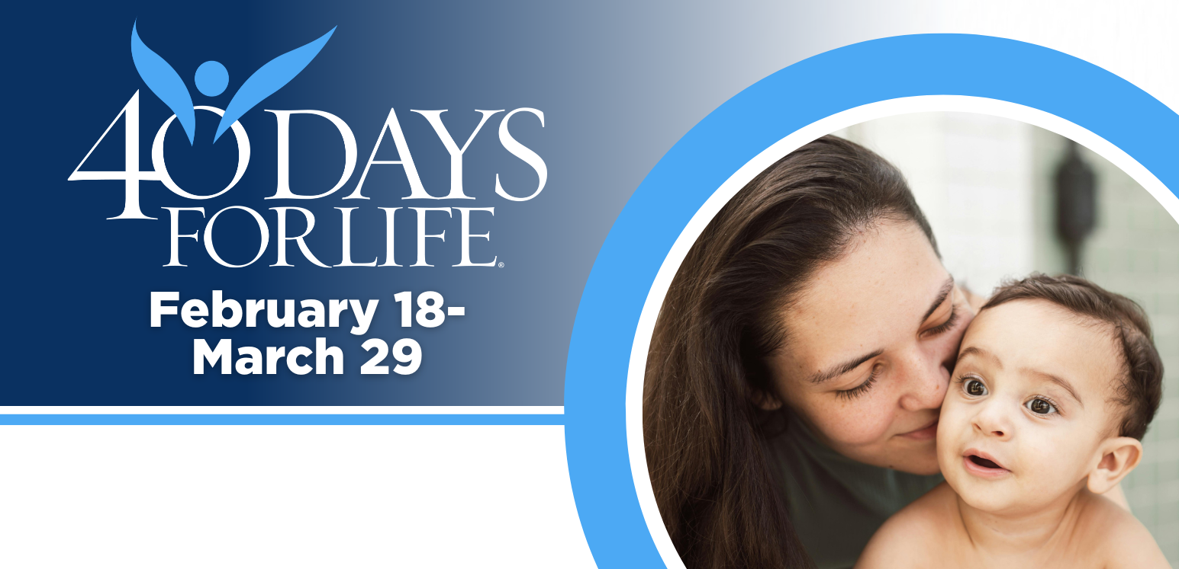

HELP SAVE LIVES IN CHICO!

You can protect mothers and children by joining this worldwide mobilization to pray and fast for an end to abortion!
Through prayer and fasting, peaceful vigils and community outreach, 40 Days for Life has inspired 1,000,000+ volunteers!
With God’s help, here are the proven results in 30 coordinated campaigns:
- Over 26,000 saved babies
- More than 180 closed facilities
- More than 275 converted workers

Here’s how to take part in 40 Days for Life in our community:
Vigil location: Outside Enloe Hospital on the Esplanade between 5th and 6th Ave.
Vigil hours: 6 am to 9 pm Mon-Sat
Local contact: Mary 530-519-8818 or Diane 530-519-9749, 40dayschico@gmail.com
Learn more … get involved … and sign up for prayer times by visiting our campaign at the web address shown below!

40daysforlife.com/en/chiconorth

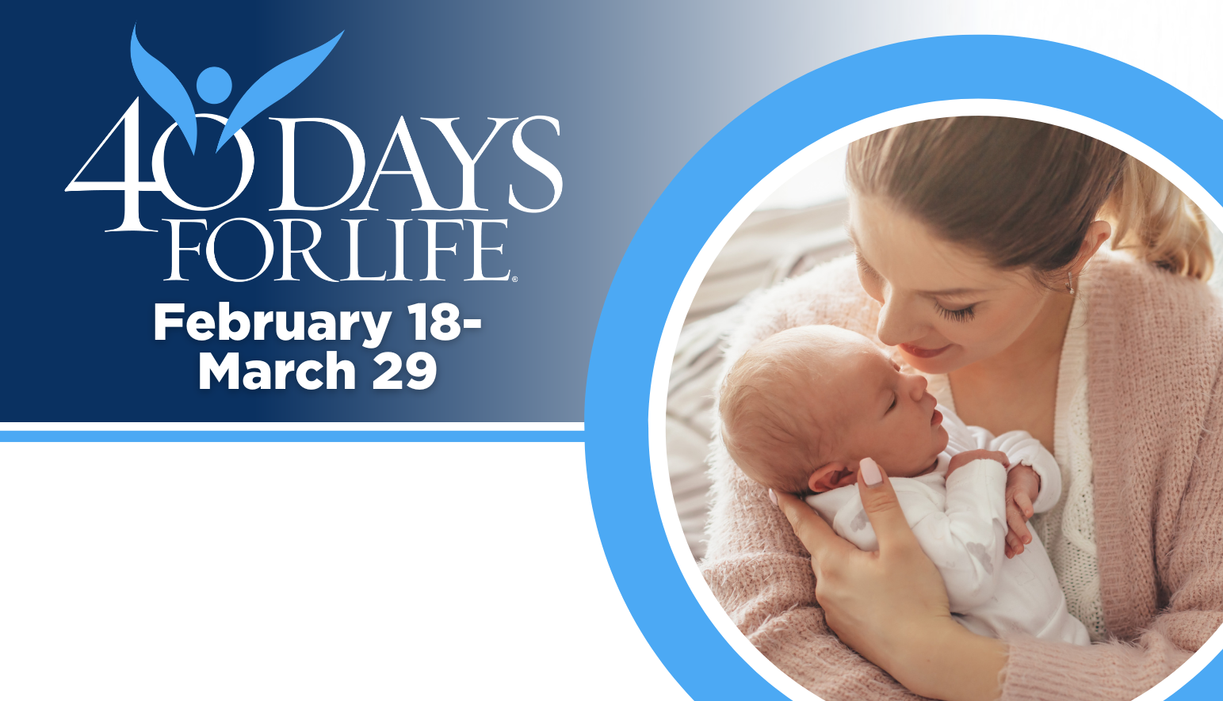

HELP SAVE LIVES IN CHICO!
You can protect mothers and children by joining this worldwide mobilization to pray and fast for an end to abortion!
Through prayer and fasting, peaceful vigils and community outreach, 40 Days for Life has inspired 1,000,000+ volunteers!
With God’s help, here are the proven results in 30 coordinated campaigns:
- Over 26,000 saved babies
- More than 180 closed facilities
- More than 275 converted workers
Here’s how to take part in 40 Days for Life in our community:
Vigil location: Outside; Enloe Hospital on the Esplanade between 5th and 6th Ave (6 am to 9 pm Mon-Sat) Planned Parenthood at 3100 Cohasset Rd (Fri 8:30-11 am) Women’s Health Specialist (Wed 8:30-11 am)
Local contact: Mary 530-519-8818 or Diane 530-519-9749, Hannah 530-591-3079
Learn more … get involved … and sign up for prayer times by visiting our campaign at the web address shown below!

40daysforlife.com/en/chiconorth
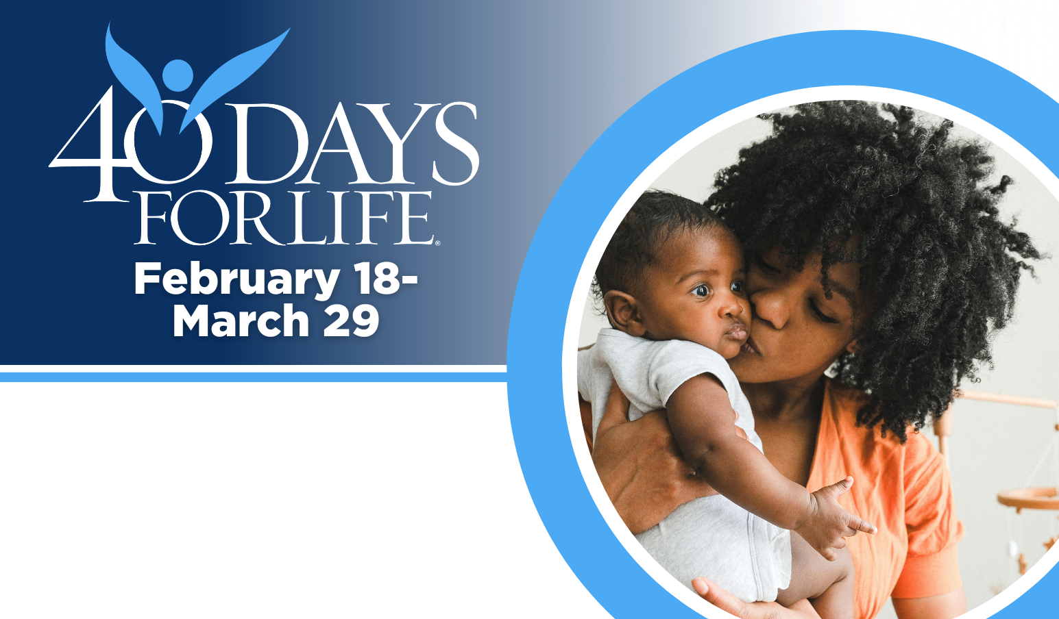

HELP SAVE LIVES IN CHICO!

Here’s how to take part in 40 Days for Life in our community:
Vigil location: Outside Planned Parenthood at 3100 Cohasset Rd (Fri 8:30-11 am) Women’s Health Specialist (Wed 8:30-11 am)
Local contact: Hannah 530-591-3079, hannahbananalang@gmail.com
Learn more … get involved … and sign up for prayer times by visiting our campaign at the web address shown below!
You can protect mothers and children by joining this worldwide mobilization to pray and fast for an end to abortion!
Through prayer and fasting, peaceful vigils and community outreach, 40 Days for Life has inspired 1,000,000+ volunteers!
With God’s help, here are the proven results in 30 coordinated campaigns:
- Over 26,000 saved babies
- More than 180 closed facilities
- More than 275 converted workers

40daysforlife.com/en/chiconorth

