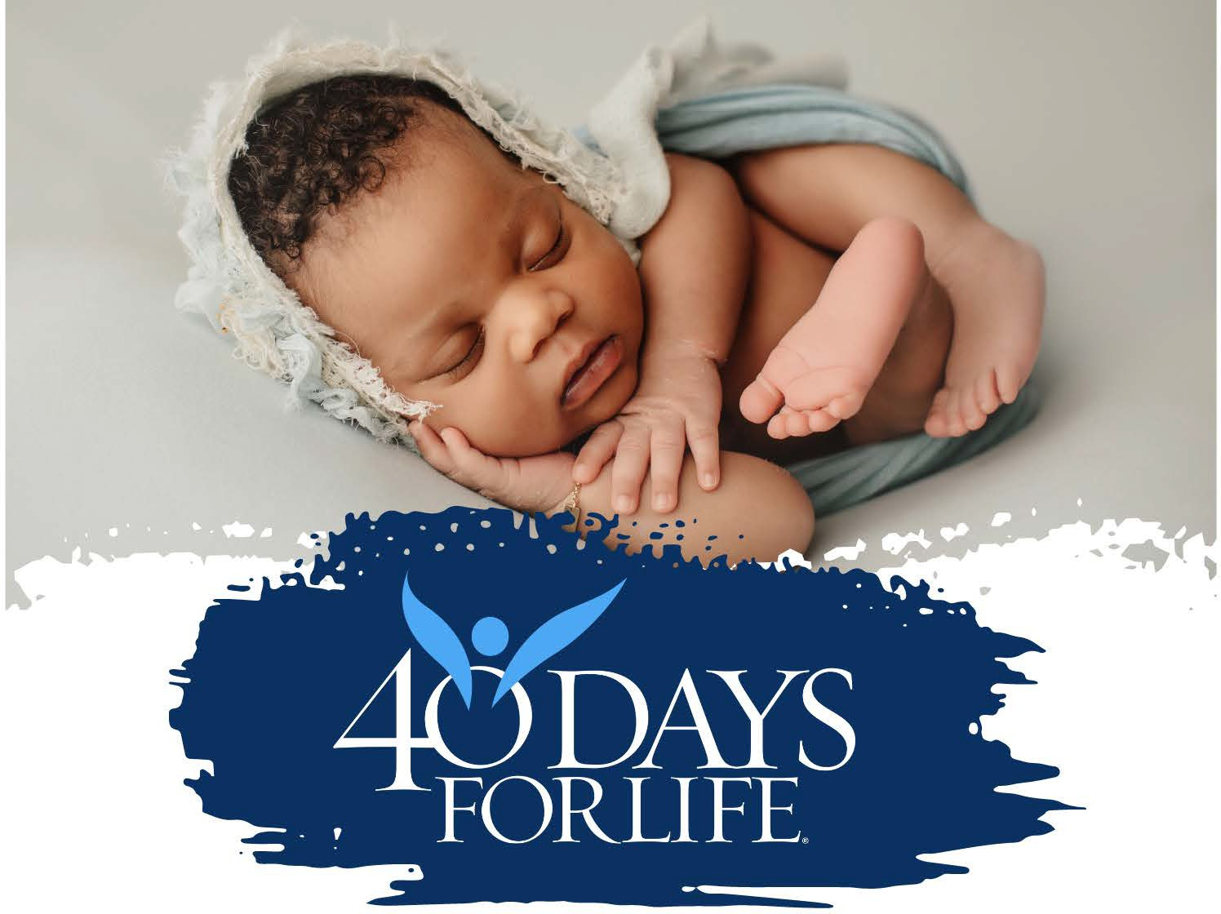
OPENING CEREMONY
FEB. 18TH 10:00-11:00 AM
302 HIGHWAY 75 NORTH, MOORHEAD, MN

Join us for a prayer filled, song filled, start to this year’s 40 Days for Life kick off.

Check back often as we confirm speakers and add details to the flier.

