Intersection of E. 71st Street and Frederick Street

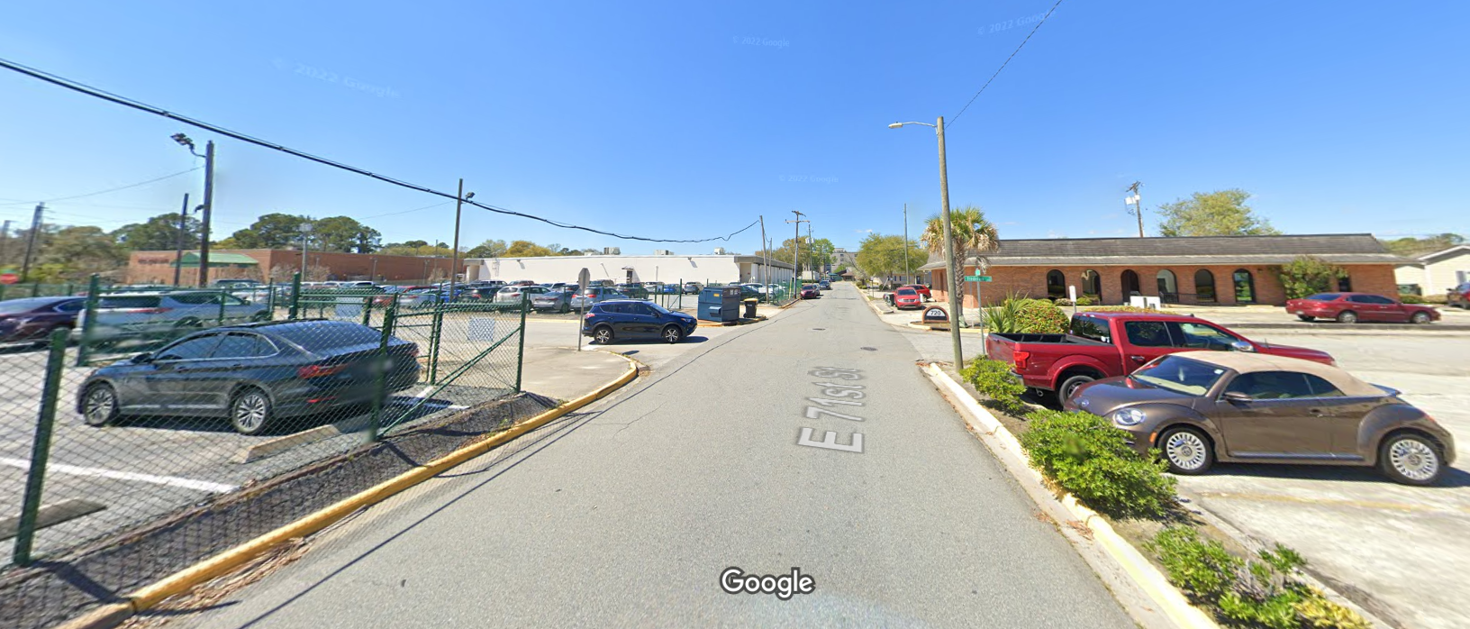
Planned Parenthood
Area to stand and pray.

