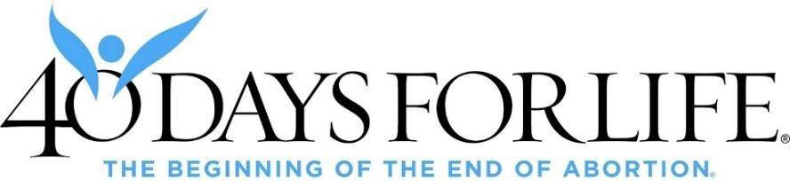
Statement of Peace

40 Days for Life is committed to ending the scourge of abortion through prayerful, peaceful, and lawful vigils.

I, ______________________________________________, agree to abide by this Statement of Peace and WILL:

PRINT NAME
- Pursue only peaceful, prayerful, and lawful solutions to end the violence of abortion by supporting life from natural conception to natural death and by demonstrating truth, love, and compassion; and
- Show compassion and reflect Christ’s love to all; and
- Strive to maintain safety and order by holding vigil in a safe, public, and lawful location; try to have at least two vigil participants on site at a time; use camera and lighting in a lawful manner; and never be alone after dark; and
- Leave and call law enforcement if I feel threatened, endangered, or unsafe; and
- Timely report to and cooperate with law enforcement about any incident in which I feel unsafe or threatened or if any unlawful act is made or threatened; and
- Be polite and cooperative with law enforcement and valid civil authority; and
- Leave or relocate if required by a valid authority, and contact 40 Days for Life HQ immediately; and
- Refrain from willfully causing harm, engaging in violence, and/or committing any crime or unlawful act, including:
  - Blocking or obstructing driveways, sidewalks, roadways, or any lawful passage;
  - Littering, defacing, destroying, stealing, damaging, or trespassing on another’s property;
  - Threatening, cursing, and using verbally abusive language;
  - Committing any unwanted touching of another;
  - Discussing or displaying weapons; and
- Refrain from all civil disobedience (“Rescues”) to end abortion at any 40DFL vigil location while a vigil is ongoing; and/or while wearing 40DFL gear or holding 40DFL signs/paraphernalia; and
- Refrain from engaging in political activities as a representative of a 40 Days for Life vigil, including advocacy (petitions, fundraising, signs, literature, etc.) related to a particular candidate for elective office or candidate’s platform; and

I am in no way, and will not become, directly or indirectly, associated with any abortion provider, including Planned Parenthood.

Please sign and abide by this Statement if you wish to participate in any 40 Days for Life activity:

Name & Signature: __________________________________________________________Date:__________________
Address: _________________________________________________________________________________________
Email: __________________________________________________________Phone:__________________________

If the participant is a minor who unaccompanied by a parent/guardian, a parent/guardian must complete the following:

PARENTAL CONSENT
I, the minor’s parent and/or legal guardian, have read and understand this Statement of Peace and agree to all terms on behalf of myself and my child/charge; I agree to be responsible on his/her behalf to the fullest extent of the law.

I,__________________________, give my permission for __________________________ to participate in a 40 Days for
PRINT NAME PRINT MINOR’S NAME
Life prayer vigil or other activity.

Name & Signature: ___________________________________________________________Date:__________________

