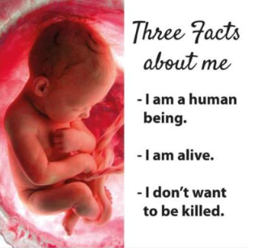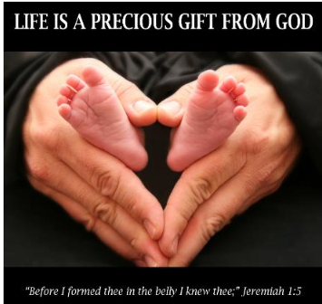


HELPS SAVE LIVES IN WHITEFISH!
Join Us for our Kickoff Rally

Saturday, September 26
1:00 – 2:30 pm

Central Bible Church
902 1st Avenue East
Kalispell

Featured Speaker: Tanaia Puchta
Founder Abort Ignorance MT

      - Meet others involved in the pro-life effort
      - Share past experiences
      - Pick up signs, brochures and handouts
Point of contact: Mike Hanson, (406) 314-7826 or mikester55@hotmail.com
40daysforlife.com/whitefish

