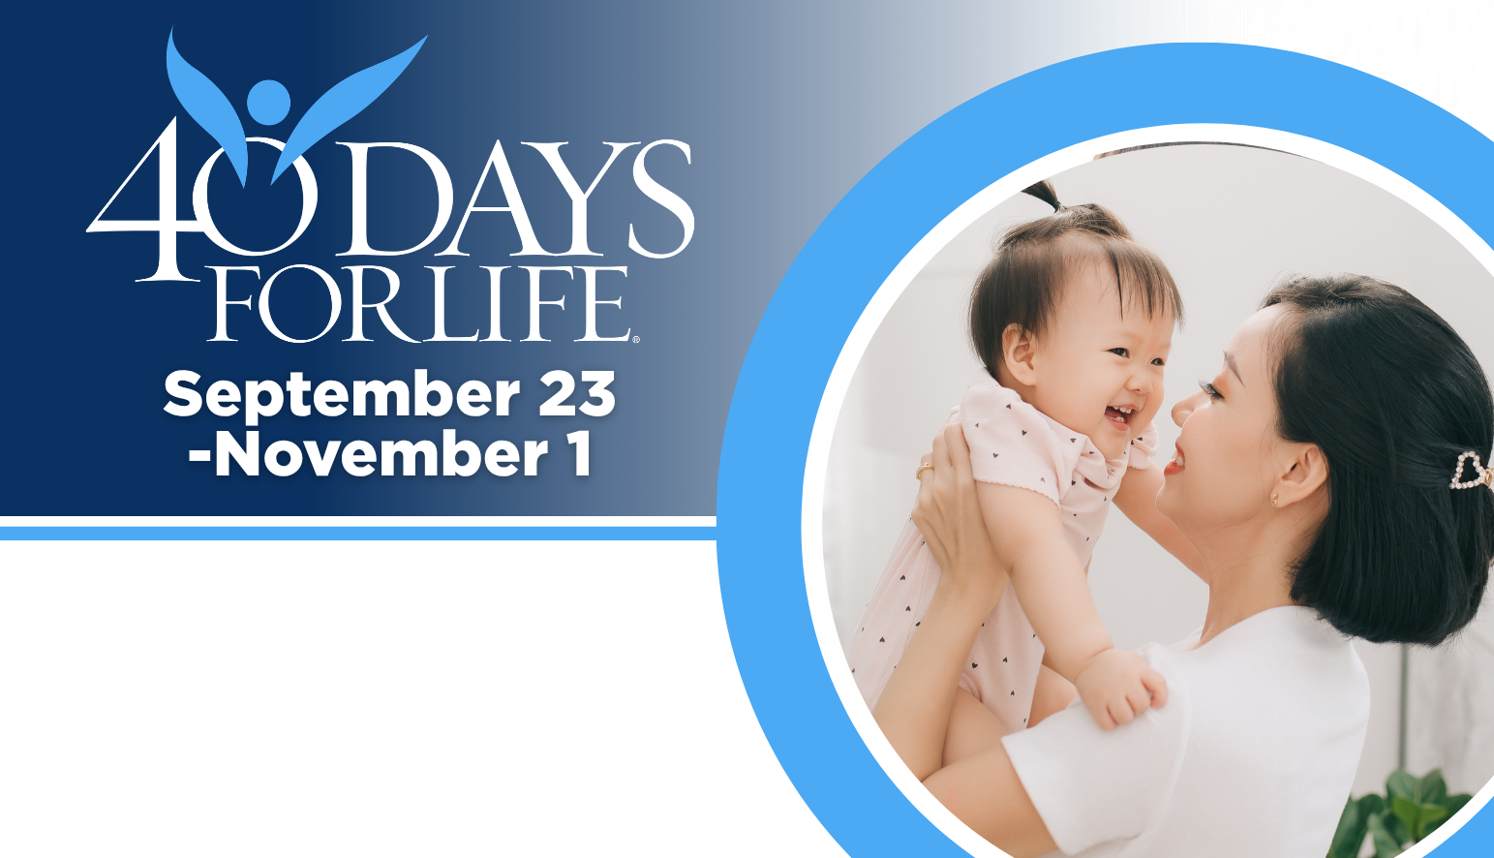

HELP SAVE LIVES IN CLEVELAND, PAINESVILLE, BEDFORD!
You can protect mothers and children by joining this worldwide mobilization to pray and fast for an end to abortion!
Through prayer and fasting, peaceful vigils and community outreach, 40 Days for Life has inspired 1,000,000+ volunteers!
With God’s help, here are the proven results in 32 coordinated campaigns:
- 26,550 saved babies
- 187 closed facilities
- 278 converted workers
Here’s how to take part in 40 Days for Life in our community:
Vigil locations: Preterm - 12000 Shaker Blvd. Cleveland 44120 Planned Parenthood - 25350 Rockside Road - Bedford – 44146 Signature Health - 54 So. State St. Painesville – 44077

Vigil hours: 7 am – 7 pm daily at all three sites

Local contact: John Noall 216-245-9744 email: clevelandpraysforlife@gmail.com
Learn more… get involved and sign up for prayer times by visiting our campaigns at the websites shown below!

40daysforlife.com/cleveland
40daysforlife.com/painesville
40daysforlife.com/bedfordheights

