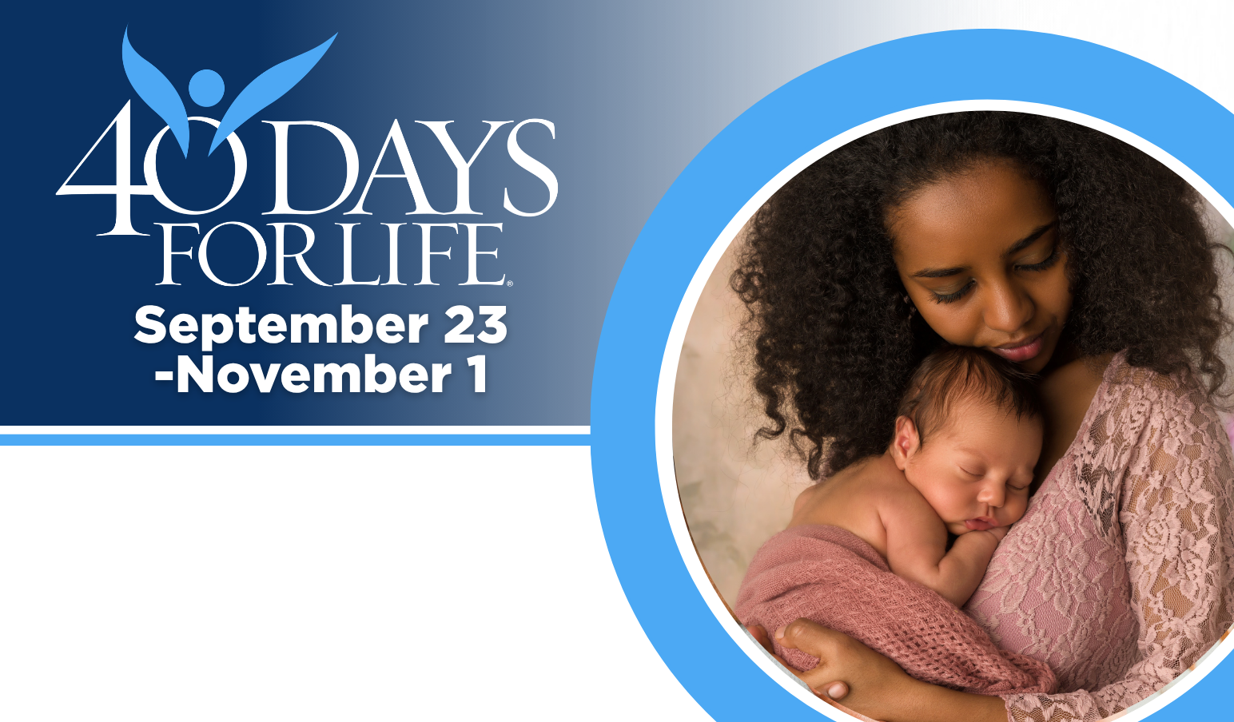

HELP SAVE LIVES IN RALEIGH!
Join us for any hour of Mercy!
Vigil location: On Drake (traffic) Circle across from “A Woman’s Choice” abortion business-- 3305 Drake Circle, Raleigh NC
Vigil hours: 7 am to 7 pm daily
Local contact: Dr Karen Ross MD
Raleigh40daysforlife@gmail.com
Park on Harden Road and walk along Myron Drive to the half-wooded traffic circle.
Sign up for Prayer times by searching below!
You can protect mothers and children
by joining this worldwide mobilization to pray and fast for an end to abortion!
Through prayer and fasting, peaceful vigils and community outreach, 40 Days for Life has inspired 1,000,000+ volunteers!
With God’s help, here are the proven results in 30 coordinated campaigns:
- Over 26,000 saved babies
- More than 180 closed facilities
- More than 275 converted workers



