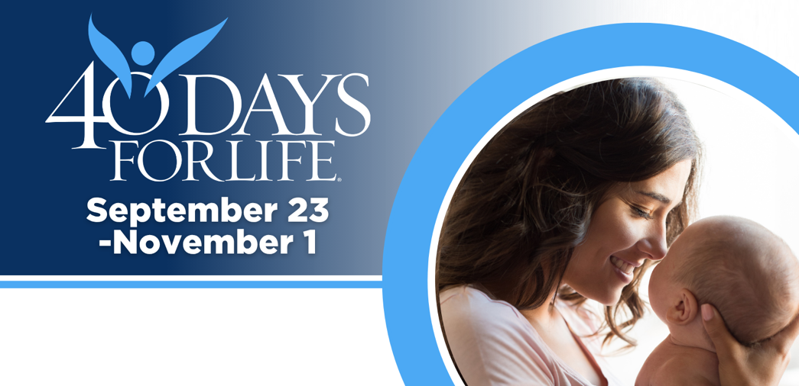

HELP SAVE LIVES IN OVERLAND PARK
You can protect mothers and children by joining this worldwide mobilization! Through prayer and fasting, peaceful vigils and community outreach, 40 Days for Life has inspired 1,000,000+ volunteers!
Here’s how to take part:
- Vigil location: Outside the Center for Women’s Health abortion facility at 4840 College Blvd., Overland Park, KS 66211 (just west of Roe Ave.)
- Vigil hours: 7 am to 7 pm daily
- Local contact: Annie Fowler, 816.726.4659, anniekcc4life@gmail.com
Learn more and get involved by visiting our campaign:

40daysforlife.com/overlandpark

HELP SAVE LIVES IN OVERLAND PARK
You can protect mothers and children by joining this worldwide mobilization! Through prayer and fasting, peaceful vigils and community outreach, 40 Days for Life has inspired 1,000,000+ volunteers!
Here’s how to take part:
- Vigil location: Outside the Center for Women’s Health abortion facility at 4840 College Blvd., Overland Park, KS 66211 (just west of Roe Ave.)
- Vigil hours: 7 am to 7 pm daily
- Local contact: Annie Fowler, 816.726.4659, anniekcc4life@gmail.com
Learn more and get involved by visiting our campaign:

40daysforlife.com/overlandpark

