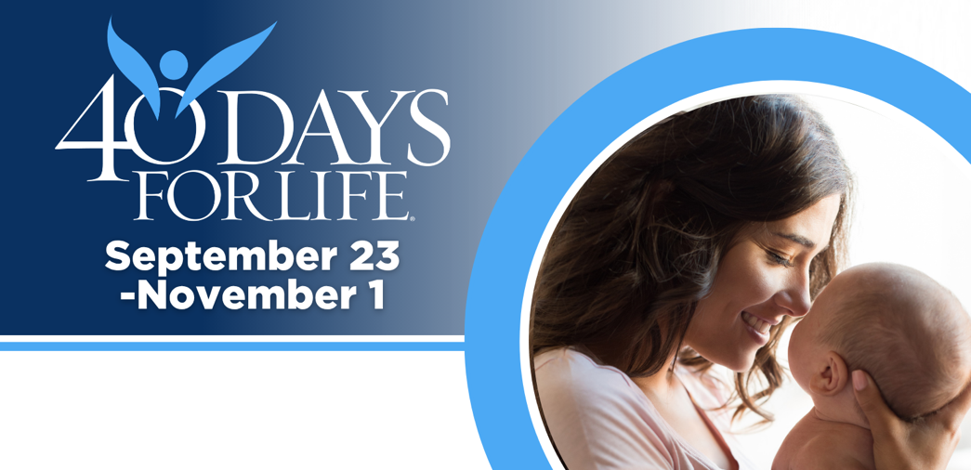

HELP SAVE LIVES IN FALLS CHURCH
You can protect mothers and children by joining this worldwide mobilization! Through prayer and fasting, peaceful vigils and community outreach, 40 Days for Life has inspired 1,000,000+ volunteers!
Here’s how to take part:
- Vigil location: On the sidewalk outside of Falls Church Healthcare Center, 900 S. Washington St. Falls Church, VA
- Vigil hours: 7 am to 7 pm daily from Sept. 23 – Nov. 1
- Local contact: Joe Flaherty, jflaherty1310@aol.com
Learn more and get involved by visiting our campaign:

40daysforlife.com/FallsChurch

HELP SAVE LIVES IN FALLS CHURH
You can protect mothers and children by joining this worldwide mobilization! Through prayer and fasting, peaceful vigils and community outreach, 40 Days for Life has inspired 1,000,000+ volunteers!
Here’s how to take part:
- Vigil location: On the sidewalk outside of Falls Church Healthcare Center, 900 S. Washington St. Falls Church, VA
- Vigil hours: 7 am to 7 pm daily from Sept. 23 – Nov. 1
- Local contact: Joe Flaherty, jflaherty1310@aol.com
Learn more and get involved by visiting our campaign:

40daysforlife.com/FallsChurch

