Colorado Chapter Membership
YOU ARE AN ANGENCY OWNER

AGENCY OWNER
Each Agency (AKA Jurisdiction) will now have only one Owner. The Owner is the only person who can renew membership for the entire agency at the same time. And is also the only person that can add seats (memberships) as needed. Owners can also post jobs on the website.

AGENCY MANAGER
Each Agency can have one or more Managers. Managers can appoint others as managers, add new members (only if there are available seats) and post jobs on the website. If more seats are needed the agency Owner can purchase additional seats and then the Manager can add members.
Please contact a website administrator for help and any questions
Gil Rossmiller gilrossmiller@coloradocode.net
Cornelia Orzescu corzescu@parkeronline.org

Log in to the website and go to your account

THEN
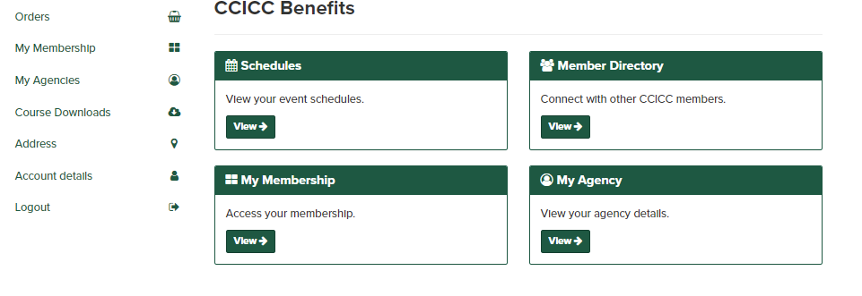

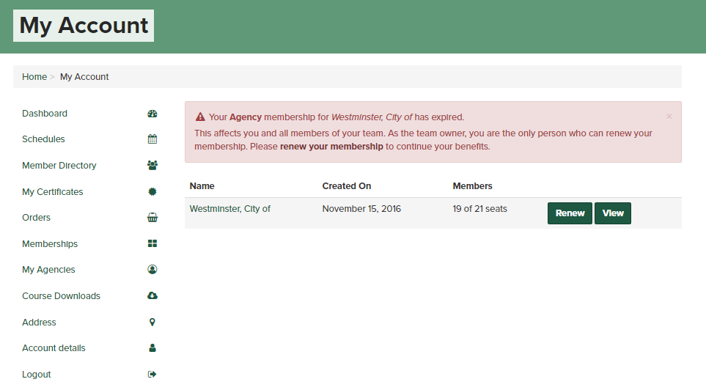

This is where you can Renew the entire Agency at the same time. Note that the current agency has 19 of 21 seats. This would typically mean that there are two seats that can be taken for new members. HOWEVER as this is the first time as the red tad states above all memberships have expired.
Why does this agency have 21 seats and only 19 members? Transferring all the old data into the new membership system was a real task and we did the best we could. We now can set up each agency correctly.
One seat equals one membership.

The first step is to determine how memberships in total you want.
Currently the example has 21 seats (Memberships) and if you were to select the renew button the system would add 21 seats to your cart, and you would proceed to purchase.

If, however you want less than the number of seats shown, you must remove the those who will not be part of your team. In the example below the current number of seats is five. The desired number is 3. Then two members would need to be removed BEFORE you can change the number of seats to a lower number.
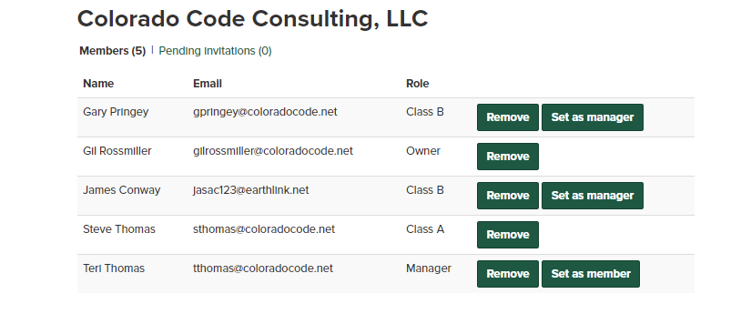
If you need to change the number of seats, select the View button:

Then select Account Settings:
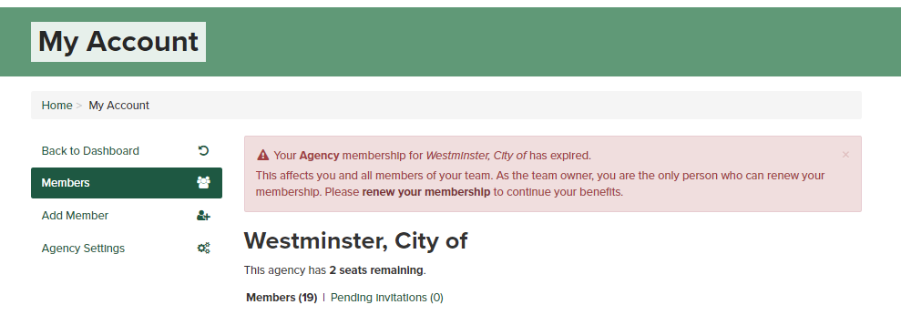

Then Select Change Seats:
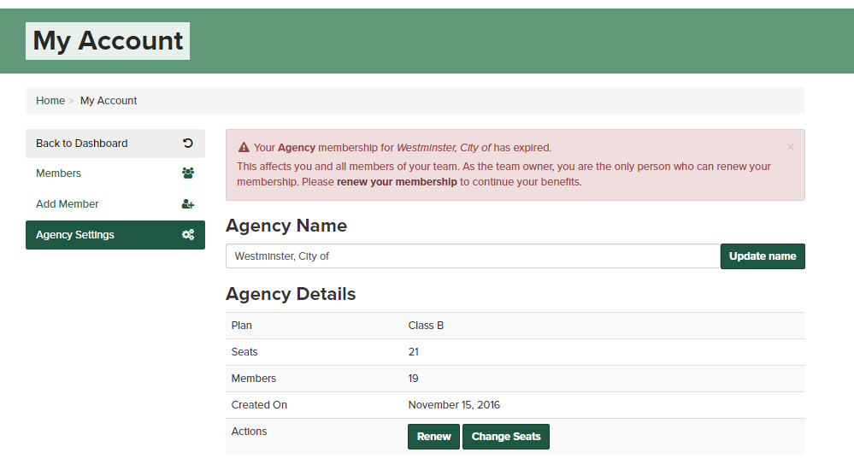
Then enter the number of seats (Memberships) you want to purchase
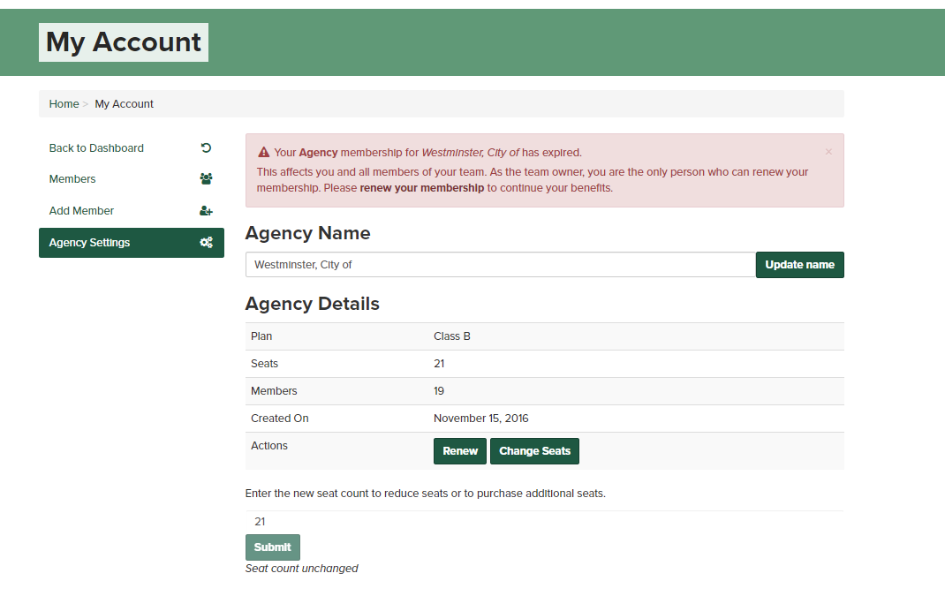

After you have the correct number of seats then go back to your dashboard
Select My Agency
Select Renew and the system will add the number of seats to your cart. Proceed and pay for the seats. If your jurisdiction does not allow website purchases send a check to the Chapter and mark attention membership.
Now the correct number of seats has been established you can add or remove members as you need. Go back to View your Agency

You now can remove anyone who is not a member and add those add those that are. To remove select the remove button. You can also set any member to be a Manager. You can have as many managers as you want. You can also remove someone as a manager. Notice one member has a ‘Set to Member’ button. This means the person is currently a Manager. Select this button and the person will have only membership permissions.

Now to add a member if you have available seats select Add Member.
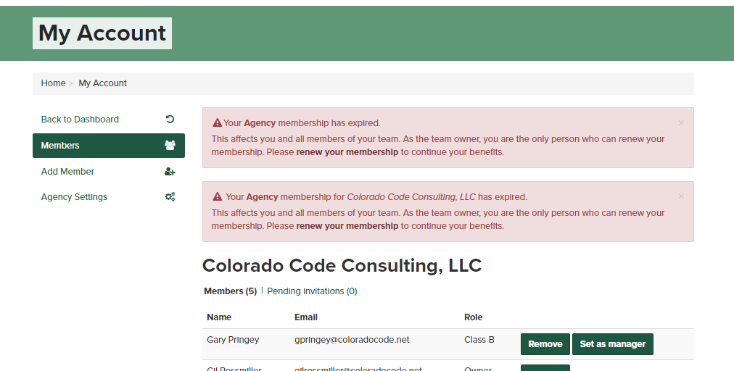

This agency has one seat remaining so you can add one member. Start to enter their email in the email field and if they are in the system their name will show up. Select them and hit the add member button. The system will not send an email to them, they will automatically be part of your agency and a member. If the email does not appear, enter their email and the system will send an email to them asking them to create and account. They will not be required to pay any fees just create an account. All new members will automatically become a Class B. If you want one person to be the Class A member (only one allowed per jurisdiction) contact a website administrator and they can give that person a Class A designation for that Agency.

