Jurisdiction Survey on Extended Stay Hotels
Conducted by Shaunna Mozingo, Mozingo Code Group
October 2024
Question:
Is an extended stay hotel, that advertises stays longer than 30 days, truly an R-1 Occupancy or in fact an R-2 Occupancy. They are transient in nature, kind of, but do have kitchens. What definition or occupancy group do you think they meet?

[A] DWELLING. A building that contains one or two dwelling units used, intended or designed to be used, rented,
leased, let or hired out to be occupied for living purposes.

[A] DWELLING UNIT. A single unit providing complete, independent living facilities for one or more persons, including permanent provisions for living, sleeping, eating, cooking and sanitation.

[BG] DWELLING UNIT, EFFICIENCY. A dwelling unit where all permanent provisions for living, sleeping, eating and cooking are contained in a single room.

[A] SLEEPING UNIT. A single unit that provides rooms or spaces for one or more persons, includes permanent provisions
for sleeping and can include provisions for living, eating and either sanitation or kitchen facilities but not both.
Such rooms and spaces that are also part of a dwelling unit are not sleeping units.

[BG] TRANSIENT. Occupancy of a dwelling unit or sleeping unit for not more than 30 days.

310.2 Residential Group R-1. Residential Group R-1 occupancies containing sleeping units where the occupants are
primarily transient in nature, including:

Boarding houses (transient) with more than 10 occupants
Congregate living facilities (transient) with more than 10
occupants
Hotels (transient)
Motels (transient)

310.3 Residential Group R-2. Residential Group R-2 occupancies containing sleeping units or more than two dwelling units where the occupants are primarily permanent in nature, including:

Apartment houses
Congregate living facilities (nontransient) with more than
16 occupants
Boarding houses (nontransient)
Convents
Dormitories
Fraternities and sororities
Monasteries
Hotels (nontransient)
Live/work units
Motels (nontransient)
Vacation timeshare properties

RESPONSES:
- One of the biggest things to consider is can the unit in question be the person’s legal residence. If they are receiving mail at the “hotel”, then it’s an R-2. If not and they’re just staying there more than the “transient” time frame established by the building code, then it’s an R-1. This is all spelled out in the commentary. It has to do with Fair Housing.

- I believe the key term in the descriptions of both R1 and R2 is “primarily”
Simple as that. Does the lodging facility “primarily” house guests for less than 30 or more than 30.
Difficult as that. How do you get annual lodging statistics of length of stay from a building not yet built? The same chain company would likely have different statistics for different locations.
This article states the average extended stay is 5 to 25 days, but it was only about a 2 minute Google search, so I’d first want to check other sources if I were doing full research.
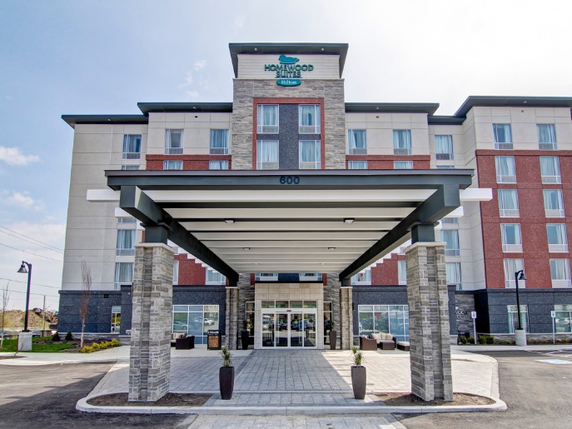
The truth behind extended-stay hotels' underrated success
hotelmanagement.net

It looks like the hospitality industry has an acronym for this statistic: (ALOS). I bet the hospitality industry nonprofit has done this research and would have statistics.

- In my opinion, this is an R-1 occupancy as the rooms may be advertised and rented on a 30+ day term (characterizing it as ‘non-transient’), but they can also be rented for much shorter terms (transient). I’ve stayed in an extended stay suite type hotel with a kitchenette for just a few days myself.

We believe that the transient/non-transient characteristic is the most important factor when determining code compliance provisions – not the sleeping unit vs. dwelling unit argument. Always better to assume the worst until proven otherwise!

- We have had some of these in our jurisdiction and if they meet the non transient definition it would be classified as an R-2 - hotel (non- transient) and then need to meet all of the various requirements including the accessibility for units.

- I believe the code for long term hotels (R-1) is for short/long term and the occupants should not be permanent in nature, the occupants should not be assigned the same room constantly for a long term. I believe the stay in a long term (My Place) is addressed with the fees and are used for 15-90 days for business reasons; which leaves it as a transient use in my view.
There are other factors that come into play with tourist tax etc when someone rents for long term
With this being a building/planning issue, there is a lot of grey in the uses related to R1 and R2, I would run the argument that when an R-1 is used for long term 90 days plus it becomes more dangerous to the occupant and the structure in general due to the hoarding for lack of better words.

- We interpret R1s and R2s to both be able to have dwelling units. The determining factor for us is the length of stay. If a hotel room can be rented as both shorter and longer than 30 days, we apply R2 as it has stricter requirements (travel distance for example) and per the section in chapter 1 the more restrictive requirement should apply.
STRs are another question…

- R-2 it is required. R-1 is not required but they are allowed if items are code compliant. No hot plates per code. Micro, refrig and coffee are ok. We will make NEW comply with both R1/R2 and do annual inspections when they classify themselves as extended stay.

- I think the code is pretty clear, transient is defined in Chapter 2 in the IBC. If a hotel is renting for more than 30 days, then it’s not transient and would be an R-2.

- If all stays must be 31 days or longer, that is clearly an R-2 because the residential occupancy is by definition not transient. However, if you can stay less than 31 days, that is transient occupancy = R-1... except since they are dwelling units not sleeping units, that use does not clearly fit R-1 or R-2. What do we do then? We comply with IBC 302.1, classify the occupancy as sometimes transient = R-1 (which it most closely resembles) and sometimes non-transient as R-2, and design the hotel to comply with all the requirements of both an R-1 and an R-2 occupancy.

302.1 Occupancy classification.
An area, room or space that is intended to be occupied at different times for different purposes shall comply with all applicable requirements associated with such potential multipurpose. . . Where a structure is proposed for a purpose that is not specified in this section, such structure shall be classified in the occupancy it most nearly resembles based on the fire safety and relative hazard.

- I believe each occupancy classification is going to vary based on the project and it’s important to consider the data that the applicant may already have. Generally speaking, if a resident’s average stay was for 30 consecutive days or less before checking out, then the occupancy needs to be classified as an R-1. If a resident’s average stay was more than 30 days consecutively, then it should be an R-2 occupancy. I’d want to see data from the applicant justifying what the average occupancy timeline is (and I’d look at occupancy from check-in to check-out where the same space cannot be leased to another occupant/ occupant group). If there was a lack of data or confidence in the accuracy of the provided data, I’d probably require an analysis from the design team to show me which occupancy was more restrictive and require the occupancy to be classified that way.

